A&S:
- Augmented 6th chords are called that because they’re characterized by an augmented 6th
- The interval expands outward to an octave
  - Part of a V chord
- “To generalize, the bass of an augmented 6th chord is a half step above 5 (6 in minor or b6 in major), one of the upper voices is a half step below 5, and the resolution is ton an octave on 5 as part of dominant harmony.”
- Aug 6th cannot occur diatonically
  - The sound of +6th to an octave is unique in tonal music
  - Augmented sixth chords are often used just before important structural points
- This is leading-tone chromaticism:
  - The leading tone to 5
  - But this is different from normal applied chords in that the chord itself doesn’t belong to the key of the chord of resolution
  - (only the leading tone is an “agent of tonicization”)
  - Thus, the resolution of an +6th chord will not sound like tonic (this makes it good for emphasizing important dominant chords)
- Origins:
  - It comes from the common use of fi as a passing tone
  - When fi replaces fa in a minor iv6 – V progression, you get an augmented sixth
- Names:
  - Simplest is the Italian 6th (augmented 63)
  - German 6th or German 65 (augmented 65)
  - French 6th (augmented 43)
  - Geography is meaningless, but the names are useful and widely used
- Major requires b6 as well
- Italian:
  - Third is doubled (other doublings result in weird sound, awkward melodic lines, parallel octaves)
  - Sometimes nothing is doubled (three-note chord)
  - Thinnest/transparentest aug 6th chord
- German:
  - Most frequently used
  - Fuller sound than the Italian
  - Typically moves to cadential 64
    - (two common tones in minor, one in major)
  - Can also go directly to V, but then parallel 5ths are inevitable
- French:
  - Has a lot of dissonances:
    - +6 above the bass and +4 above the bass
    - +4/d5, M2/m7 in the upper voices
  - Can go to V or cadential 64
- Approaching form IV and II
  - “Augmented 6th chords frequently represent a chromatically inflected IV or II on the way to V. Important possibilities include the chromatic inflection n4-#4, usually from IV6, and chromaticized voice exchange, usually from IV, but also from II65, etc. Augmented 6th chords can also result from the chromatic inflection n6-b6 in the bass, often from altered II or IV (V or VII of V). Voice exchange between augmented 6th and diminished or half-diminished 7th applied to V is also possible.” (point for review)
  - A6 chords can appear in different contexts
    - They can start a piece without any prep (rare and never before Beeth)
  - Usually prepared by a IV chord (usually IV6)
    - “in such cases the augmented 6ths continue subdominant harmony; they are chromaticized subdominants that have become active in the direction of V.”
    - #4 is a chromatic passing tone
    - Sometimes as a result of a chromatic voice exchange with IV (through a passing 64 auxiliary)
  - Sometimes prepared by II
  - The chromaticism weakens their status as a chord in themselves (they’re linear)
- Applied chords to V are like A6 chords in that they are chromatically altered forms of IV or II
  - They all have #4
  - Sometimes A6 chords are introduced with a V7/V with b6 as a passing tone in the bass
- Approach from I
  - Pretty common, especially in minor
  - After i53
  - Or by leaping from i6
- Approach from VI (or bVI in major)
  - Just add #4
- Sometimes it comes about as a chromatic upper neighbor to V
- Modulation:
  - Important role in modulation
  - Particularly in: modulations from I to V and also in back to I
  - This is done with I/IV as a pivot
    - (For example, in going back to the global tonic from the dominant, a tonicized IV chord is transformed to an A6 which then goes to the global V.)
    - (or from I to V, I is transformed to an A6, retroactively making it a IV in V)
- Composers can avoid the parallel fifths of Ger – V by skipping to another member of the Ger chord or up to the root of the V chord
- A6 can move directly to V7 too, even though this thwarts the resolution of A6-P8
- Inverted augmented sixth chords
  - Same pitches, but with something other than b6 in the bass
  - Much less frequent
  - Sometimes #4 is in the bass (also resolves to root position V)
  - Usually #IV7 (same pitches as Ger65)
  - Other inversions (neither b6 nor #4 is in the bass) probably won’t go to root position V
- In sequences
  - They’re especially useful here since they can precede tonicizing applied dominants
  - They can resolve to I too (almost always major I) in which case they have a very “Neapolitan” flavor
- Ger = V7/bII
  - (enharmonically equivalent)
  - Can be very useful in chromatic modulations

C&M:
- German would produce parallel fifths if it moved right to V
- They all contain b6, 1, #4:
  - Italian has nothing else
  - German adds b3
  - French adds 2

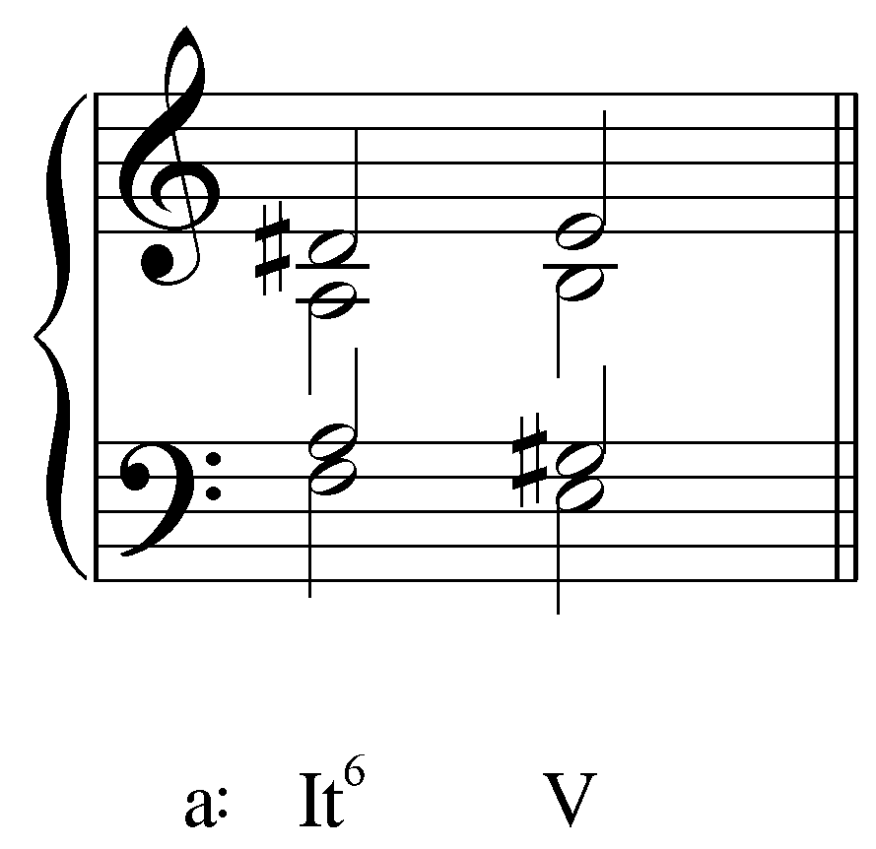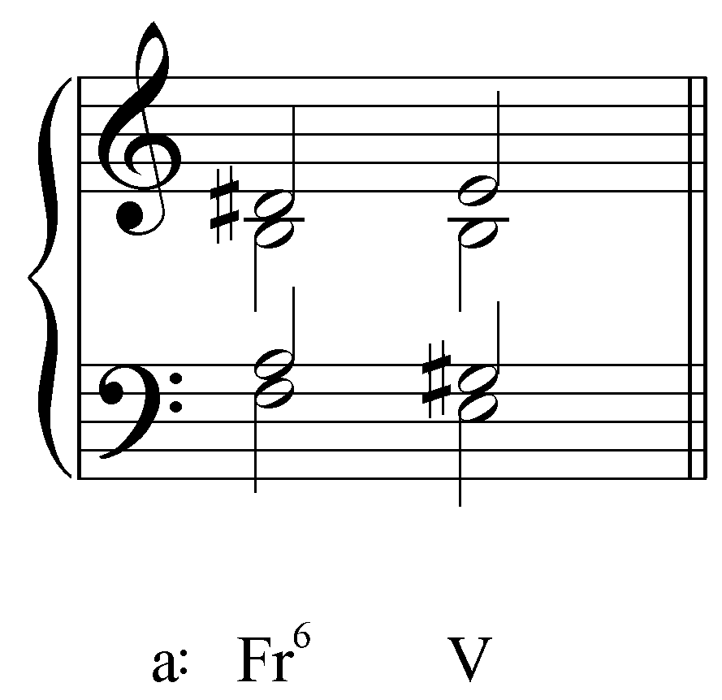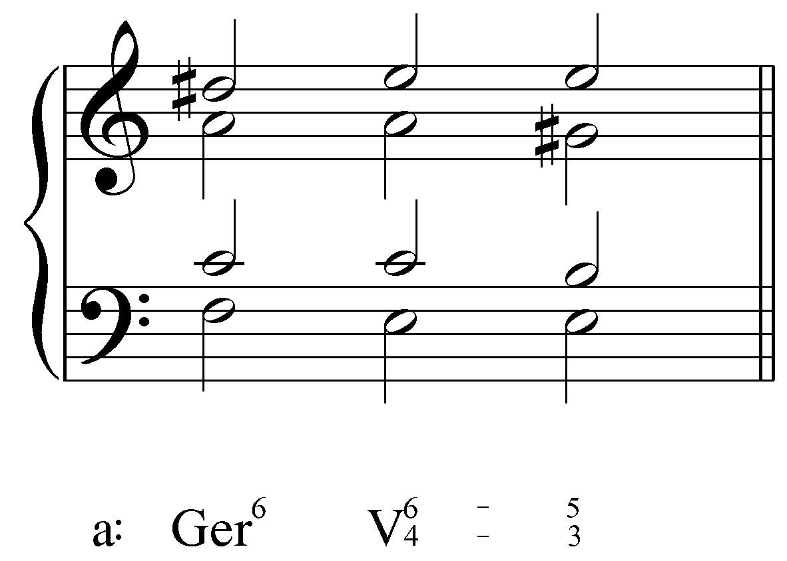

Outline:

- Introduction
  - Unique sound in tonal music (like a double leading tone)
    - There are no diatonic augmented sixths
- Structure and function
  - Like a leading tone going to the tonic, Augmented sixth chords feature an augmented sixth that expands outward to an octave
    - The octave is usually scale degree 5
    - Show the interval expanding to an octave bare bones
      - start with M6-P8 Then raise the bass note (fa becomes fi)
  - Usually, b6 is in the bass
    - Other positions are possible, but are less frequent
- Function and context
  - Predominant
    - Often used to signify important structural points because they’re so distinctive
    - It has a leading tone, so it’s like an applied chord, but it doesn’t belong to the key being tonicized, so the resolution doesn’t sound like tonic
  - The approach:
    - Usually prepared by a IV(6) chord
      - “in such cases the augmented 6ths continue subdominant harmony; they are chromaticized subdominants that have become active in the direction of V.”
      - #4 is a chromatic passing tone
    - Approach from I
      - Common in minor, after i6 or i53
    - Approach from VI (bVI in major)
      - just add #4
- Different types
  - Different types of filling
    - Always have #4, b6, and 1
  - Italian
    - 63
    - simplest
    - scale degree 1
    - thinnest texture
  - French
    - 43
    - scale degree 1 and 2
    - lots of dissonances
      - +6 above the bass and +4 above the bass
      - +4/d5, M2/m7 in the upper voices
    - Can go to V or V64
  - German
    - 65
    - scale degrees 1 and 3 (b3 in major)
    - thickest texture
    - most frequently used
    - usually moves to V64 to avoid ||5ths, but can go directly to V as well
    - enharmonically a dominant seventh chord
- Modulation
  - Particularly in modulations from I to V and back to I
    - I=IV is the pivot
  - Also, the Ger can function as V7/bII

- Conclusion

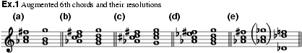
Andre,

Aug. 6ths in Schubert, Schöne Müllerin, song no. 18 ("Trockne Blumen"), mm. 13-17, mm. 27-29 (all of the Italian type).

LR

And while I'm at it with the chorales, looking forward to the aug. 6th lesson, look at Riemenschneider number 19, m. 1, beat 2, an Italian 6th (NB the suspension in the alto to a c#, which is the aug. 6th).
Aug. 6ths in Schubert, Schöne Müllerin, song no. 18 ("Trockne Blumen"), mm. 13-17, mm. 27-29 (all of the Italian type).

MOZART
K. 284/i, mm. 15-17
K. 310/i, mm. 71-74
K. 332/i, mm. 119-124
BEETHOVEN
op. 53/i (Waldstein), mm. 20-23; mm. 257-261
op. 13/iii (Pathetique), mm. 29-33; 43-47; 205-210
MENDELSSOHN
Songs Without Words
op. 30/4, mm. 55-60
op. 102/3, mm. 11-13, 15-17, 24-28
op. 102/6, mm. 13-15, 24-25

