Lesson 9: Auxiliary Sonorities

Introduction:

Techniques of harmonic expansion are among the most important to the tonal repertoire. By expanding harmonies over time, composers are able to build and sustain musical tension, and to expand musical works to large dimensions. We have already learned about melodic embellishment as a means of decorating individual tones. These techniques can be broadened, through combination with basic interval progressions, to embrace entire harmonies.

In this lesson you will apply your knowledge of basic interval progressions to expand a single harmony. We will begin by expanding a chord in root position with a neighboring auxiliary sonority. From there we will expand a harmony as it changes from root position to first inversion through a passing auxiliary sonority. In each case, the chord undergoing expansion will be called a reference sonority.

Neighboring auxiliary sonorities:

Let us begin by considering the expansion of a single triad:

Example 1:
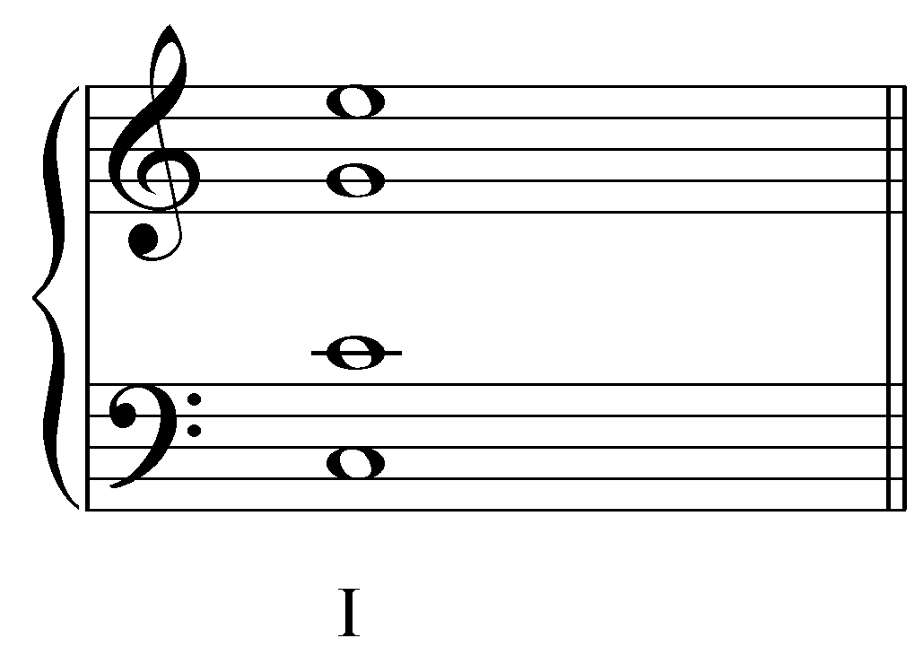

In this example, a root-position tonic triad will serve as the reference sonority. This soprano may be decorated through a simple melodic embellishment, a lower neighbor tone (N):

Example 2:
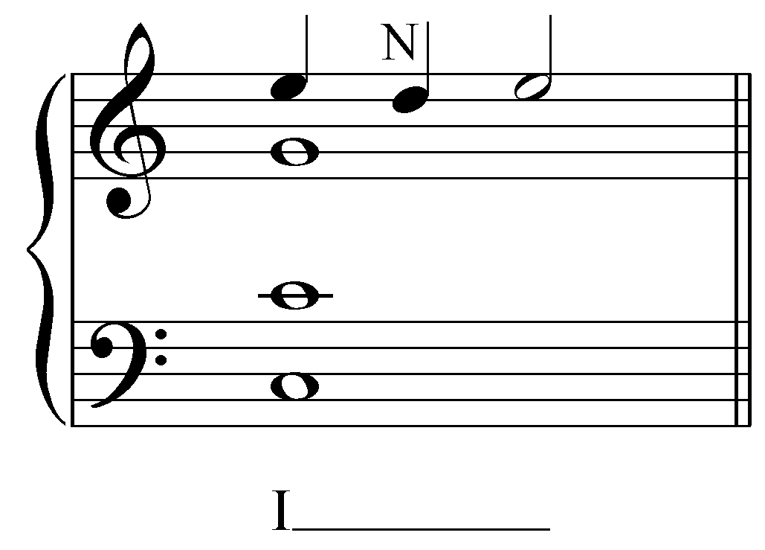

This neighbor note in the soprano can be accompanied in the bass, creating parallel thirds between the outer voices.

Example 3:
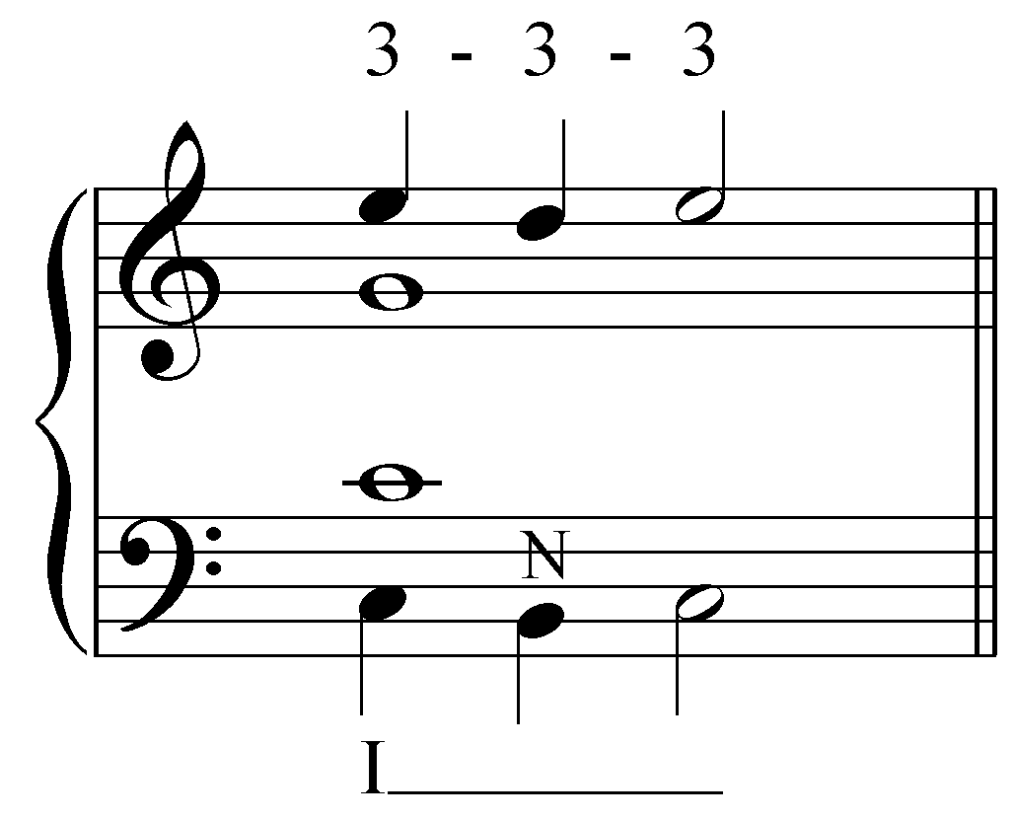

The above example may be left alone as a simple expansion of tonic harmony, with melodic embellishments in the outer voices. However, we can take the embellishments a step further. In the following example, the tenor is given an upper neighbor while the alto sustains a G:

Example 4:
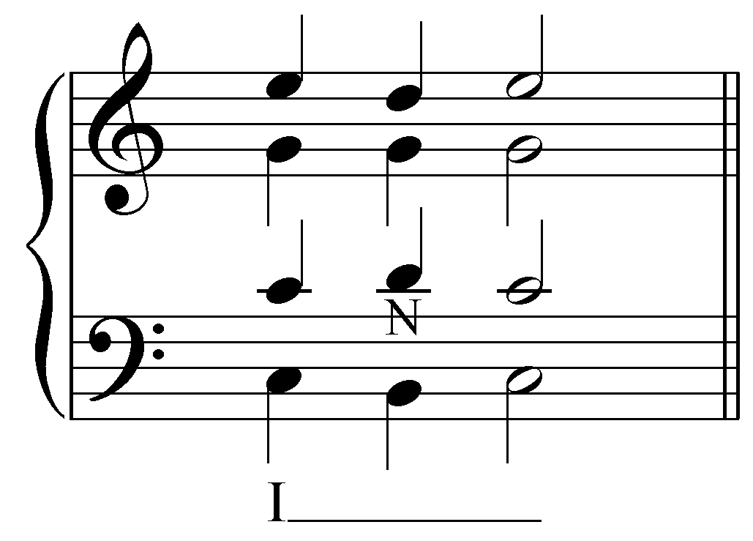

Here we have the tenor moving away from C to its neighbor note, D, so that it is consonant with the neighbor notes in the soprano and bass. Both of the inner voices form valid interval progressions: the alto creates a “6 - 5 - 6” with the soprano and a “5 - 6 - 5” with the bass, while the tenor forms a “3 - 1 - 3” with the soprano and a “1 - 3 - 1” with the bass. We will refer to such four-part expansions as auxiliary sonorities. Coincidentally, the multiple neighbor notes in this auxiliary sonority produce the pitches of a first-inversion V chord.

A perfect fourth appears between the tenor and alto on the second beat. This fourth is a resultant interval and does not present a problem:

- because it is not formed with the bass and, additionally
- because the auxiliary (neighboring) sonority is merely transitory, subordinate to the tonic undergoing expansion.

Popup Box: You may have noticed that the pitches in the above auxiliary sonority form a valid triad on their own. The G, B, and two Ds of the auxiliary sonority constitute a V⁶ chord. However, this sonority comes about through neighbor-note motions. Although the notes of a V⁶ are undeniably present, the melodic origin of the sonority signals its subordinate function as a neighboring sonority tied to the tonic chord from which it arises. In order to indicate that subordinate function, the progression is labeled “I____” or “I (V⁶) I” to emphasize the expansionary process.

This type of expansion occurs frequently in tonal music. The following examples show excerpts from four-part chorales by J.S. Bach:

Example 5 (J.S. Bach, “Wie nach einer Wasserquelle,” BWV 32.6, m. 1):
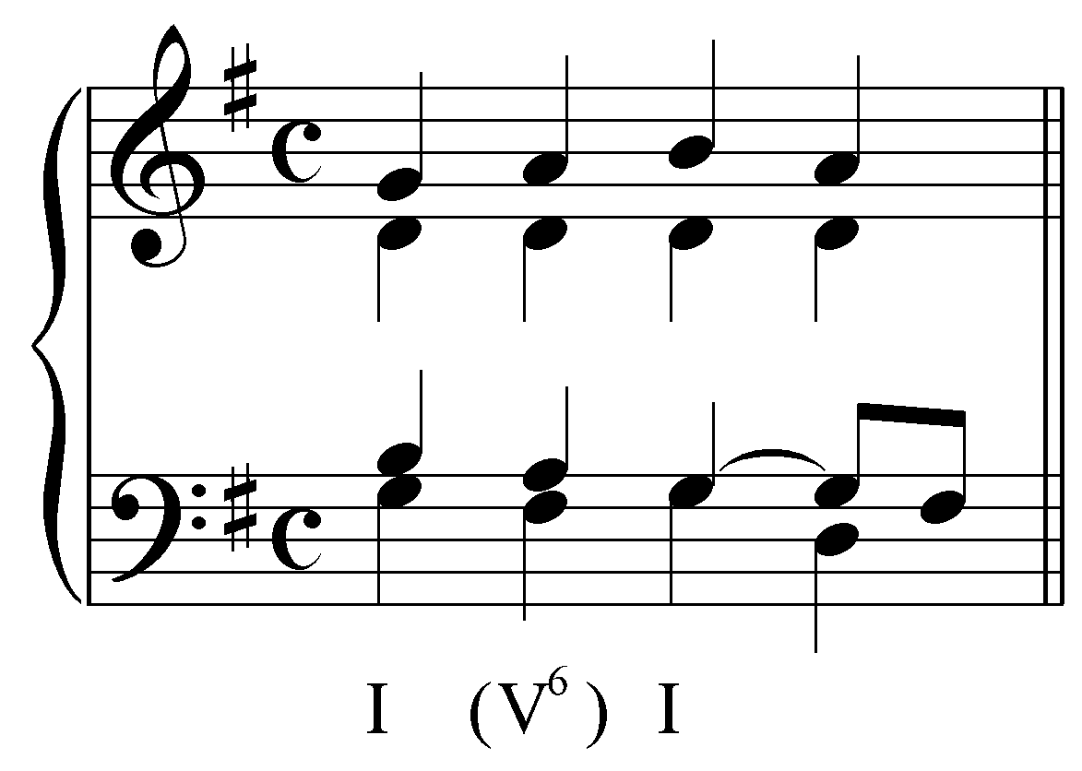

Example 6 (J.S. Bach, “Ach wie nichtig, ach wie flüchtig,” BWV 26.6, m. 1):
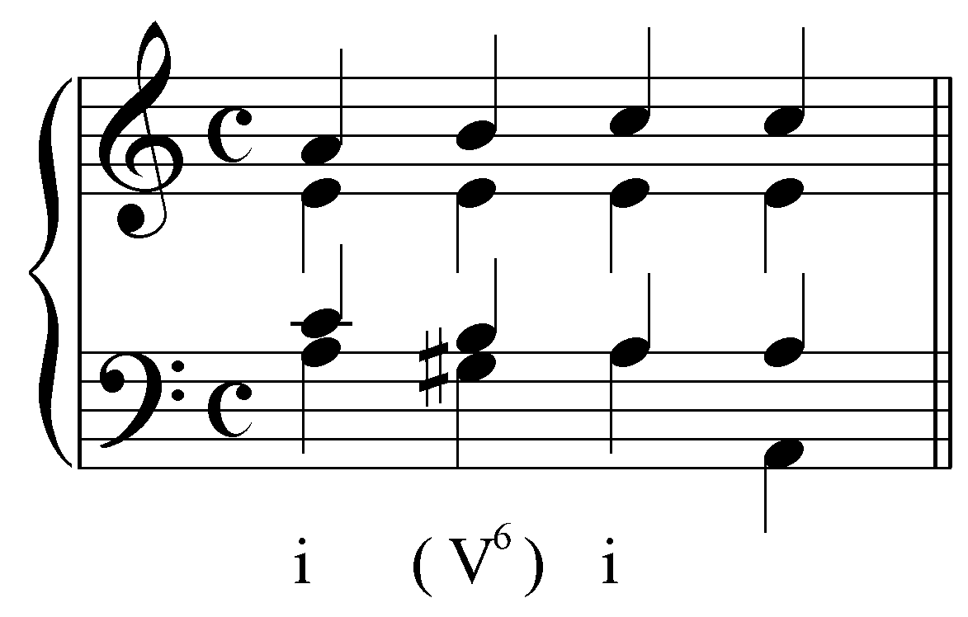

Both of these examples show the expansion of the opening tonic triad with an auxiliary sonority. In each case, the bass is embellished with a lower neighbor tone while one of the upper voices is held and the other two are decorated with passing tones.

Activity 9.1:
In this activity you will complete an expansion of a tonic triad by providing the pitches of an auxiliary sonority whose bass is a lower neighbor tone. For now, use only passing, neighbor, and sustained tones and aim for smooth voice leading.

Exercise 9.1a:
Complete the following expansion of the D-major reference sonority with an auxiliary sonority whose bass is a lower neighbor tone. What pitch should appear in the bass?
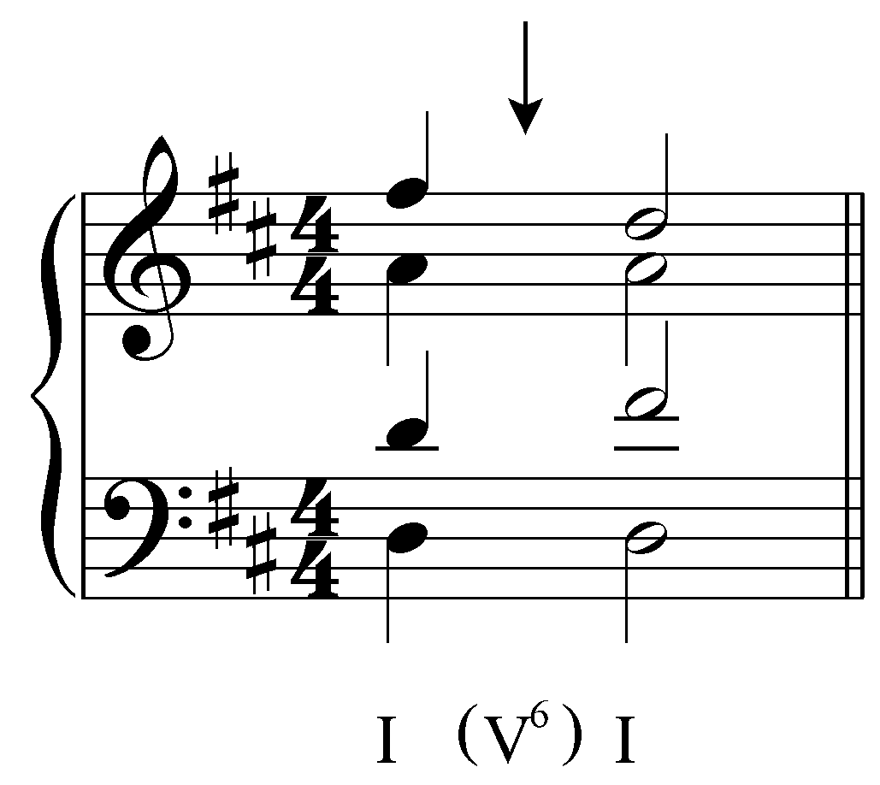
[Answer: C#. Response if correct: “Correct!” Response if incorrect: “Incorrect. Remember, the bass of the auxiliary sonority should be the same as the bass of a V⁶ chord in D major. Try again.”]
[Follow-up question:
Now fill in the three upper voices.
[Answer: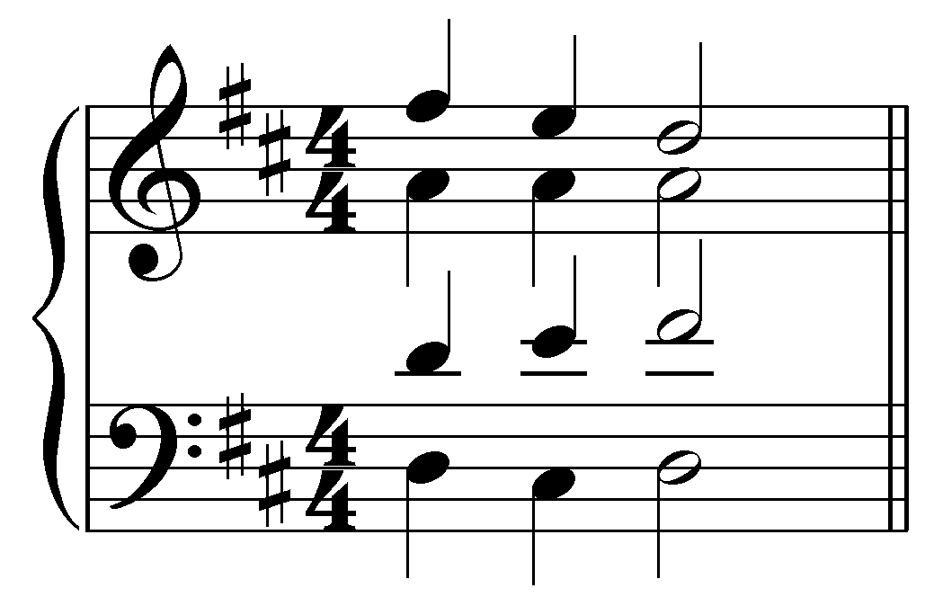. Response if correct: “Correct!” Response if partially correct (one or two of S/A/T is incorrect): “That is partially correct, but your [S/A/T] needs adjusting. Remember to use only sustained, neighbor, and passing tones in the upper voices. Try again.” Response if entirely incorrect: “None of your voices are correct. Remember to use only sustained, neighbor, and passing tones in the upper voices and try again.”]

Exercise 9.1b:
Complete the following expansion of the F-major reference sonority with an auxiliary sonority whose bass is a lower neighbor tone. What pitch should appear in the bass?
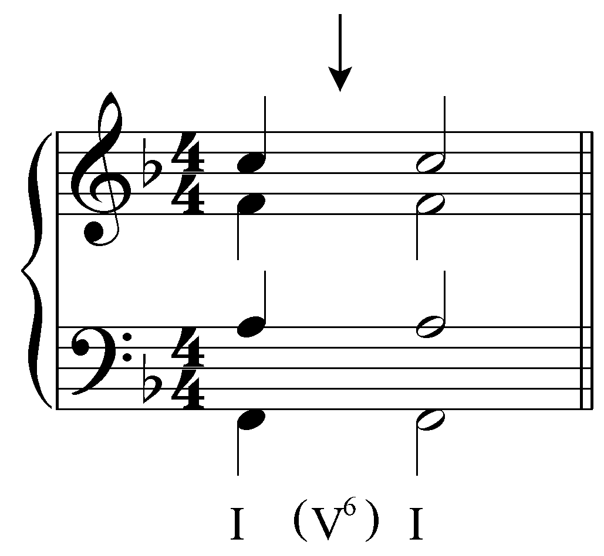
[Answer: E. Response if correct: “Correct!” Response if incorrect: “Incorrect. Remember, the bass of the auxiliary sonority should be the same as the bass of a V⁶ chord in F major. Try again.”]
[Follow-up question:
Now fill in the three upper voices.
[Answer: 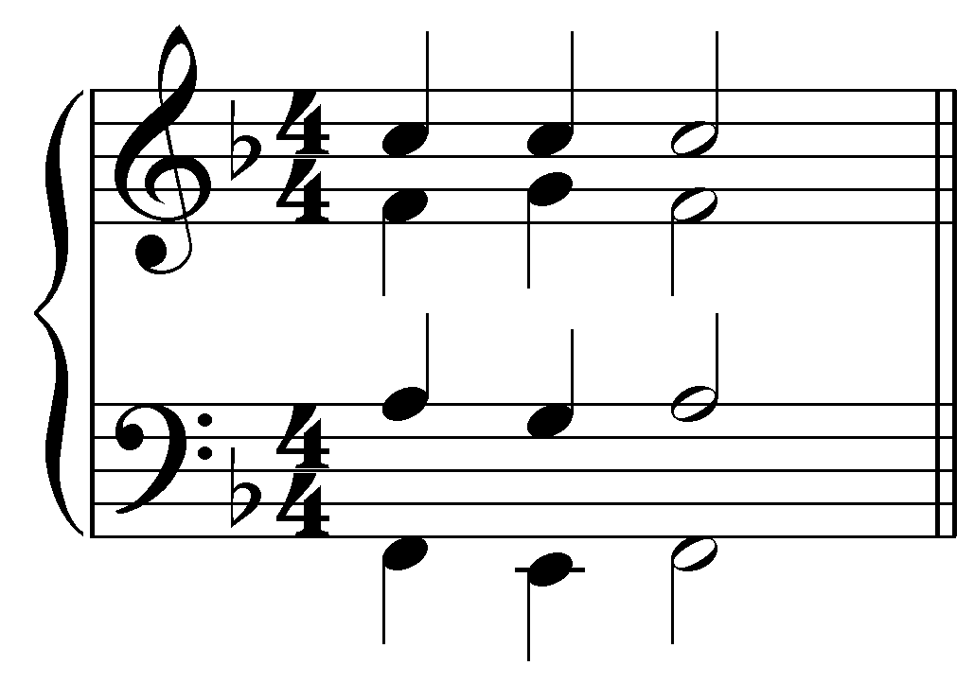. Response if correct: “Correct!” Response if partially correct (one or two of S/A/T is incorrect): “That is partially correct, but your [S/A/T] needs adjusting. Remember to use only sustained, neighbor, and passing tones in the upper voices. Try again.” Response if entirely incorrect: “None of your voices are correct. Remember to use only sustained, neighbor, and passing tones in the upper voices and try again.”]

Exercise 9.1c:
Complete the following expansion of the G-major reference sonority with an auxiliary sonority whose bass is a lower neighbor tone. What pitch should appear in the bass?
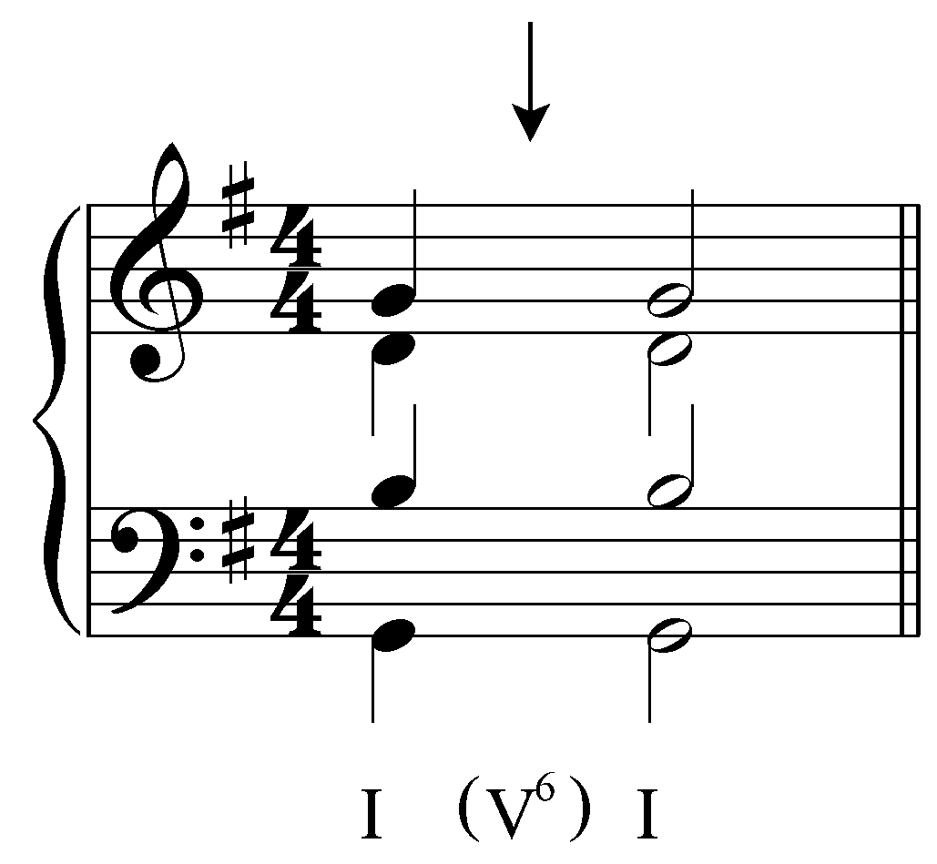
[Answer: F. Response if correct: “Correct!” Response if incorrect: “Incorrect. Remember, the bass of the auxiliary sonority should be the same as the bass of a V⁶ chord in G major. Try again.”]
[Follow-up question:
Now fill in the three upper voices.
[Answer: 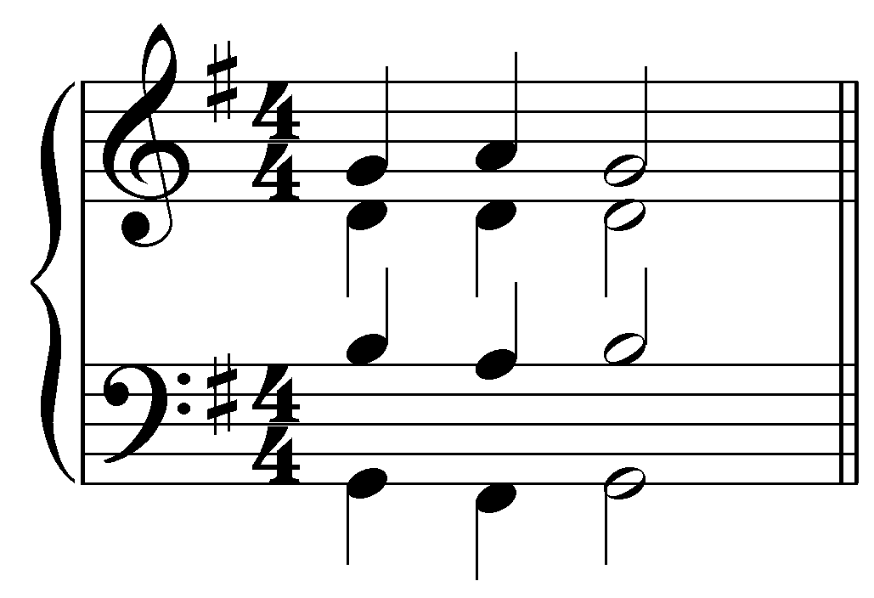. Response if correct: “Correct!” Response if partially correct (one or two of S/A/T is incorrect): “That is partially correct, but your [S/A/T] needs adjusting. Remember to use only sustained, neighbor, and passing tones in the upper voices. Try again.” Response if entirely incorrect: “None of your voices are correct. Remember to use only sustained, neighbor, and passing tones in the upper voices and try again.”]

Exercise 9.1d:
Complete the following expansion of the B^{b}-major reference sonority with an auxiliary sonority whose bass is a lower neighbor tone. What pitch should appear in the bass?
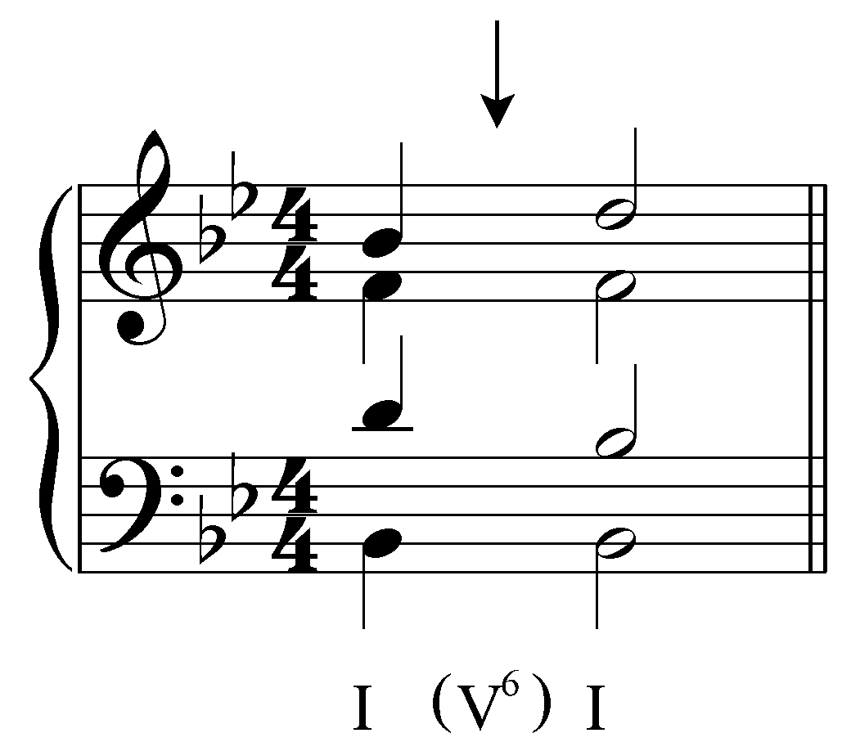
[Answer: A. Response if correct: “Correct!” Response if incorrect: “Incorrect. Remember, the bass of the auxiliary sonority should be the same as the bass of a V⁶ chord in B^{b} major. Try again.”]
[Follow-up question:
Now fill in the three upper voices.
[Answer: 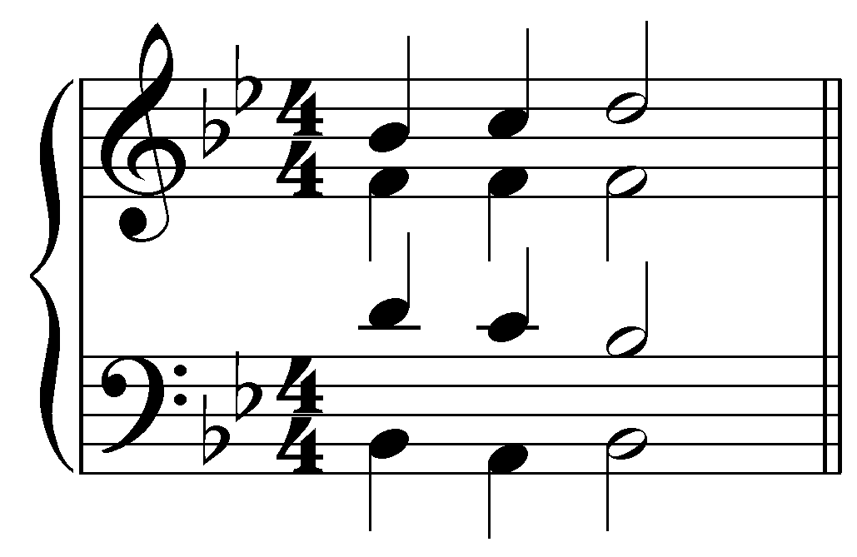. Response if correct: “Correct!” Response if partially correct (one or two of S/A/T is incorrect): “That is partially correct, but your [S/A/T] needs adjusting. Remember to use only sustained, neighbor, and passing tones in the upper voices. Try again.” Response if entirely incorrect: “None of your voices are correct. Remember to use only sustained, neighbor, and passing tones in the upper voices and try again.”]

The above examples are by no means the only way to expand a chord. What if, for example, the bass were given an upper neighbor? The outer voices would form a “3 - 1 - 3” progression:

Example 7:
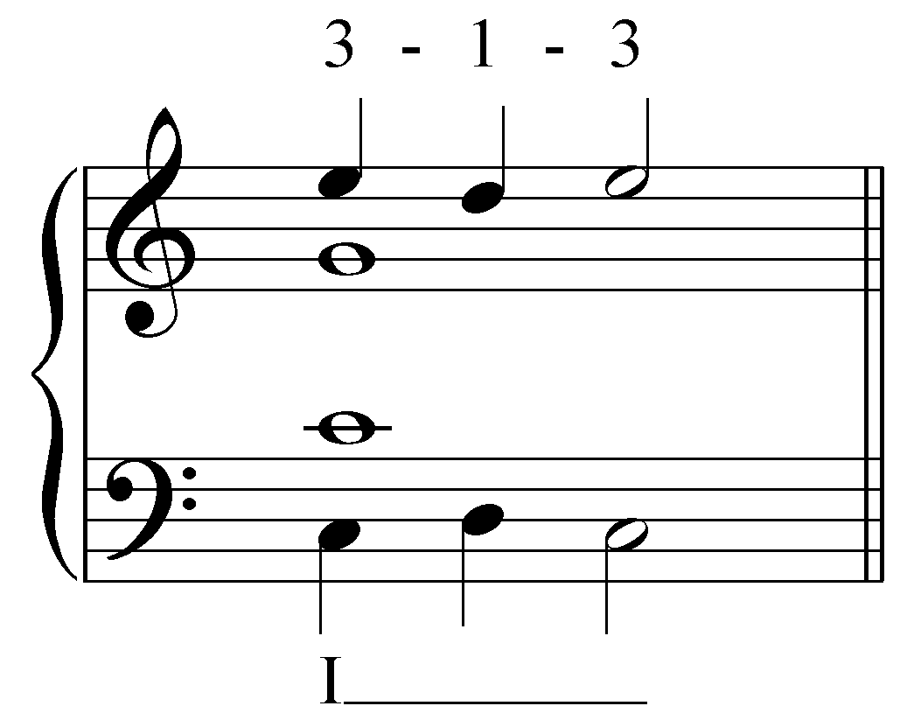

This expansion may be “filled out” in the same manner as above. Note that the tenor embellishment has been changed to a lower neighbor in order to avoid parallel octaves with the bass:

Example 8:
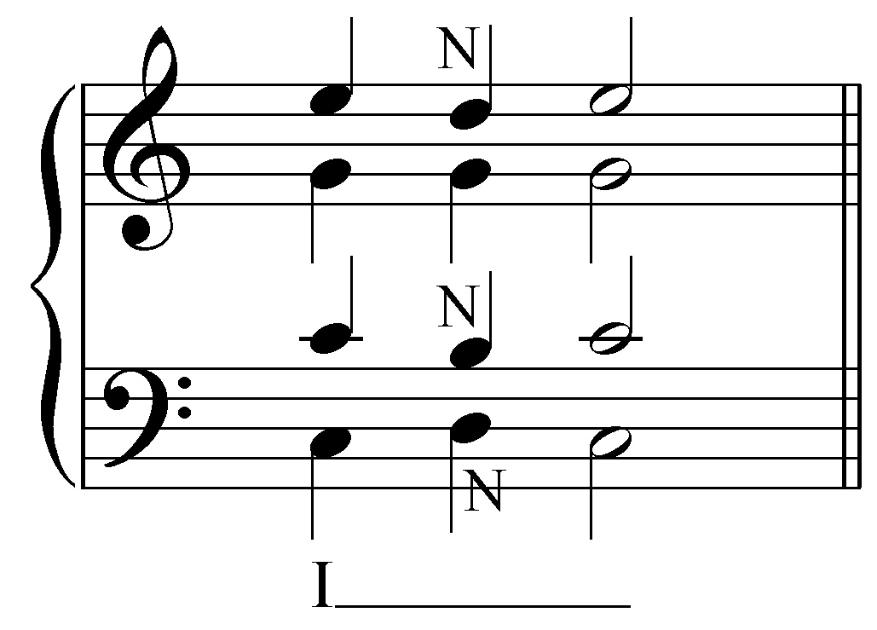

Here we have an interesting situation. In lesson 1, it was stated that perfect fourths are considered dissonant in two-voice textures. That rule was qualified to permit perfect fourths as resultant intervals for voice pairs not involving the bass. In this example, we see that the alto forms a perfect fourth with the bass. This type of situation requires a further qualification of the perfect-fourth rule.

Perfect fourths may occur with the bass when part of an auxiliary sonority associated with a reference sonority. In Example 8, the perfect fourth between the alto and the bass occurs during the expansion of a tonic triad in a sonority that coincidentally produces the pitches of a V${}_{4}^{6}$ chord.

Popup Box: Perfect fourths are considered dissonant and must be treated as such. They are not permitted in two-voice textures. In textures with more than two voices, perfect fourths are permitted as resultant intervals between voice pairs not involving the bass. Perfect fourths may occur with the bass in an auxiliary sonority, such as a passing ${}_{4}^{6}$ chord.

A similar type of neighboring auxiliary sonority occurs when the bass is held. Consider the following example where the soprano of the same reference chord is given an upper neighbor note.

Example 9:
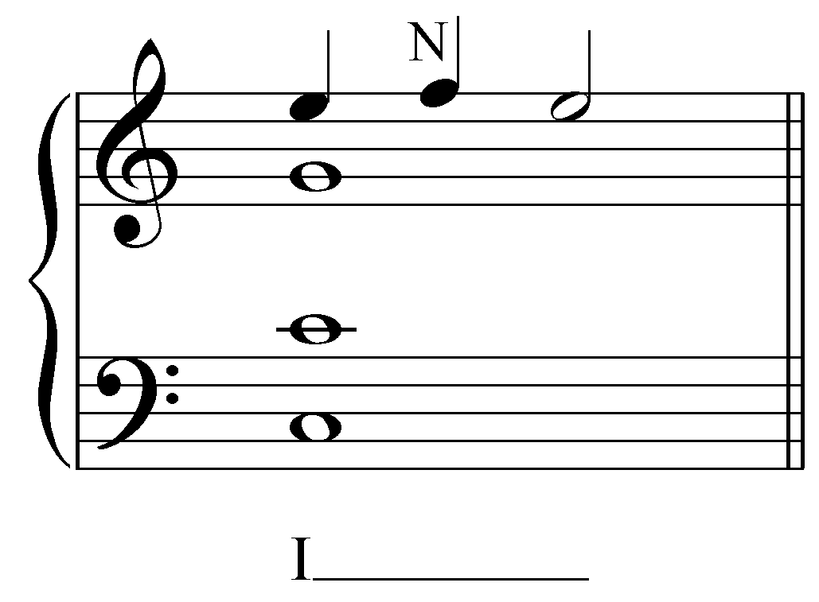

This F in the soprano forms a dissonance (again, a perfect fourth) with the bass, but this is permissible since it is merely a melodic embellishment. The following example shows the alto accompanying the soprano in parallel sixths with an upper neighbor note of its own:

Example 10:
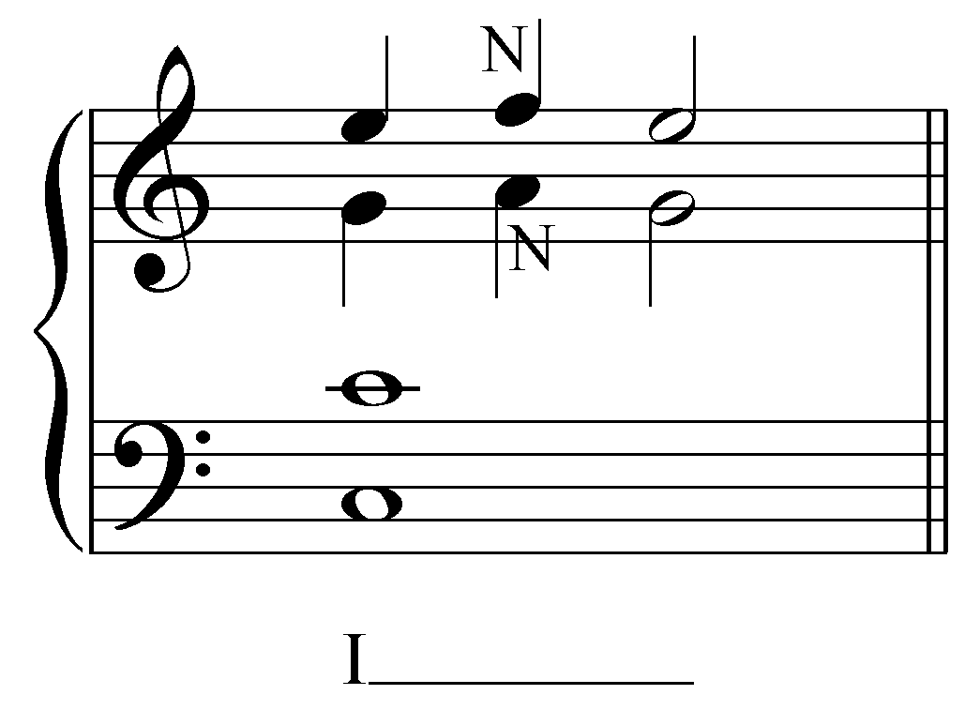

The tenor and bass may hold C throughout, as the following example indicates:

Example 11:
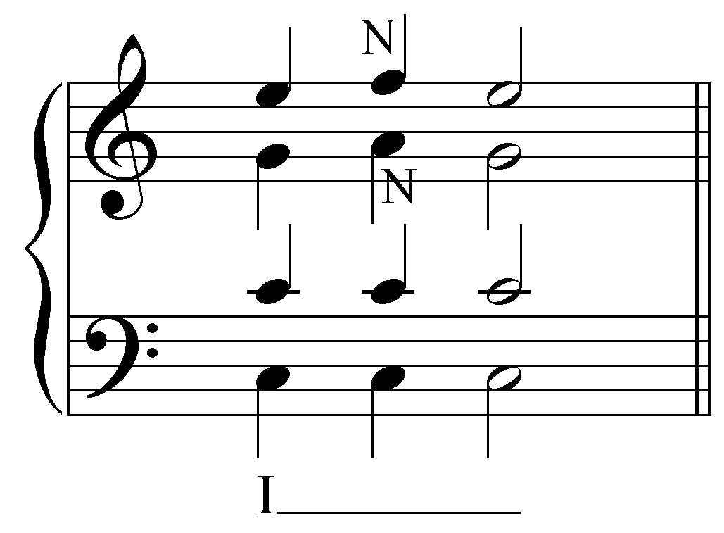

This example illustrates how an auxiliary sonority may coincidentally produce the pitches of an inverted chord, here a IV chord apparently in second inversion, similar to the coincidental V⁶ we encountered earlier. As in that earlier case, the perfect fourth here between the bass and soprano is permissible because of the inherent instability of an auxiliary neighboring sonority.

Activity 9.2:
In the last activity you expanded a reference sonority with an auxiliary sonority whose bass is a lower neighbor tone. This time, expand the given chord with an auxiliary sonority that sustains the bass of the reference sonority. Again, remember to only use neighbor notes and hold the common tones.

Exercise 9.2a:
Complete the following expansion of the B-minor reference sonority with an auxiliary sonority that sustains the bass of the reference sonority. Fill in the upper voices:
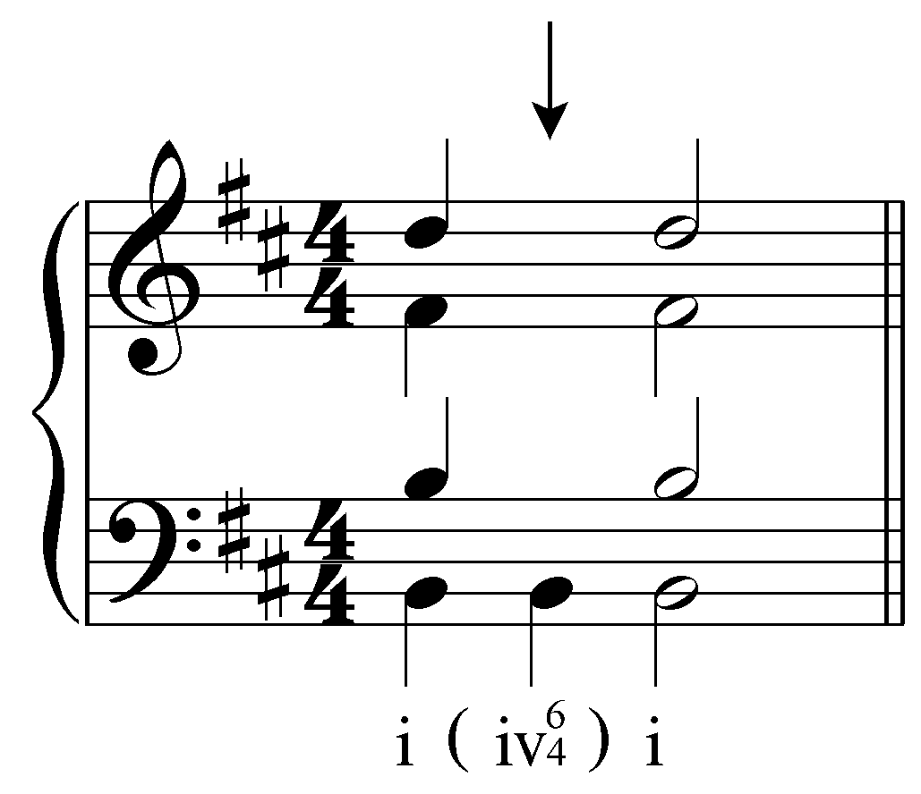

[Answer: 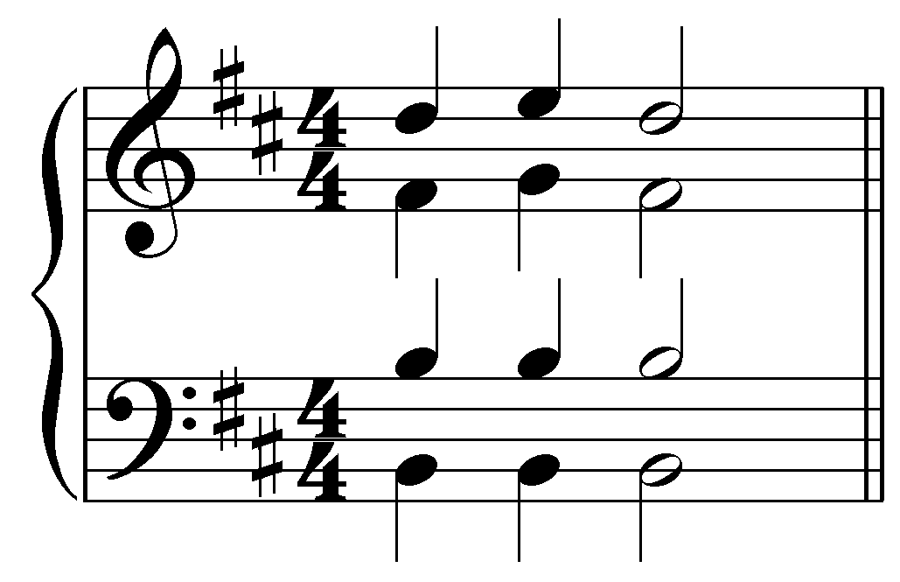. Response if correct: “Correct!” Response if partially correct (one or two of S/A/T is incorrect): “That is partially correct, but your [S/A/T] needs adjusting. Remember to use only sustained, neighbor, and passing tones in the upper voices. Try again.” Response if entirely incorrect: “None of your voices are correct. Remember to use only sustained, neighbor, and passing tones in the upper voices and try again.”]

Exercise 9.2b:
Complete the following expansion of the A-major reference sonority with an auxiliary sonority that sustains the bass of the reference sonority. Fill in the upper voices:
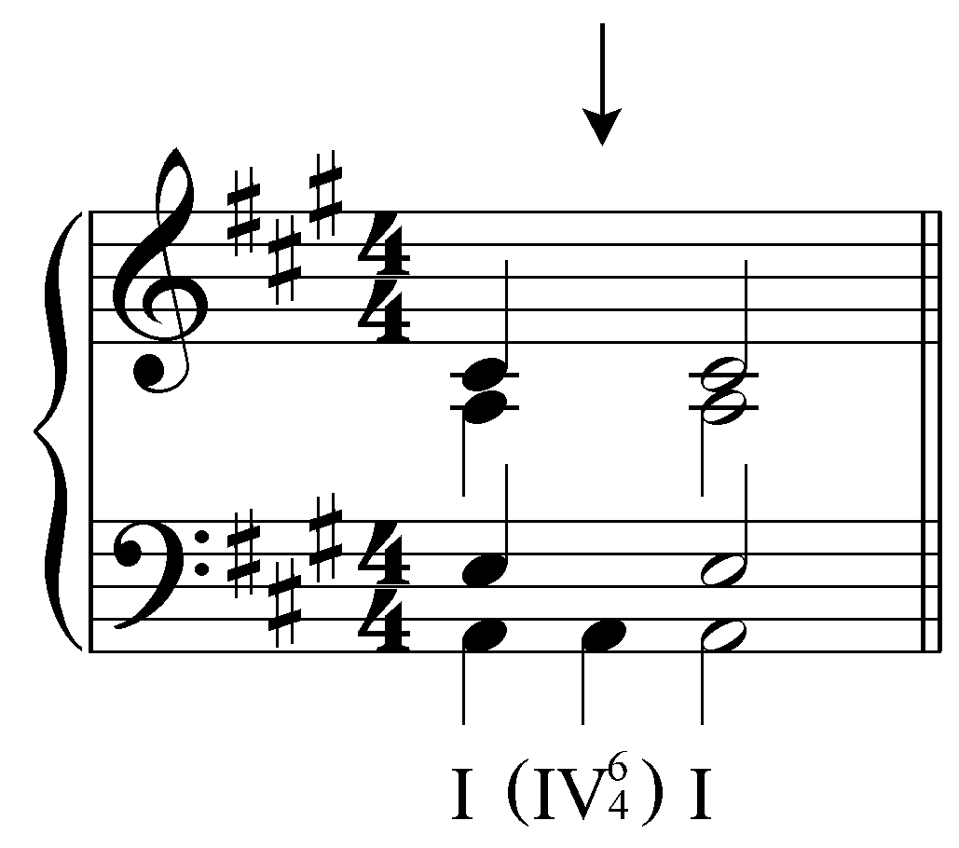

[Answer: 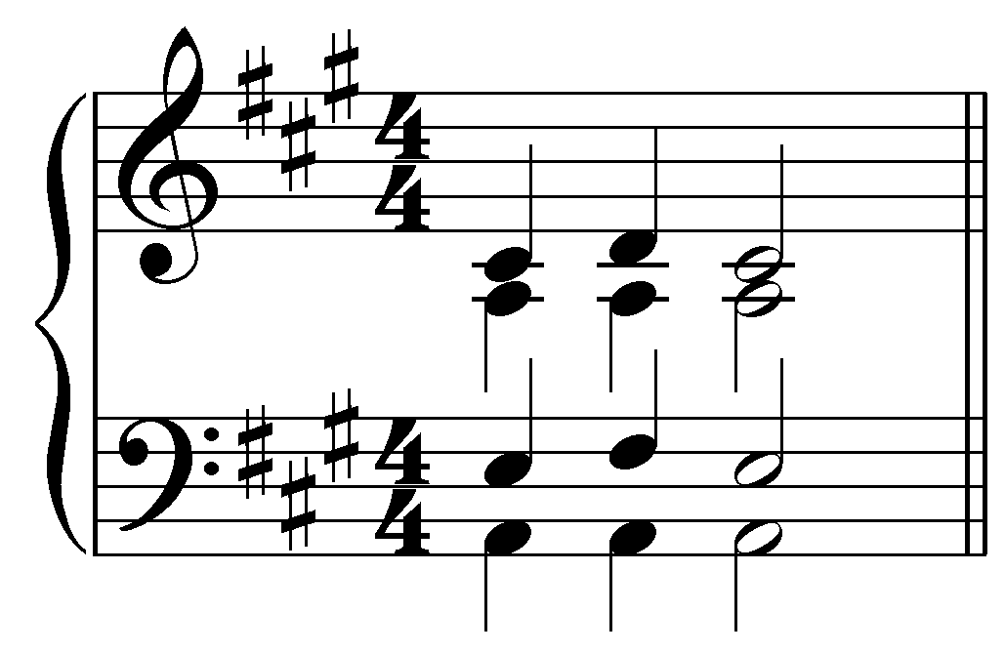. Response if correct: “Correct!” Response if partially correct (one or two of S/A/T is incorrect): “That is partially correct, but your [S/A/T] needs adjusting. Remember to use only sustained, neighbor, and passing tones in the upper voices. Try again.” Response if entirely incorrect: “None of your voices are correct. Remember to use only sustained, neighbor, and passing tones in the upper voices and try again.”]

Exercise 9.2c:
Complete the following expansion of the G-minor reference sonority with an auxiliary sonority that sustains the bass of the reference sonority. Fill in the upper voices:
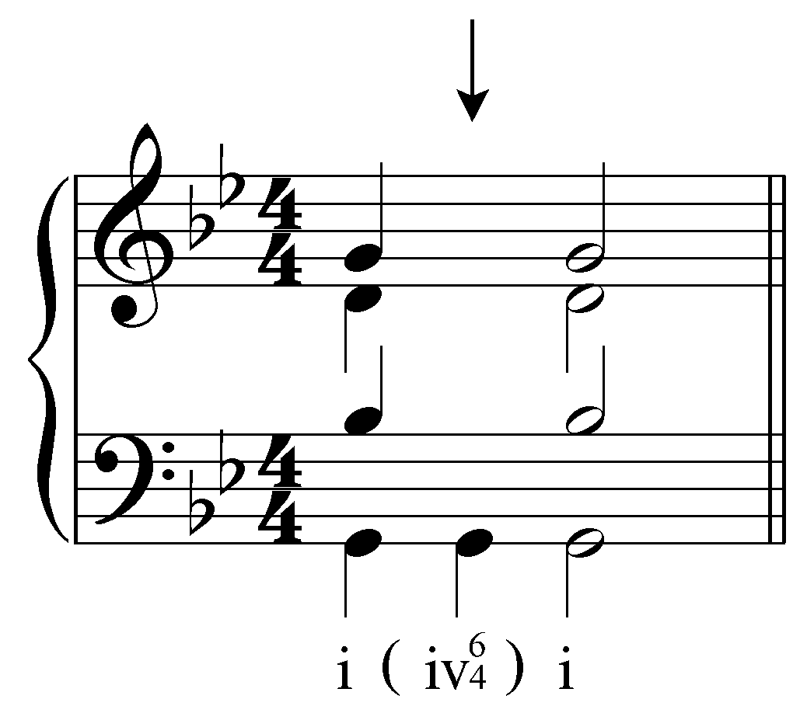

[Answer: 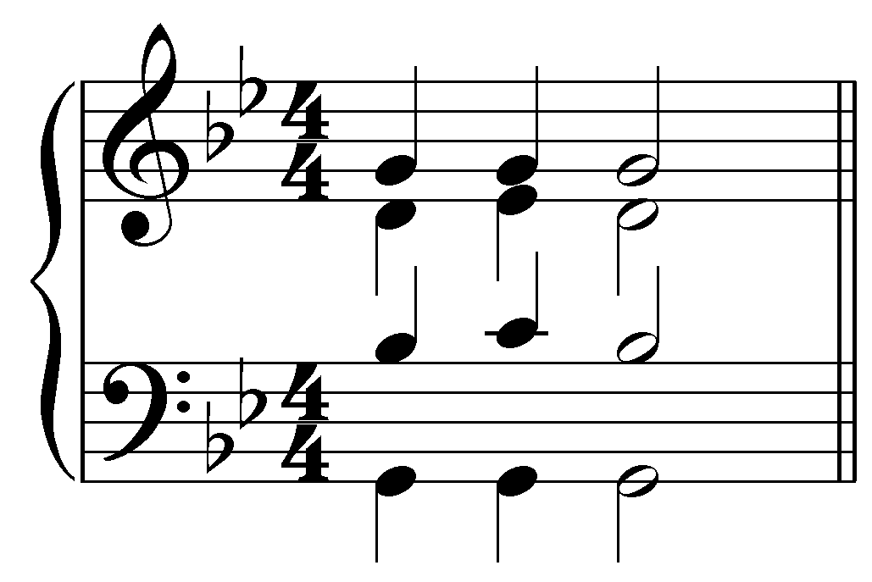. Response if correct: “Correct!” Response if partially correct (one or two of S/A/T is incorrect): “That is partially correct, but your [S/A/T] needs adjusting. Remember to use only sustained, neighbor, and passing tones in the upper voices. Try again.” Response if entirely incorrect: “None of your voices are correct. Remember to use only sustained, neighbor, and passing tones in the upper voices and try again.”]

Exercise 9.2d:
Complete the following expansion of the E^{b}-major reference sonority with an auxiliary sonority that sustains the bass of the reference sonority. Fill in the upper voices:
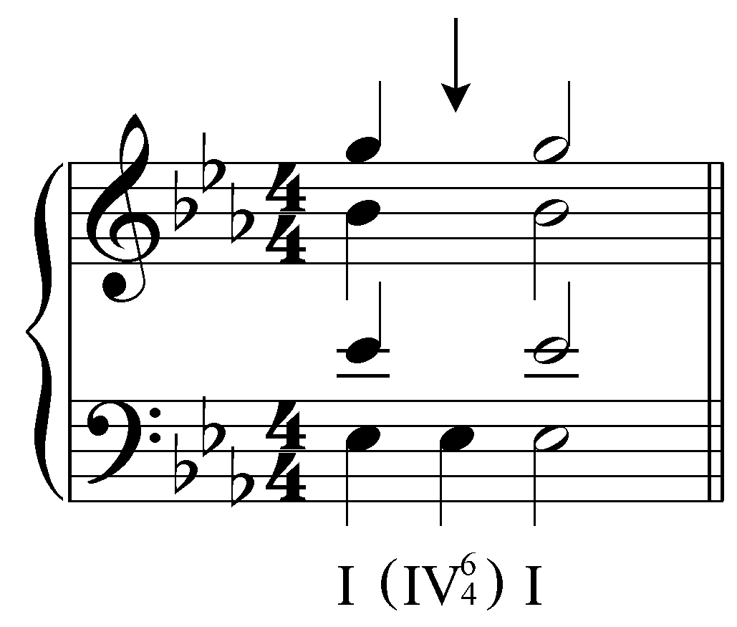

[Answer: 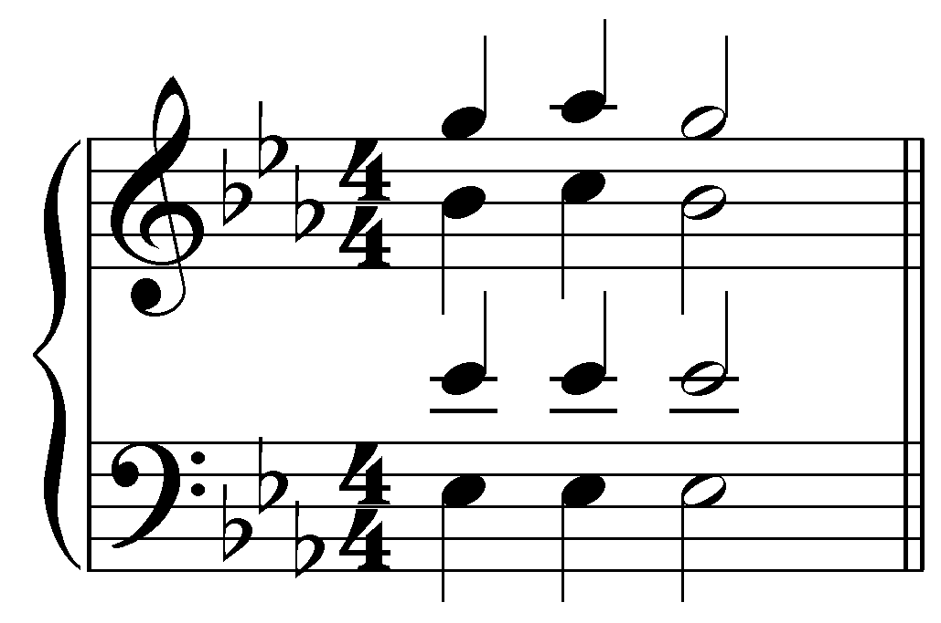. Response if correct: “Correct!” Response if partially correct (one or two of S/A/T is incorrect): “That is partially correct, but your [S/A/T] needs adjusting. Remember to use only sustained, neighbor, and passing tones in the upper voices. Try again.” Response if entirely incorrect: “None of your voices are correct. Remember to use only sustained, neighbor, and passing tones in the upper voices and try again.”]

Passing auxiliary sonorities:

Expansions with auxiliary sonorities are not limited to neighboring sonorities. Consider the following example of the common I - I⁶ progression:

Example 12:
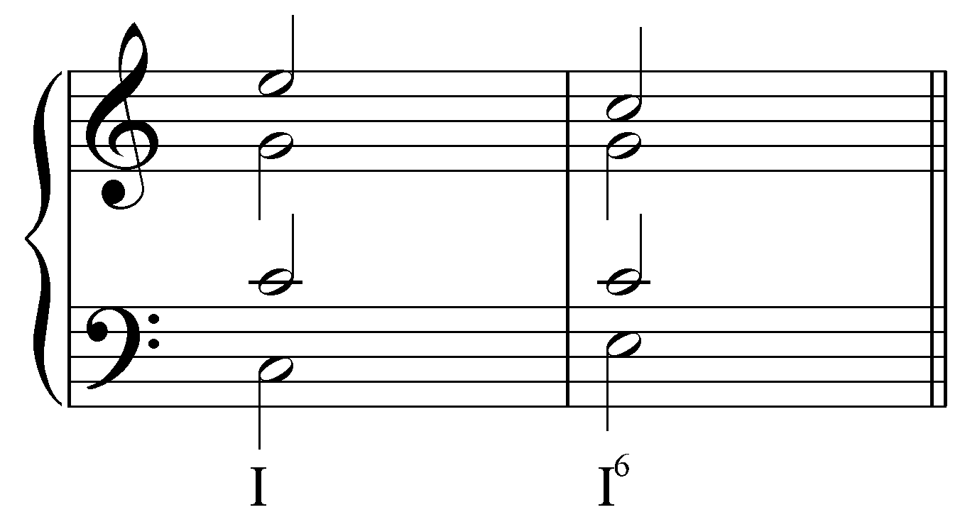

What do you notice about the outer voices? The soprano moves from E to C, while the bass does the opposite, moving from C to E. The outer voices participate in a voice exchange, creating a “10 - 6” interval progression:

Example 13:
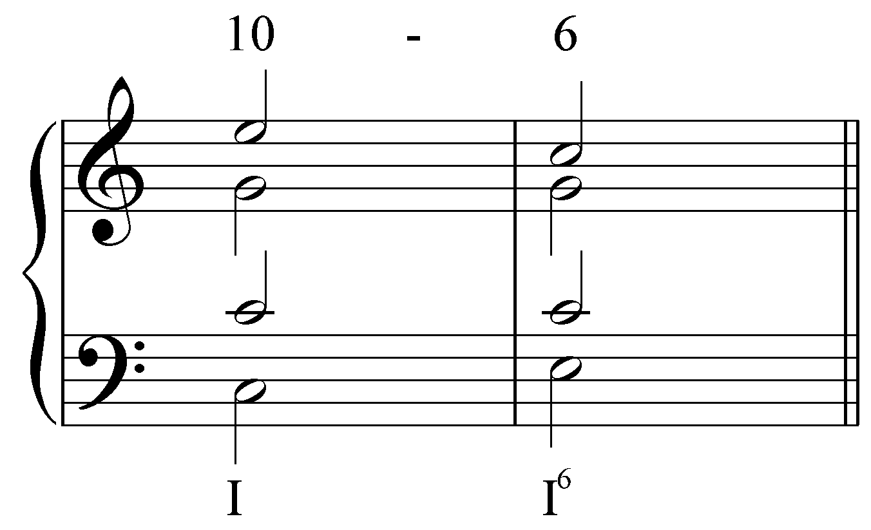

Very frequently, skips in the outer voices are filled in with passing tones. These pitches are not consonant with the reference sonority (the I chord, in this case). They are understood as melodic embellishments of the outer voices:

Example 14:
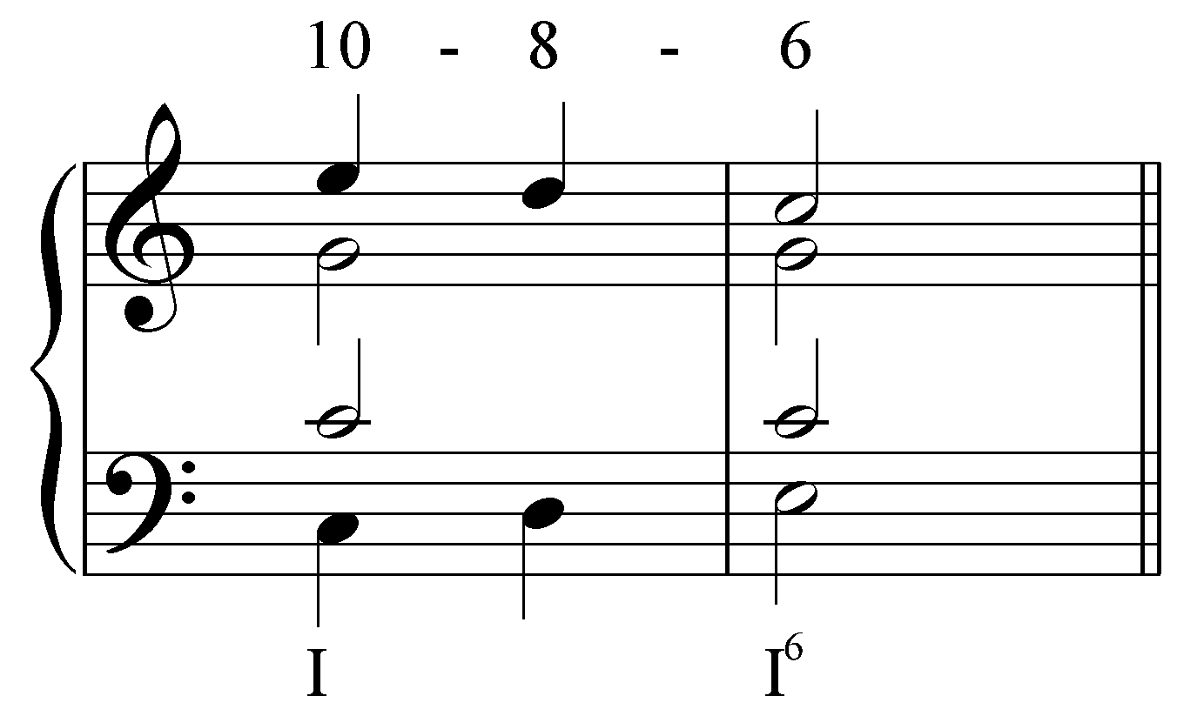

In the above example, the outer voices form a “10 - 8 - 6” progression. Just as before, we may enhance this expansion by embellishing the inner voices so that they harmonize the passing Ds:

Example 15:
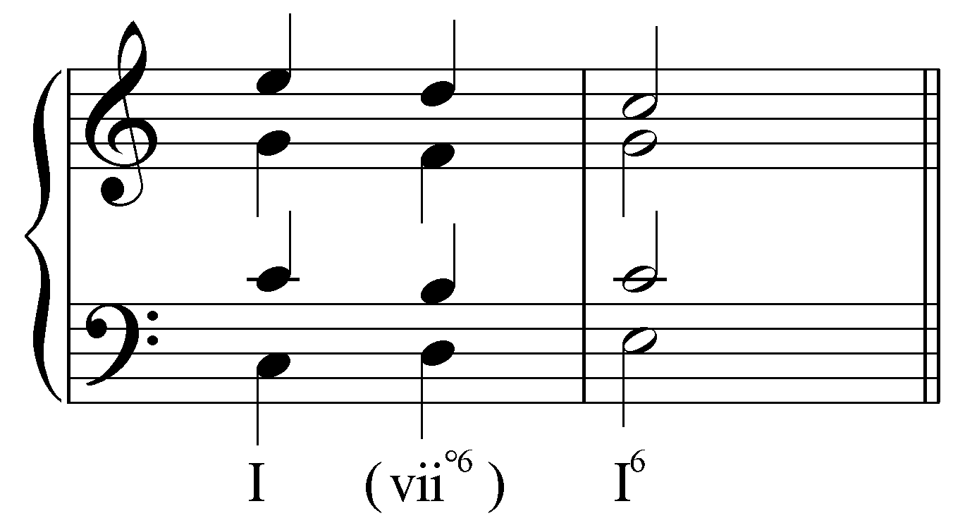

In this case, the sonority resulting from the multiple embellishments coincidentally produces the pitches of a vii°⁶ chord. In Lesson 6, we discussed the special case of this diminished triad. The triad built on the seventh scale degree of the major scale will have a diminished fifth between the root and fifth. This highly dissonant interval is permitted only when treated in specific ways. By presenting the vii° chord in first inversion, all upper voices are consonant with the bass and the dissonant tritone is hidden in the inner voices. In Example 15, the diminished fifth appears between the tenor B and the alto F. The tritone is properly resolved here as both inner voices ascend by step to form a perfect fifth, the tenor creating the basic interval progression “6 - 6” with the bass, and the alto “10 - 10” with the bass, as illustrated in Lesson 6 on the vii^{o6} chord.

Activity 9.3:
In this activity you will expand a tonic reference sonority first by creating a voice exchange between the bass and one of the upper voices and then by including an auxiliary vii^{o6} chord.

Exercise 9.3a:
Expand the tonic chord on beat one to beat two by creating a voice exchange between the bass and the soprano while sustaining the other two voices:
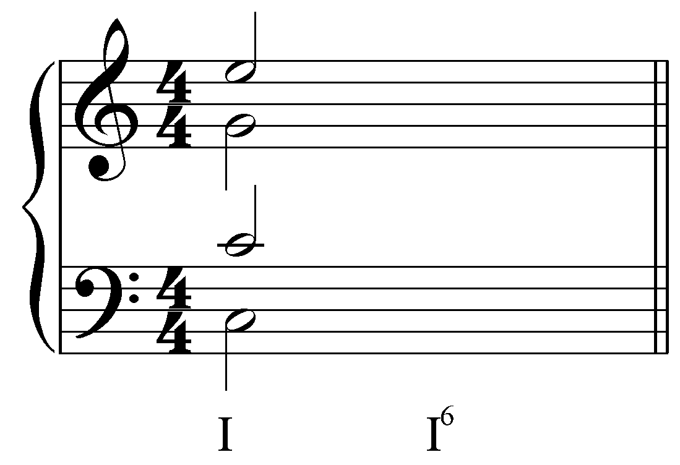
[Answer: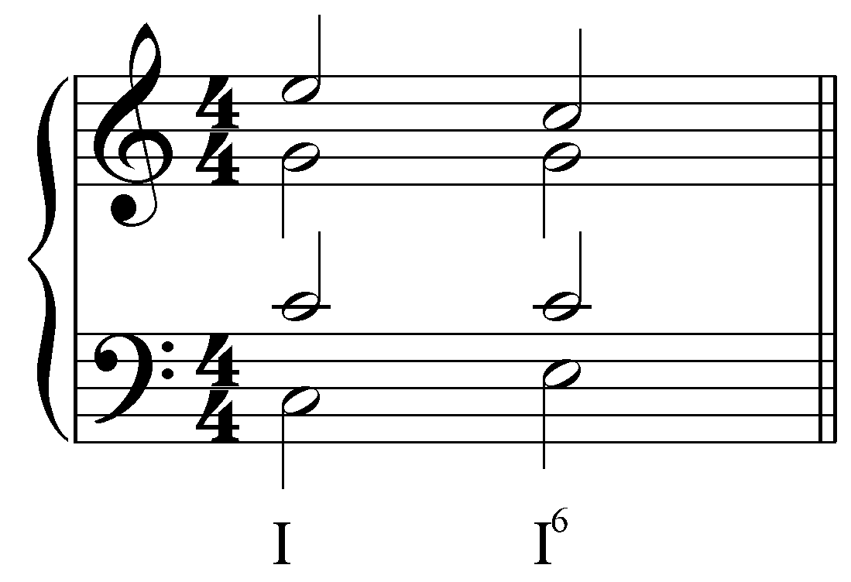. Response if correct: “Correct!” Response if incorrect: “Incorrect. Try again.”]
[Follow-up question:]
Now embellish the expansion by incorporating an auxiliary vii^{o6} chord. What pitch should appear in the bass?
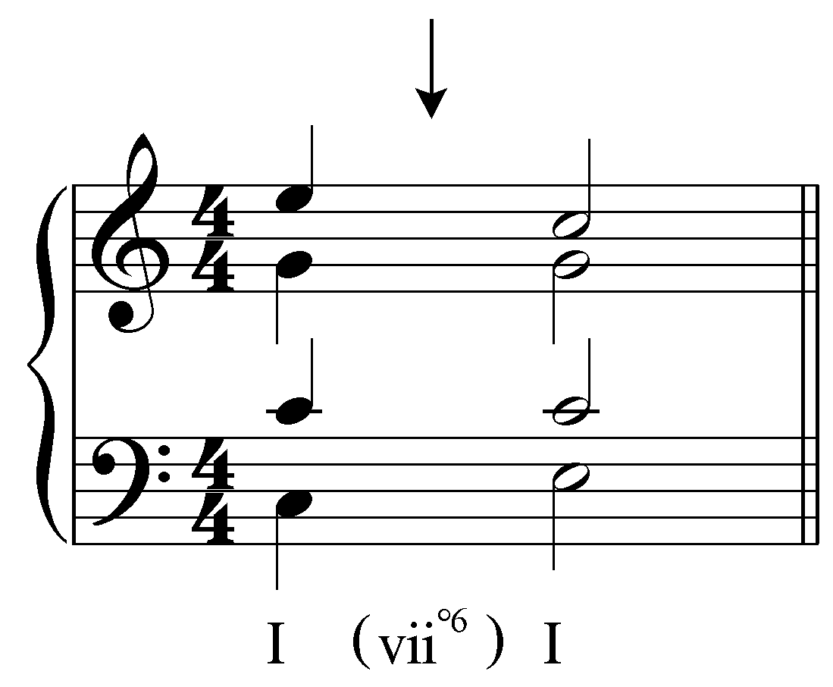

[Answer: D. Response if correct: “Correct!” Response if incorrect: “Incorrect. Remember, the bass of the auxiliary sonority should be the same as the bass of a vii^{o6} chord in C major. Try again.”]
[Follow-up question:]
Now fill in the three upper voices.
[Answer: 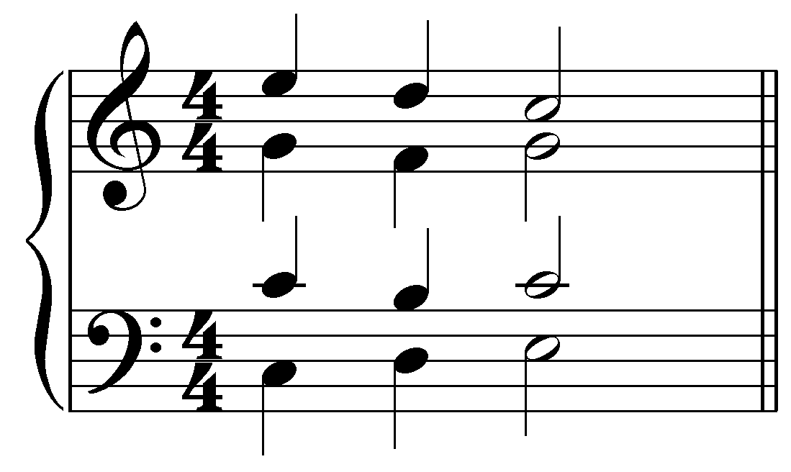. Response if correct: “Correct!” Response if partially correct (one or two of S/A/T is incorrect): “That is partially correct, but your [S/A/T] needs adjusting. Remember to use passing tones in the voices participating in the voice exchange and lower neighbors in the remaining voices. Try again.” Response if entirely incorrect: “None of your voices are correct. Remember to use passing tones in the voices participating in the voice exchange and lower neighbors in the remaining voices. Try again.”]

Exercise 9.3b:
Expand the tonic chord on beat one to beat two by creating a voice exchange between the bass and the tenor while sustaining the other two voices:
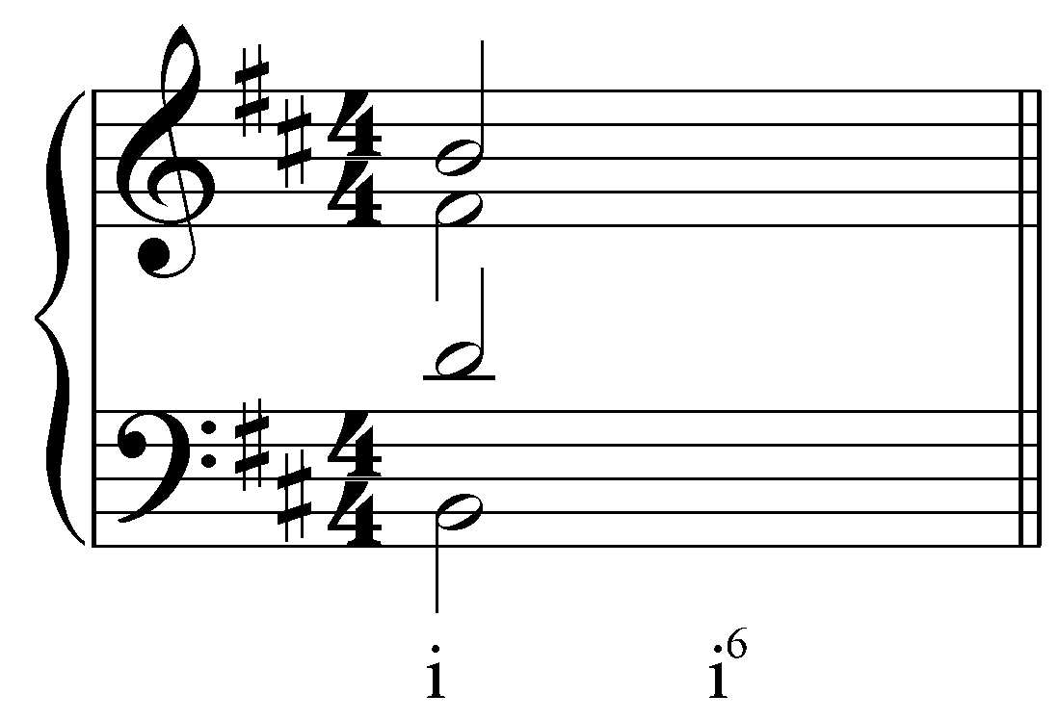
[Answer: 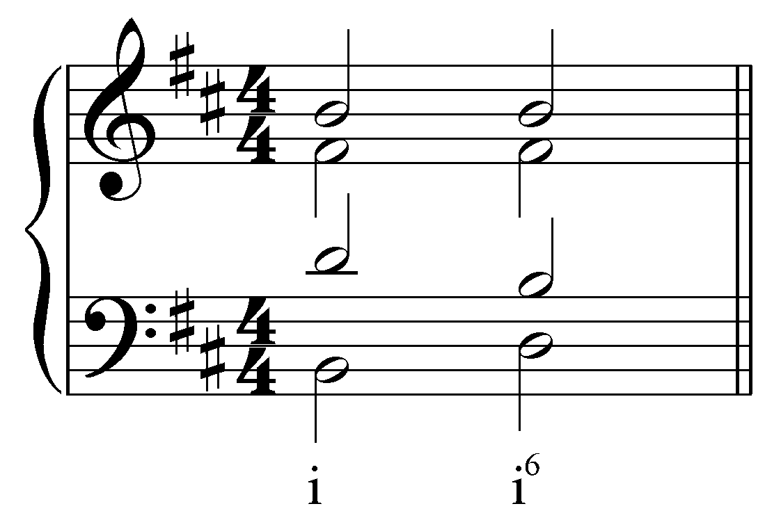. Response if correct: “Correct!” Response if incorrect: “Incorrect. Try again.”]
[Follow-up question:]
Now embellish the expansion by incorporating an auxiliary vii^{o6} chord. What pitch should appear in the bass?
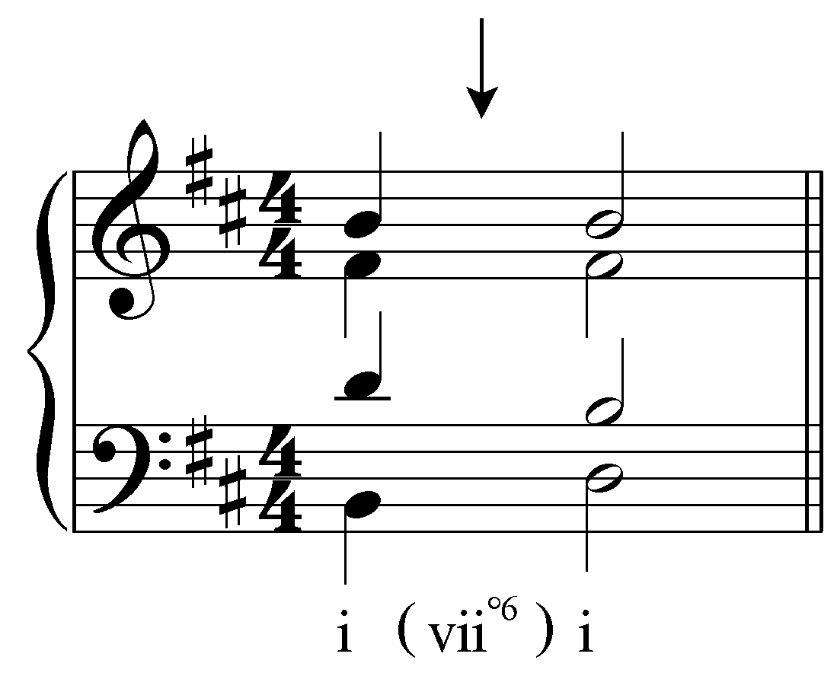

[Answer: C#. Response if correct: “Correct!” Response if incorrect: “Incorrect. Remember, the bass of the auxiliary sonority should be the same as the bass of a vii^{o6} chord in B minor. Try again.”]
[Follow-up question:]
Now fill in the three upper voices.
[Answer: 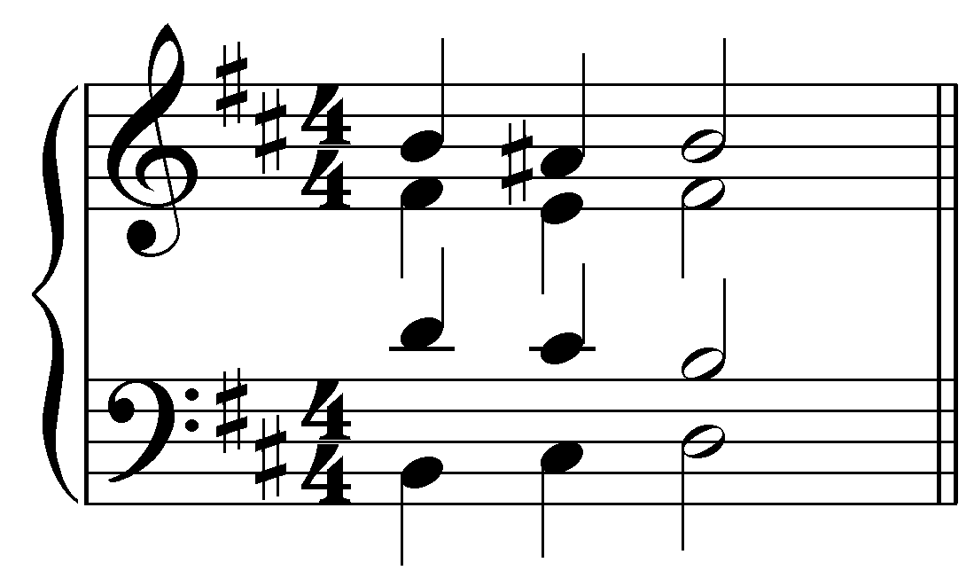. Response if correct: “Correct!” Response if partially correct (one or two of S/A/T is incorrect): “That is partially correct, but your [S/A/T] needs adjusting. Remember to use passing tones in the voices participating in the voice exchange and lower neighbors in the remaining voices. (Don’t forget to raise the leading tone!) Try again.” Response if entirely incorrect: “None of your voices are correct. Remember to use passing tones in the voices participating in the voice exchange and lower neighbors in the remaining voices. (Don’t forget to raise the leading tone!) Try again.”]

Exercise 9.3c:
Expand the tonic chord on beat one to beat two by creating a voice exchange between the bass and the soprano while sustaining the other two voices:
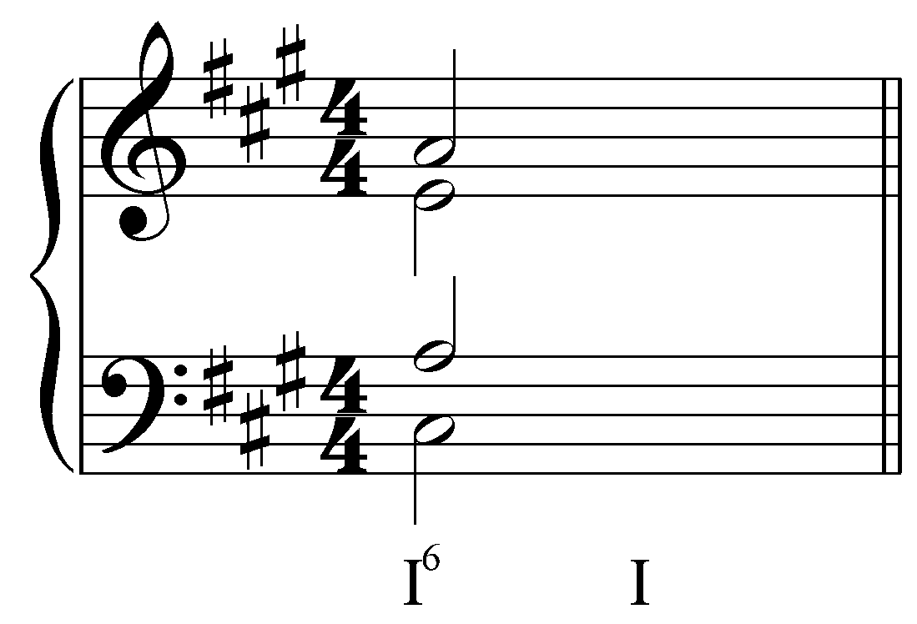
[Answer: 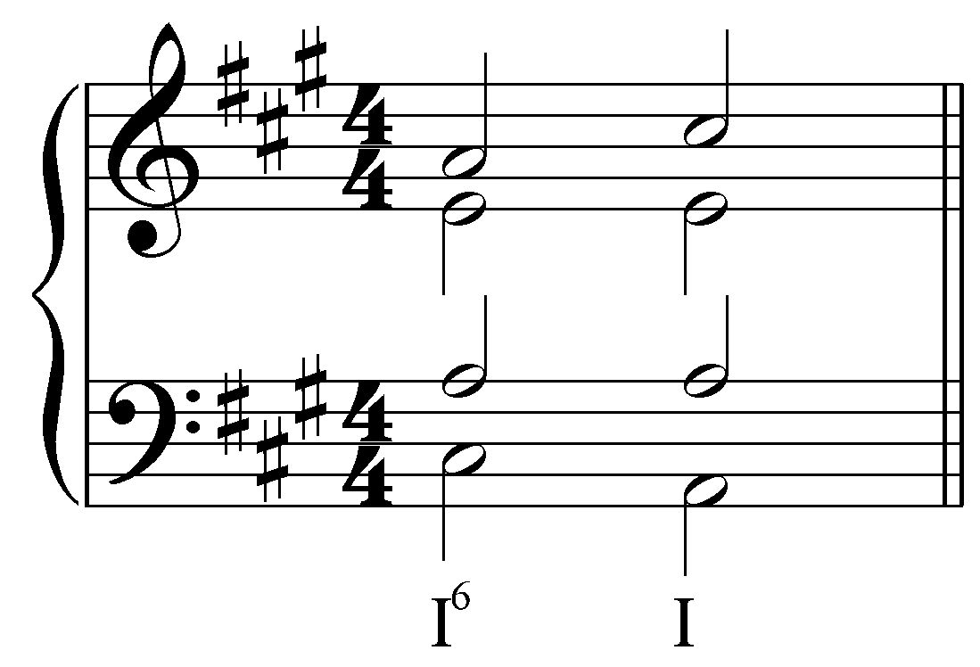. Response if correct: “Correct!” Response if incorrect: “Incorrect. Try again.”]
[Follow-up question:]
Now embellish the expansion by incorporating an auxiliary vii^{o6} chord. What pitch should appear in the bass?
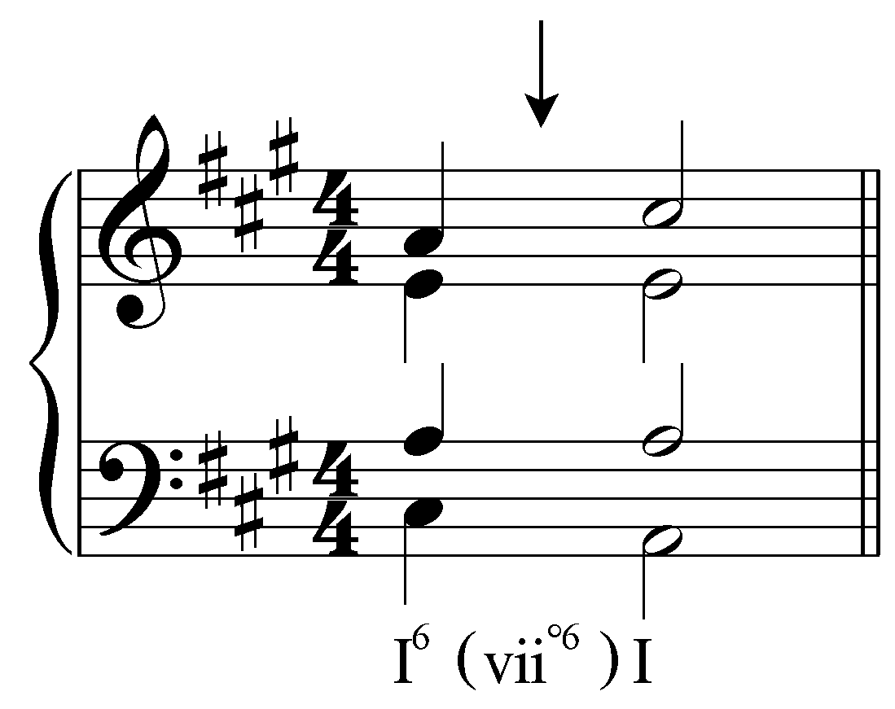
[Answer: B. Response if correct: “Correct!” Response if incorrect: “Incorrect. Remember, the bass of the auxiliary sonority should be the same as the bass of a vii^{o6} chord in A major. Try again.”]
[Follow-up question:]
Now fill in the three upper voices.
[Answer: 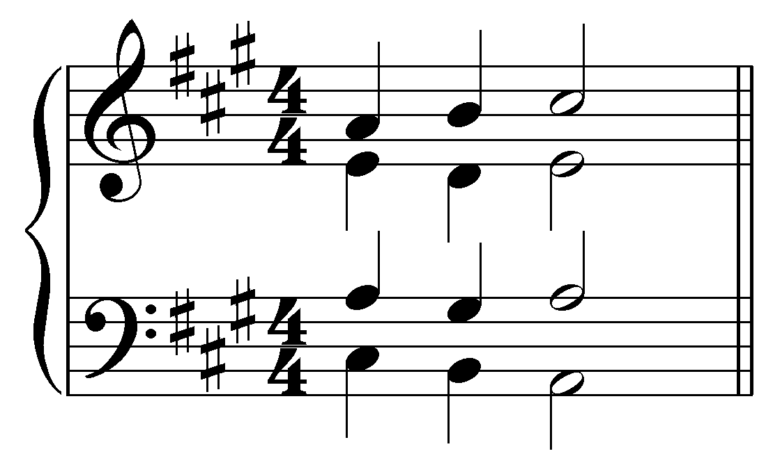. Response if correct: “Correct!” Response if partially correct (one or two of S/A/T is incorrect): “That is partially correct, but your [S/A/T] needs adjusting. Remember to use passing tones in the voices participating in the voice exchange and lower neighbors in the remaining voices. Try again.” Response if entirely incorrect: “None of your voices are correct. Remember to use passing tones in the voices participating in the voice exchange and lower neighbors in the remaining voices. Try again.”]

Exercise 9.3d:
Expand the tonic chord on beat one to beat two by creating a voice exchange between the bass and the alto while sustaining the other two voices:
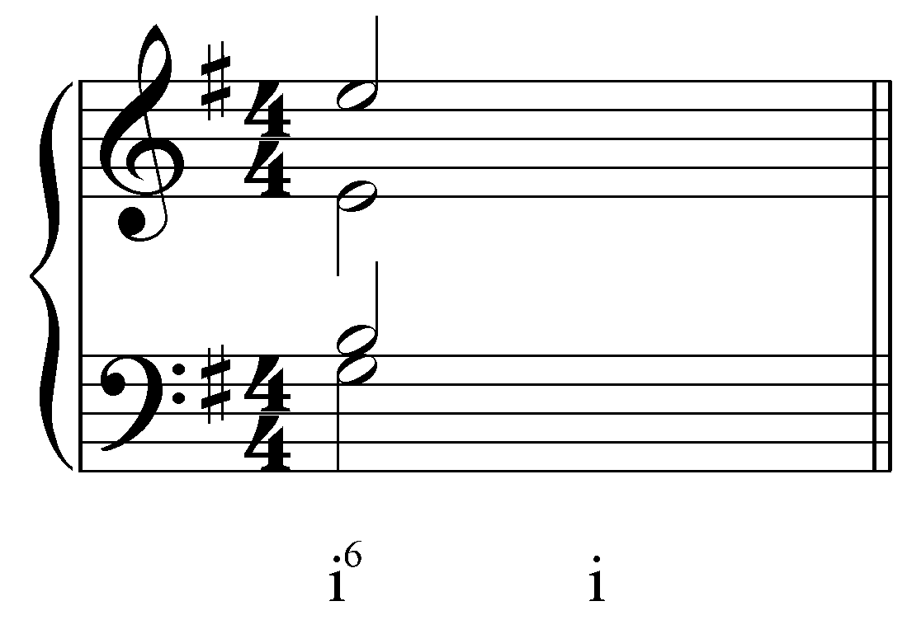
[Answer: 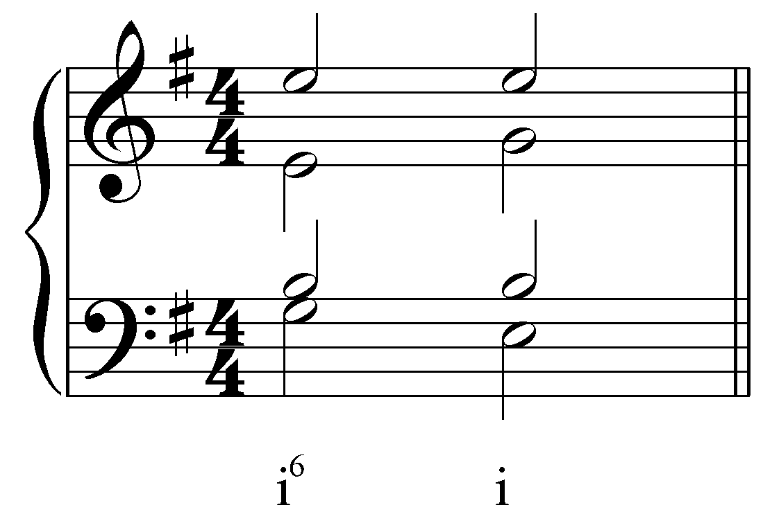. Response if correct: “Correct!” Response if incorrect: “Incorrect. Try again.”]
[Follow-up question:]
Now embellish the expansion by incorporating an auxiliary vii^{o6} chord. What pitch should appear in the bass?
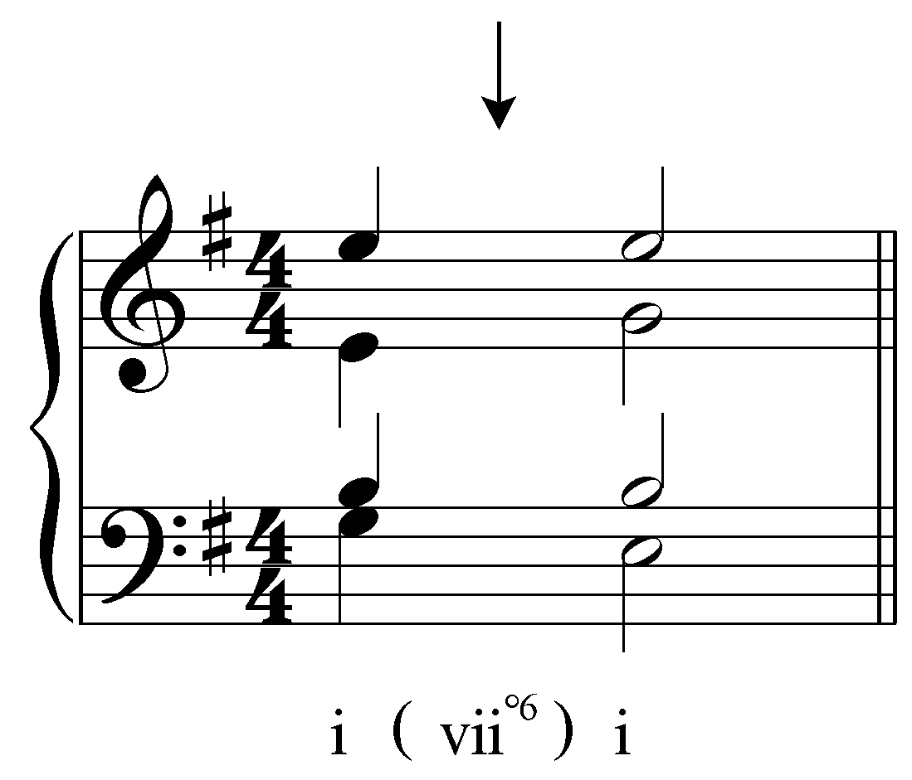

[Answer: F#. Response if correct: “Correct!” Response if incorrect: “Incorrect. Remember, the bass of the auxiliary sonority should be the same as the bass of a vii^{o6} chord in E minor. Try again.”]
[Follow-up question:]
Now fill in the three upper voices.
[Answer: 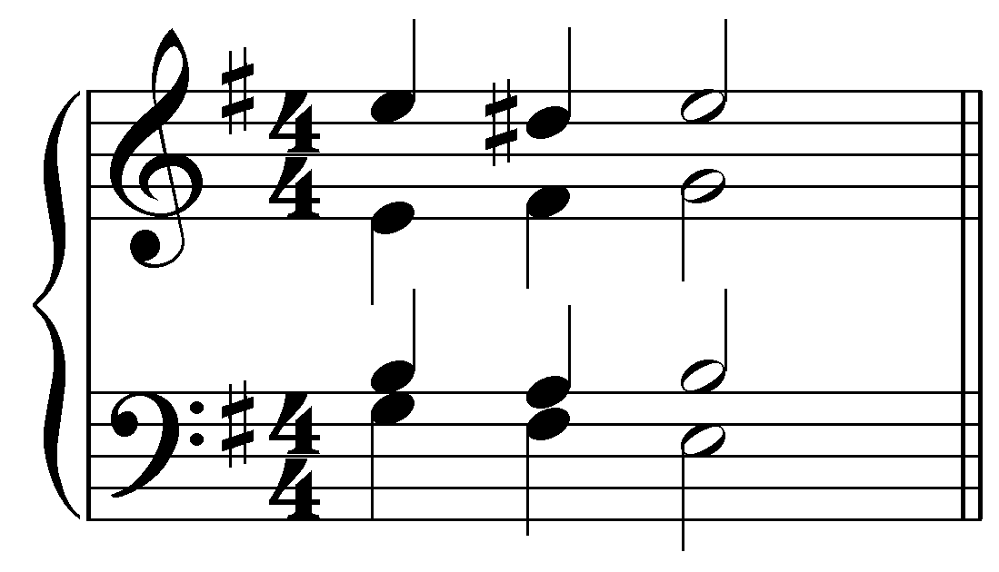. Response if correct: “Correct!” Response if partially correct (one or two of S/A/T is incorrect): “That is partially correct, but your [S/A/T] needs adjusting. Remember to use passing tones in the voices participating in the voice exchange and lower neighbors in the remaining voices. (Don’t forget to raise the leading tone!) Try again.” Response if entirely incorrect: “None of your voices are correct. Remember to use passing tones in the voices participating in the voice exchange and lower neighbors in the remaining voices. (Don’t forget to raise the leading tone!) Try again.”]

This type of expansion, like the neighboring auxiliary sonorities outlined above, occurs frequently in tonal music. The following examples show excerpts from four-part chorales by J.S. Bach:

Example 16 (J.S. Bach, “Ach Gott, vom Himmel sieh' darein,” BWV 153.1, m. 1):
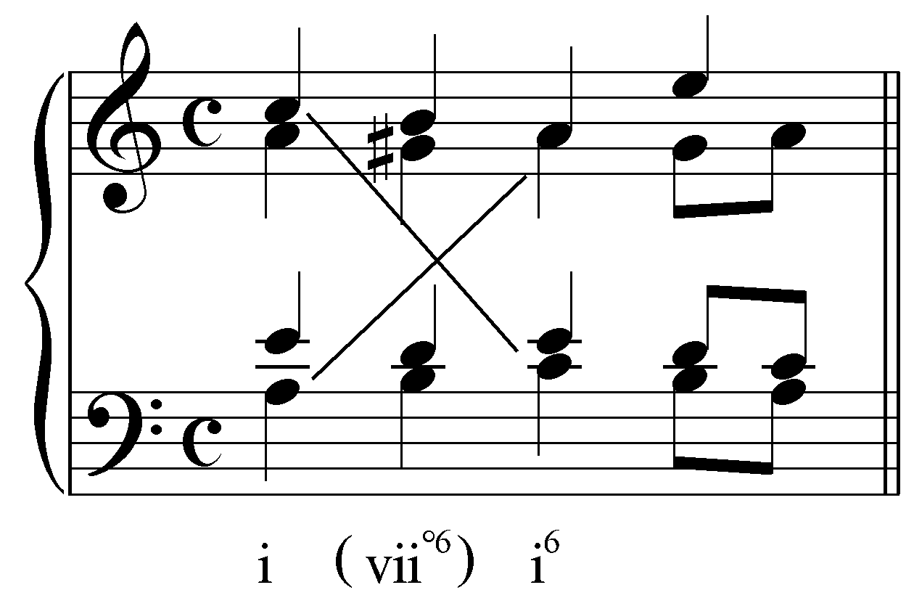

Example 17 (J.S. Bach, “Vater unser im Himmelreich,” BWV 416, m. 1):
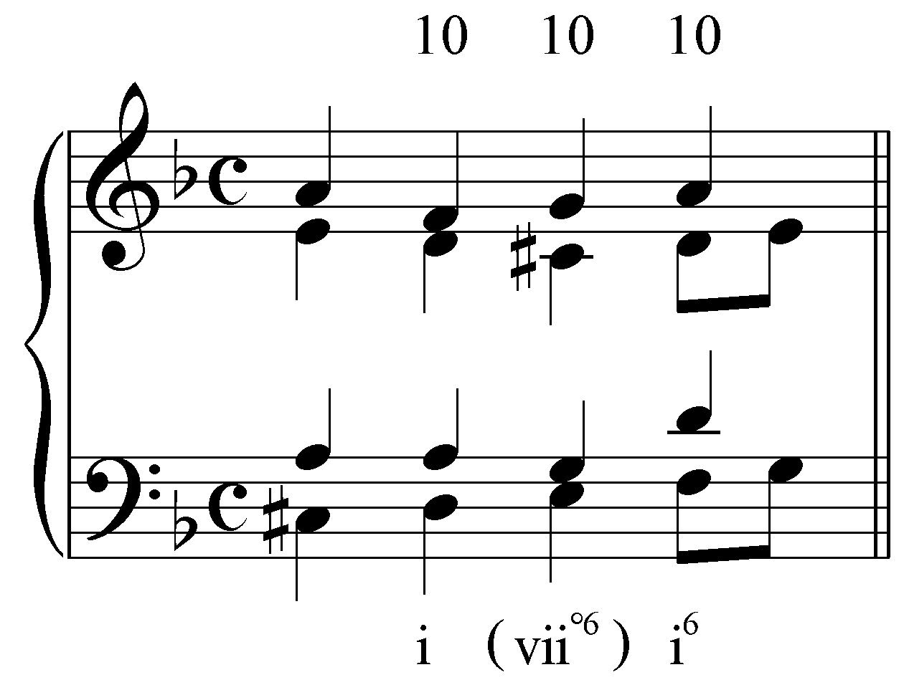

Example 18 (reduction of J.S. Bach, “Aus meines Herzens Grunde,” BWV 269, m. 9):
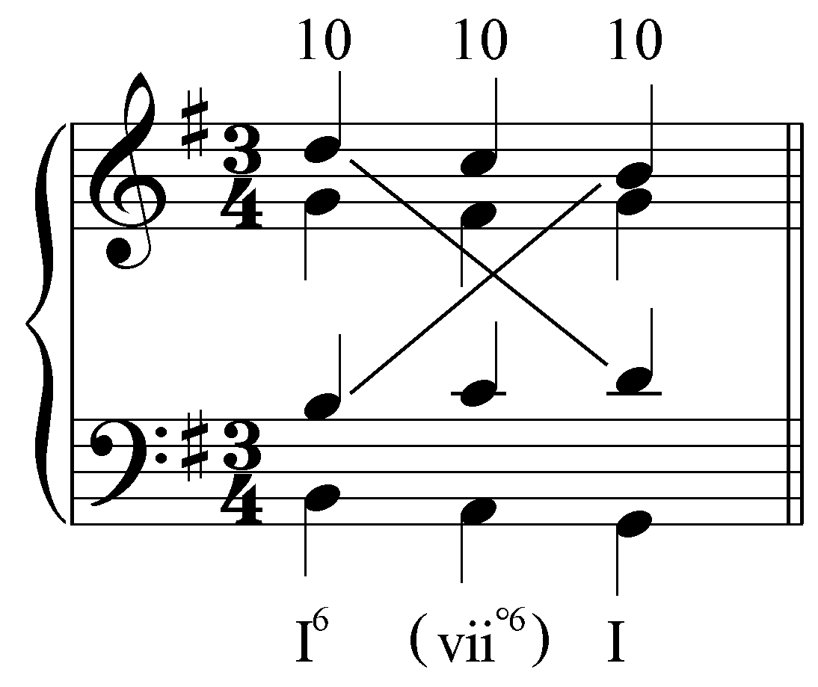

Examples 16-18 each show the expansion of the reference tonic triad with a passing auxiliary harmony coincidentally producing the pitches of a vii^{o6} chord. In each case, the bass moves stepwise through a third while the upper voices follow suit or decorate a single pitch with an upper neighbor tone. (The tenor voice on the fourth beat of Example 17 leaps up to a D because the G on the third beat is heard to resolve to the F in the bass.) Some common voice-leading patterns are worth highlighting. In Example 16 the outer voices participate in a voice exchange while in Example 17, the outer voices move in parallel tenths. Example 18 has both of these common patterns occurring simultaneously.

“Root position” auxiliary sonorities:

The auxiliary sonorities we have examined so far have been inverted triads. However, root-position triads may also serve as auxiliary sonorities to other root-position triads, or even to first-inversion triads. Consider the following excerpt from a four-part chorale by J.S. Bach (Example 20 shows a simplified reduction of Example 19):

Example 19 (J.S. Bach, “Nun danket alle Gott,” BWV 252, m. 1):
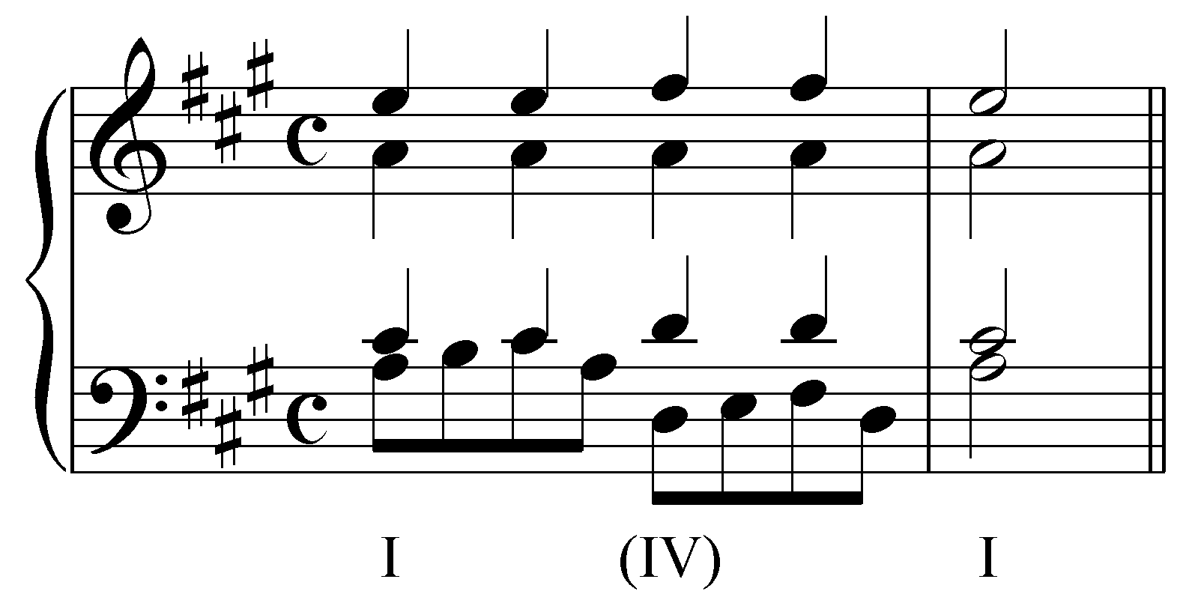

Example 20 (reduction of J.S. Bach, “Nun danket alle Gott,” BWV 252, m. 1):
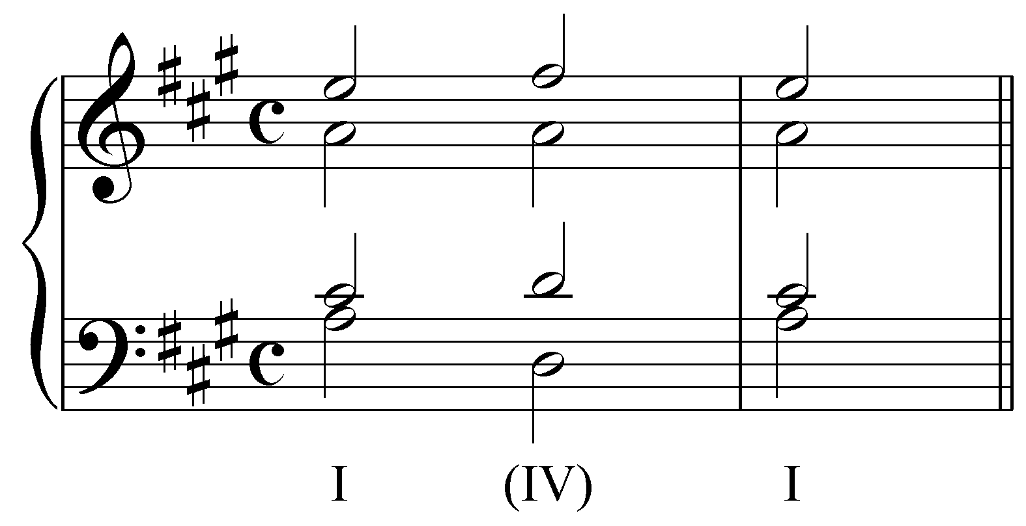

The auxiliary sonority in Examples 19 and 20 is very similar to the one in Example 11. In this case, however, the root of the IV chord (D) is in the bass. As you can see, the leaps down to D and then back up to A are more disjunct than the voice leading in the bass of Example 11. Nevertheless, the auxiliary function of the IV is clear from the surrounding reference sonority and the embellishing neighbor-note patterns in both the soprano and tenor voices. The following excerpt shows a similar situation:

Example 21 (J.S. Bach, “Ermuntre dich, mein schwacher Geist,” BWV 43.11, m. 5):
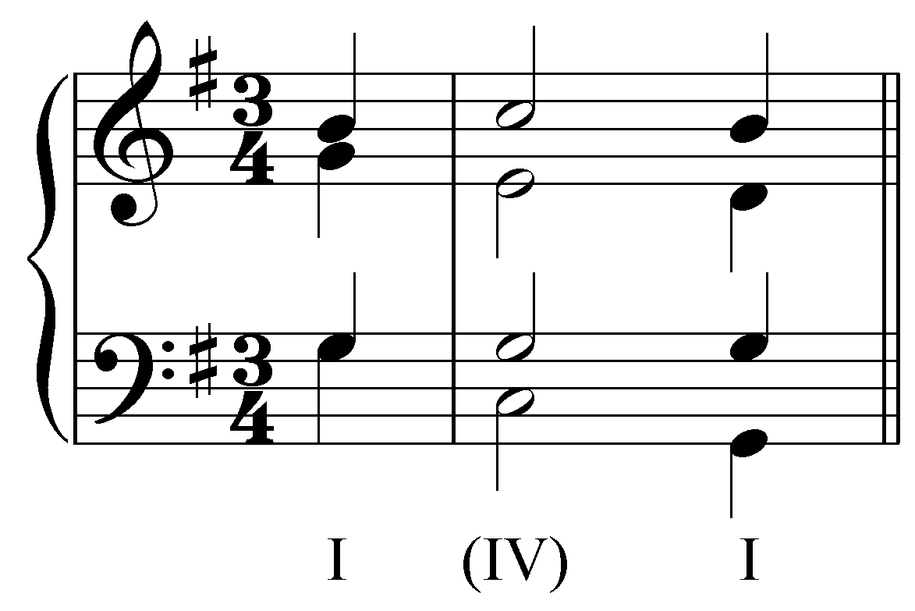

Like Example 19, Example 21 shows an expansion of a tonic harmony, as reference sonority, with a root-position auxiliary sonority on a strong beat. In this case, both leaps in the bass are descending and the alto line skips down from the root of the I chord to the upper neighbor E. Despite these minor alterations, the nature of the auxiliary sonority remains the same.

Similarly, a root-position dominant chord may serve as an auxiliary sonority to a surrounding tonic as reference sonority. Example 22 shows a tonic harmony being expanded with a root-position auxiliary dominant chord (Example 23 provides a reduction):

Example 22 (J.S. Bach, “Nun danket alle Gott,” BWV 252, m. 3):
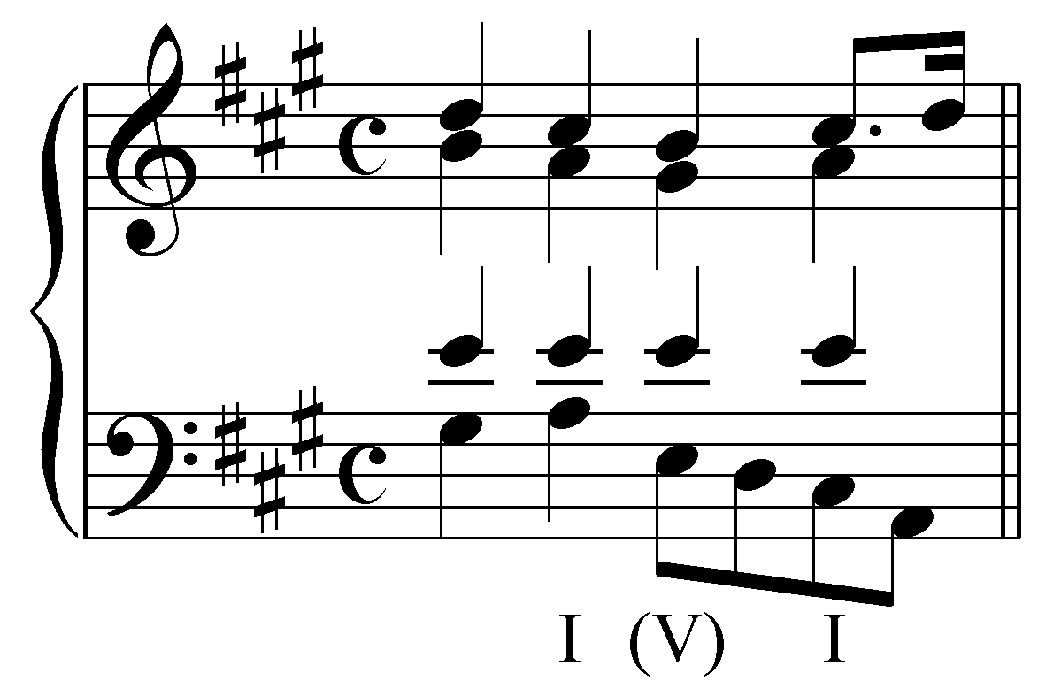

Example 23 (reduction of J.S. Bach, “Nun danket alle Gott,” BWV 252, m. 3):
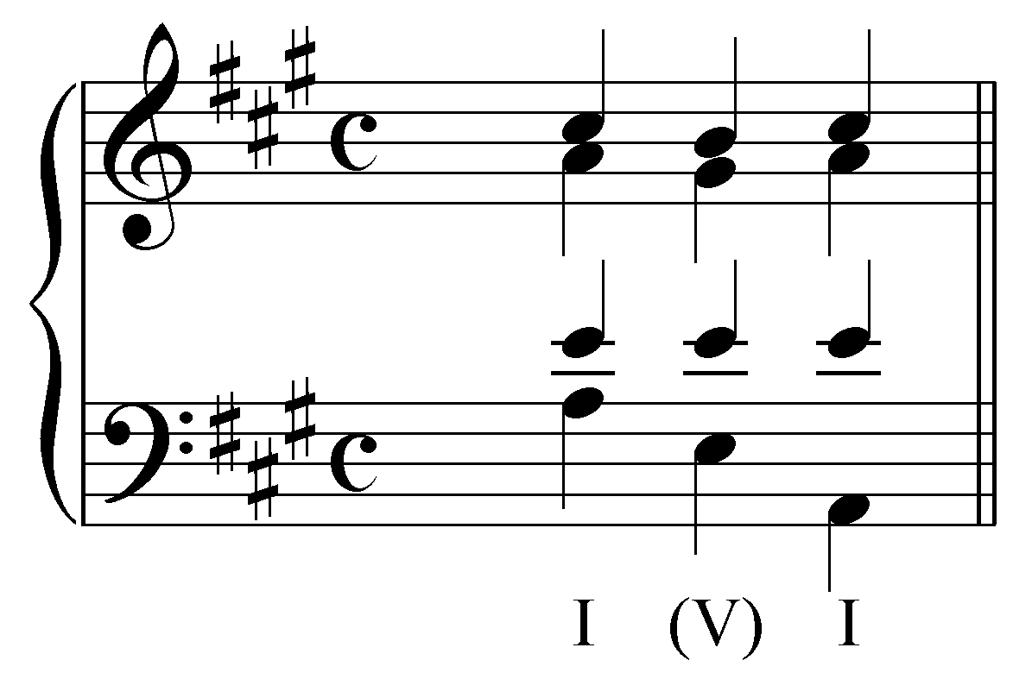

As in Example 20, note here the neighbor-note patterns, this time in the soprano and alto voices.
It is important to remember that auxiliary sonorities serve a different purpose than the functional harmonies made up of the same pitches. In Examples 22 and 23, for instance, the auxiliary sonority does not act as a functional V chord; instead, it expands the tonic harmony. This particular pattern of root position sonorities commonly appears at the end of a piece, where tonic is strongly reinforced. In codas, for instance, after the cadential I chord has arrived, we encounter such expanded reinforcements of tonic harmony. In such concluding passages, where the music routinely alternates between tonic and dominant chords, the tonics are clearly primary, the dominants secondary. They are auxiliary sonorities used to expand the referential tonic.

Activity 9.4:
It is essential to your understanding of auxiliary sonorities to be able to distinguish them from functional chords. In the following excerpt (W.A. Mozart, Sonata No. 2 in F major, K. 280, mm. 140-144) identify an auxiliary sonority by clicking on one of the roman numerals below:
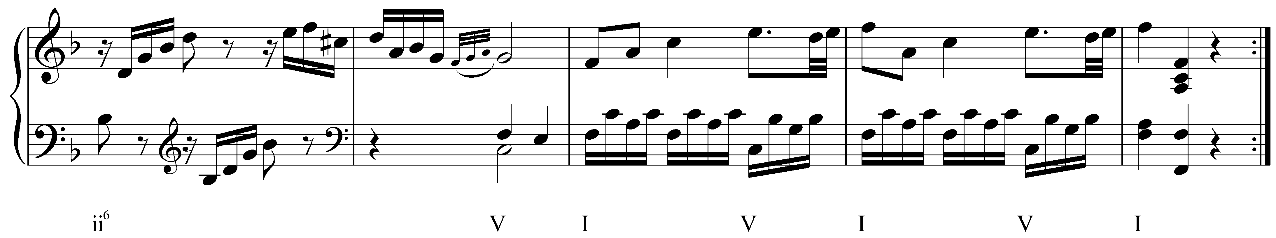
[Answer: the second or the third “V.” Response if correct: “Correct! That is an auxiliary sonority expanding the tonic harmony at the end of the movement. Response if student selects: “Incorrect. Try again.”]

While expansions of the I chord with an auxiliary dominant chord in root position are common at the ends of pieces, they are by no means limited to such sections. This type of expansion may occur wherever tonic harmony is stressed. Consider the following example where the opening tonic harmony is twice expanded by root-position dominant chords:

Example 24 (J.S. Bach, “Jesu Kreuz, Leiden und Pein,” BWV 245.28, mm. 1-2):
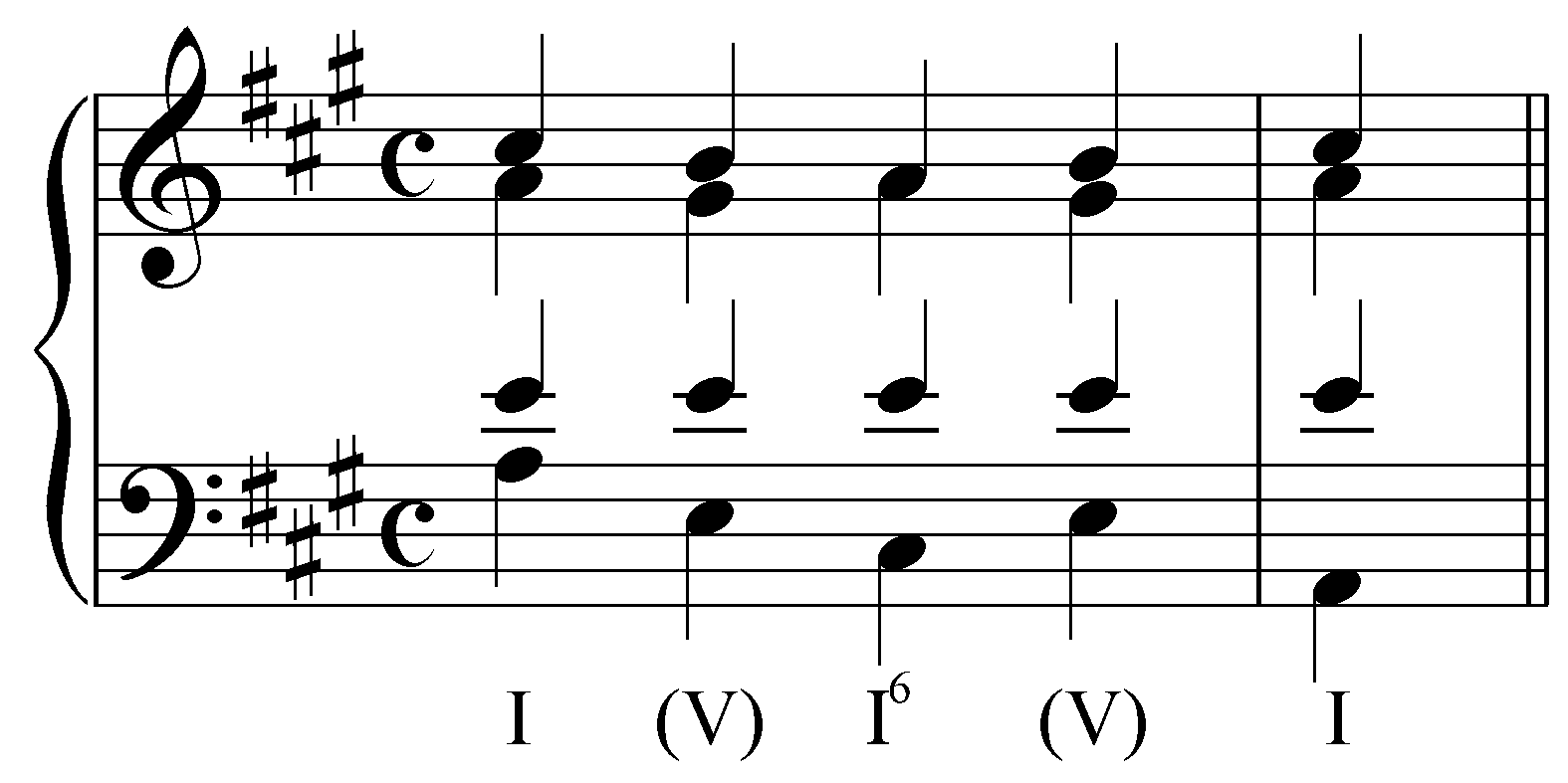

Root-position auxiliary chords are also sometimes used to expand inverted chords. In the following example, a I chord in first inversion is expanded with a root-position auxiliary ii chord:

Example 25 (J.S. Bach, “Gott lebet noch, Seele, was verzagst du doch?,” BWV 320, m. 3):
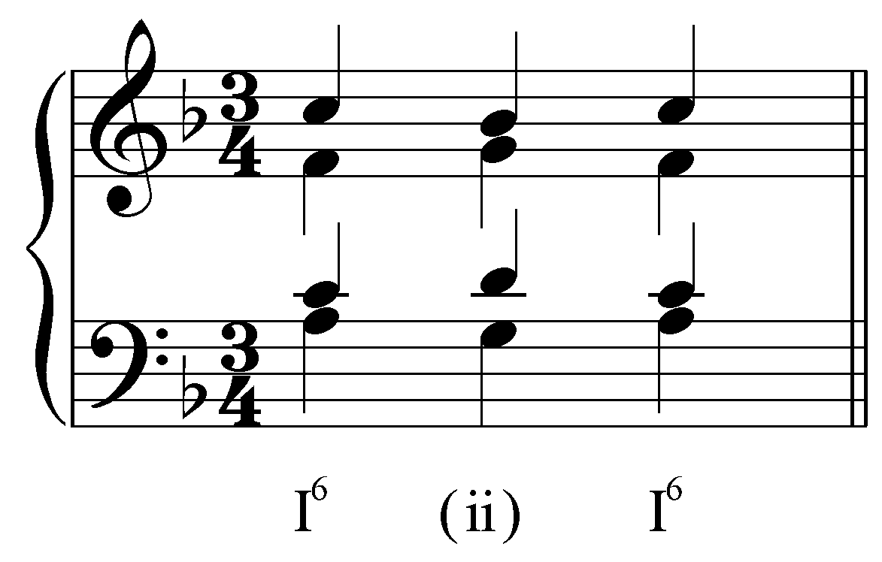

Note that the usual auxiliary sonority voice-leading patterns appear here. In this case, every voice is embellished with a neighbor tone.

Expansion of other chords:

The examples given above may be used as models for expanding other chords. For example, the “I - (vii°⁶) - I⁶” model may be used to create an expansion with ii as the reference sonority:

Example 26:
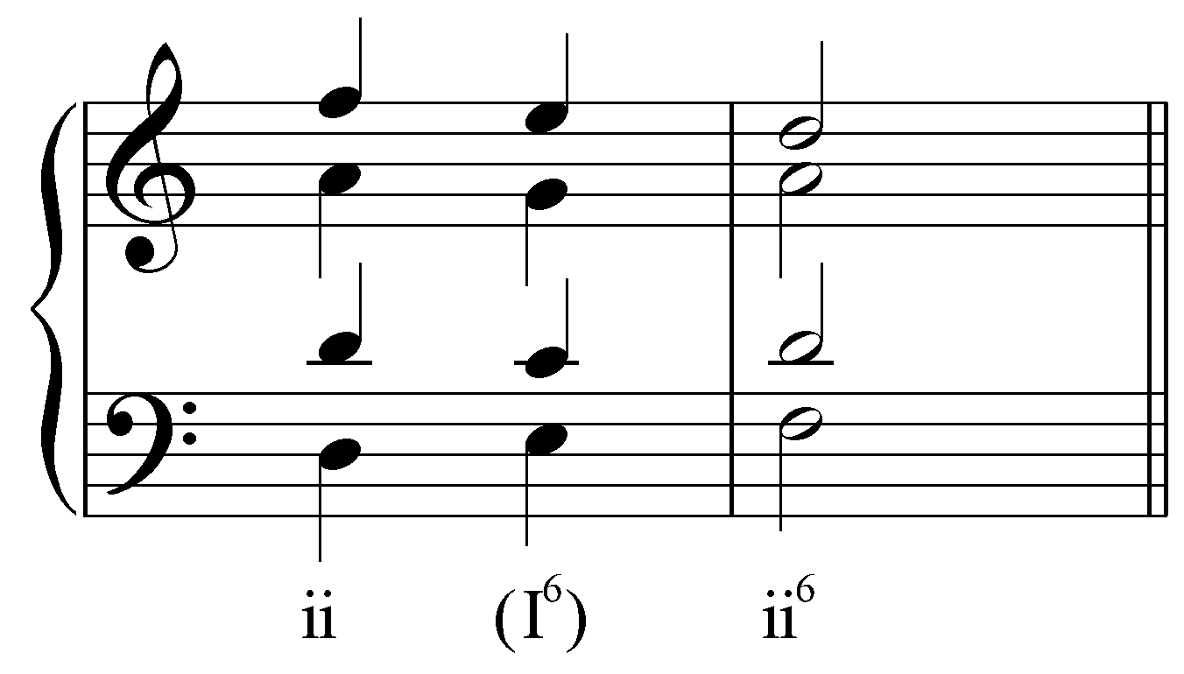

Here, an auxiliary sonority coincidentally containing the pitches of a I⁶ chord is used to expand a ii chord. Likewise, the model may be used to expand a dominant chord:

Example 27 (J.S. Bach, “Nun bitten wir den heiligen Geist,” BWV 385, mm. 3-4):
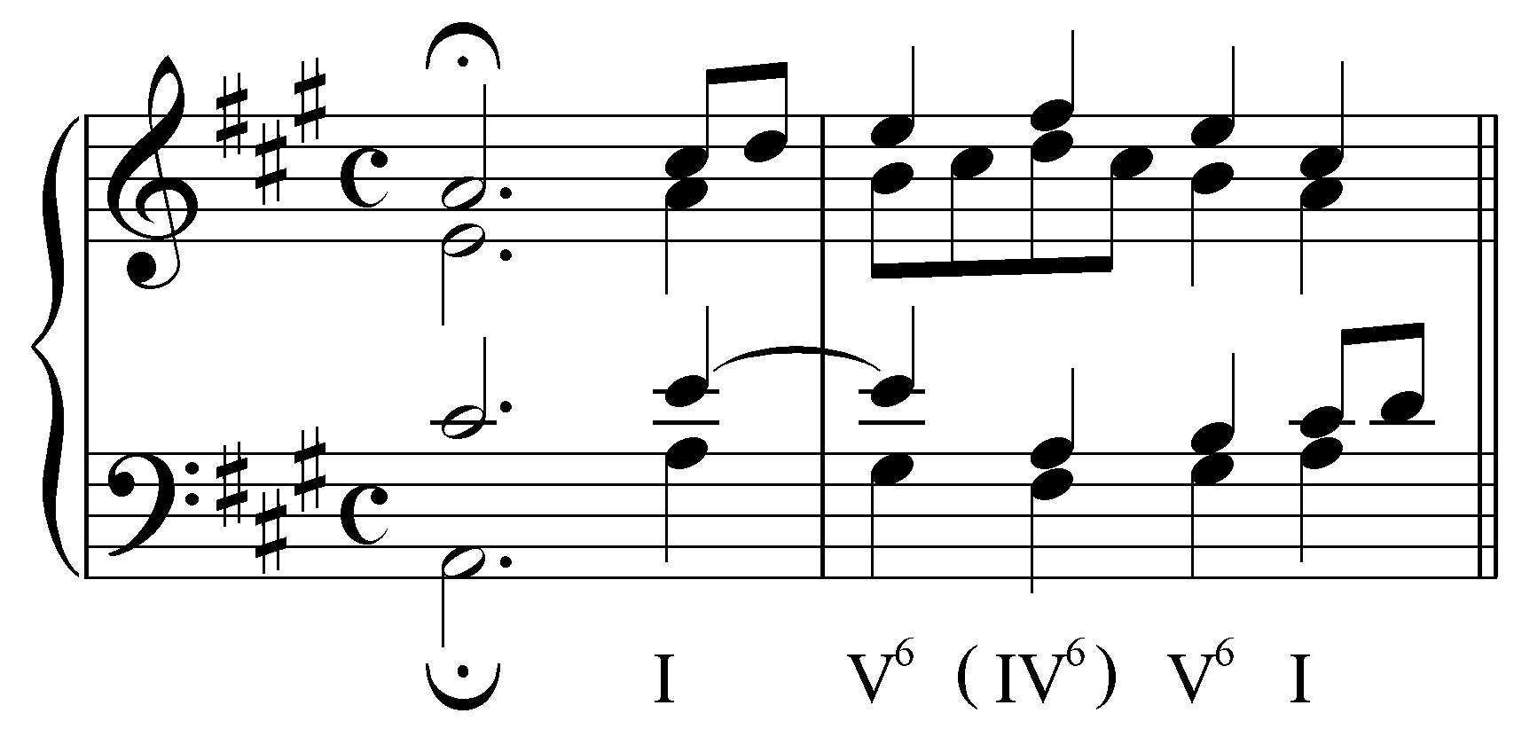

In Example 27, m. 3 is all tonic: beat 1 is a tonic chord that concludes the first phrase of the chorale and beat 4 continues that tonic. M. 4 begins with a V⁶ on beat 1. The second beat of m. 4 is a neighboring auxiliary IV⁶ which leads right back to V⁶, which in turn resolves to tonic.

Popup Box: The motion from V to the auxiliary sonority IV⁶ in Example 27 resembles what some texts refer to as a “retrogression” implying that the dominant harmony has regressed to a pre-dominant harmony. It is important to realize that this is not the case here. The D-major chord in Example 27 is nothing more than an auxiliary sonority expanding the reference V chord. The V chord is prolonged throughout the example; the auxiliary IV⁶ chord is merely a coincidence of non-harmonic tones.

Similarly, an auxiliary V chord can be used to expand a reference IV chord. Consider the following example (Example 29 provides a reduction):

Example 28 (J.S. Bach, “Jesu, deine tiefen Wunden,” BWV 194.6, mm. 7-8): 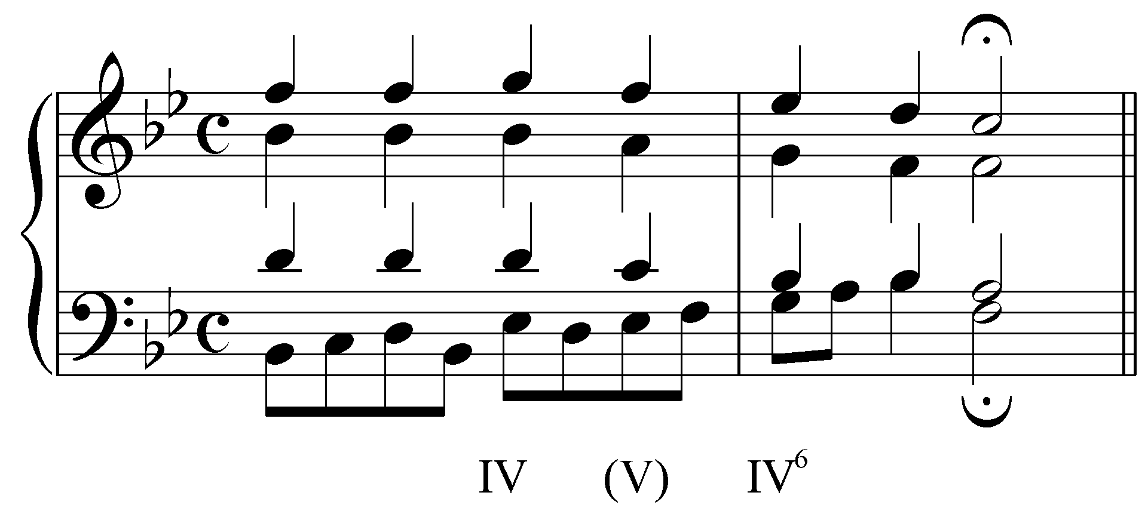

Example 29 (reduction of J.S. Bach, “Jesu, deine tiefen Wunden,” BWV 194.6, mm. 7-8):
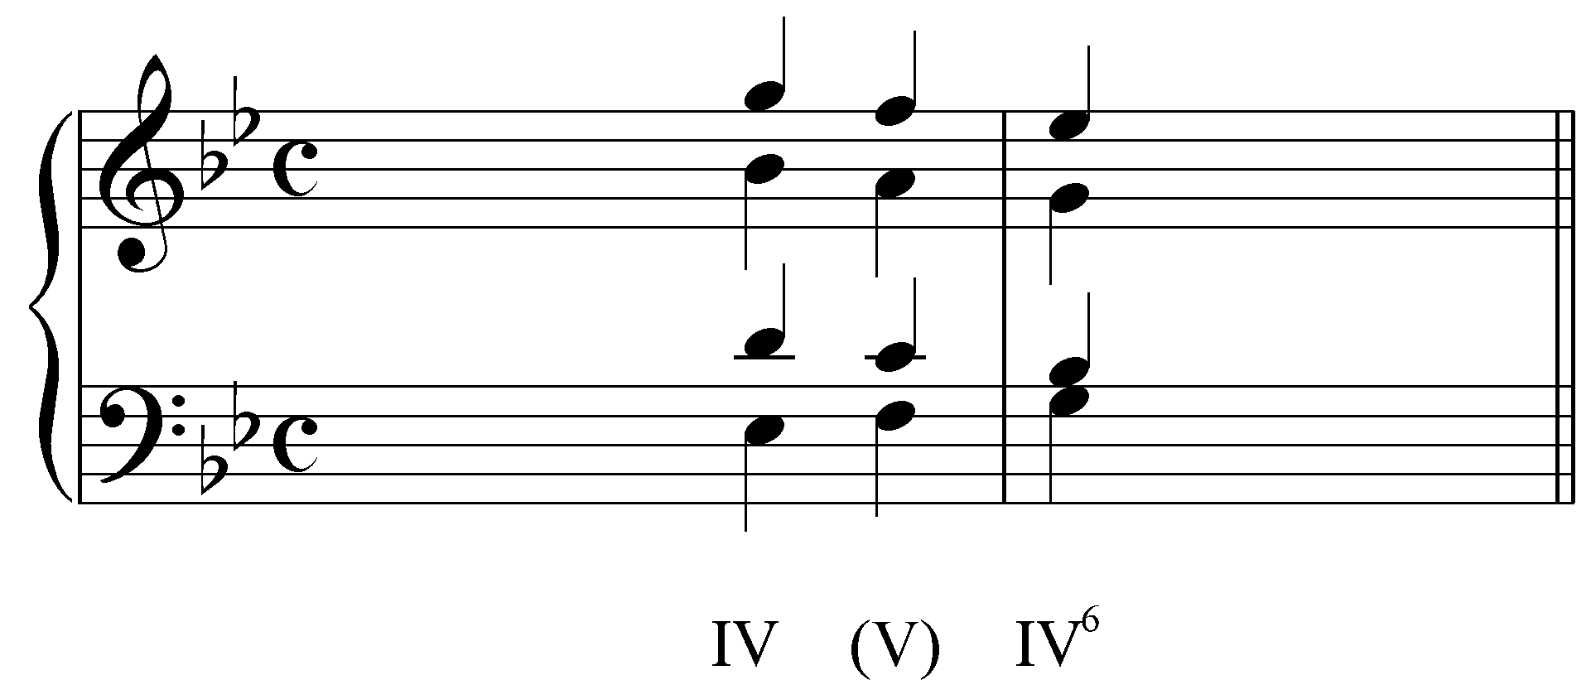

In this example, the sonority on the last beat of m. 7 is not a functional dominant harmony. As Example 29 clearly shows, each member of this chord is the result of passing motion as IV is prolonged and becomes IV⁶ through a voice exchange in the outer voices. All three chords are part of a single pre-dominant area.

Root-position auxiliary sonorities may also be used to expand harmonies other than the tonic. In the following example, V is the reference harmony. It is expanded by a tonic.

Example 30 (J.S. Bach, “Nun danket alle Gott,” BWV 252, mm. 5-6):
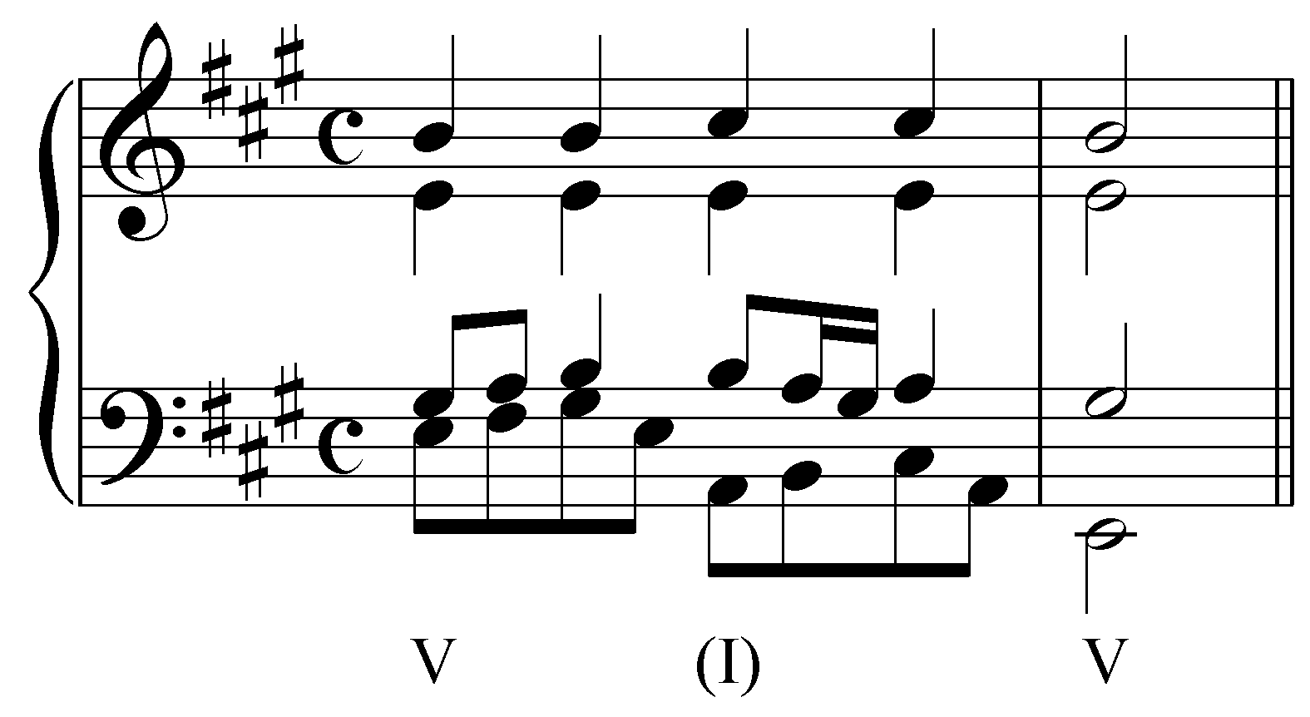

Example 31 (reduction of J.S. Bach, “Nun danket alle Gott,” BWV 252, mm. 5-6):
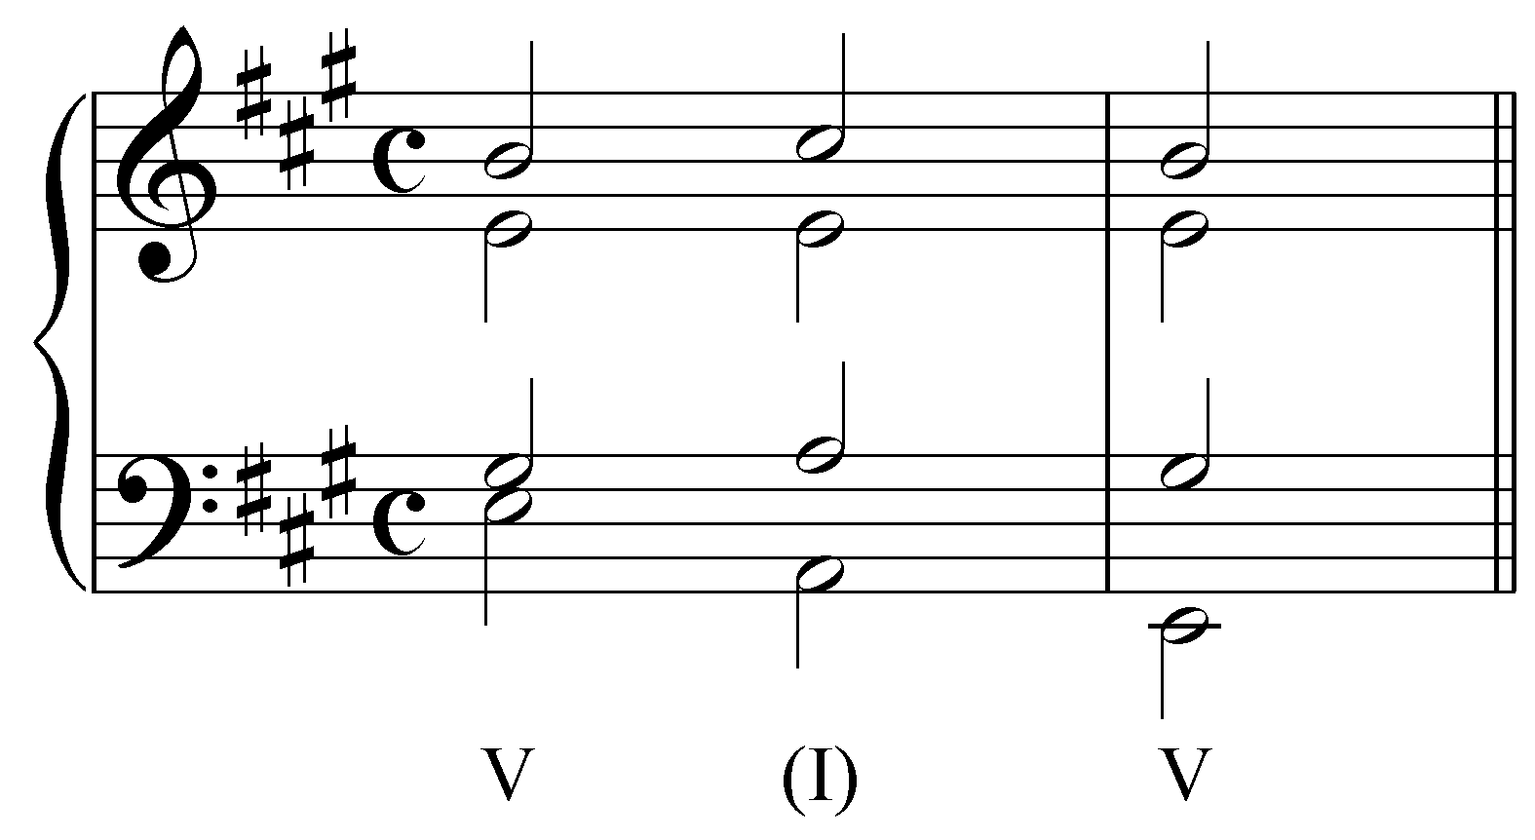

Examples 31 may, at first glance, seem similar to Example 23. Both passages seem to consist of alternating I and V chords in root position. In this case, however, V is the reference sonority and I is the auxiliary. The following example shows another possibility for expanding a V chord. In this case a root-position vi chord serves as the auxiliary sonority:

Example 32 (J.S. Bach, “Ermuntre dich, mein schwacher Geist,” BWV 43.11, m. 7):
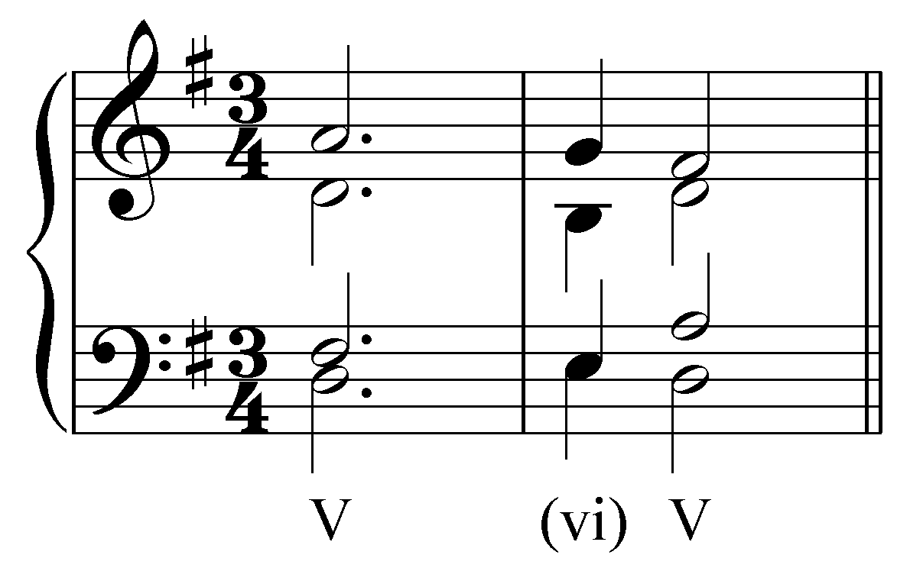

Example 33 shows another expansion with a root-position auxiliary sonority. This time, vi is expanded by a root-position iii chord:

Example 33:
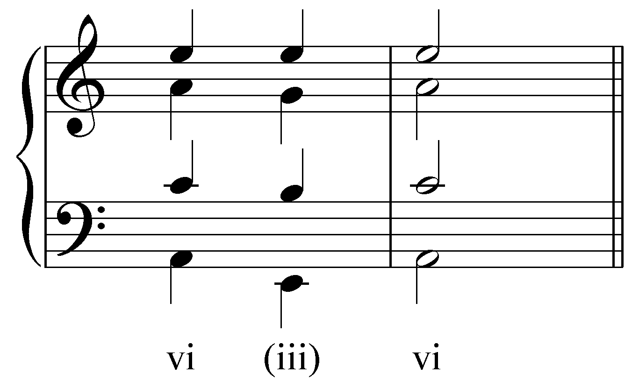

Activity 9.5:
Though not as common as in expansions of the tonic, auxiliary sonorities are often used to expand other chords. In this activity you will identify auxiliary-sonority expansions of non-tonic chords.

Exercise 9.5a:
In the following passage in A minor (J.S. Bach, “Es woll uns Gott genädig sein,” BWV 312, mm. 1-3), some non-tonic chord is expanded with an auxiliary sonority. Click on the initial reference sonority:
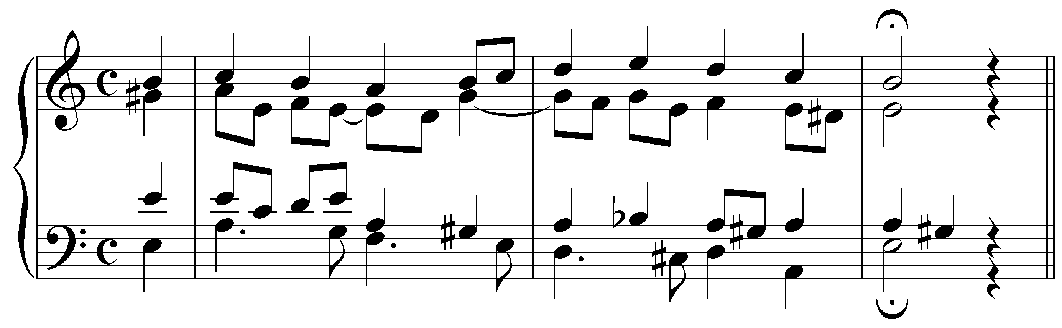
[Answer: the D-minor chord on the downbeat of m. 2. Response if correct: “Correct! The iv chord on the downbeat of m. 2 is expanded via an auxiliary sonority.” Response if incorrect: “Incorrect. Try again. (Hint: The initial reference harmony contains a “4 - 3” suspension above the bass.)”]
[Follow-up multiple choice question]
What type of auxiliary sonority expansion occurs in m. 2?
[Possible answers: “iv (V) iv,” “iv (vii^{o7}/iv) iv,” “iv (i⁶) iv,” “iv (viiº${}_{4}^{6}$) iv.” Correct answer: “iv (vii^{o7}/iv) iv.” Response if correct: “Correct!” Response if incorrect: “Incorrect. Try again.”]

Exercise 9.5b:
In the following passage in F major (J.S. Bach, “Gott lebet noch, Seele, was verzagst du doch?,” BWV 320, mm. 3-6), some non-tonic chord is expanded with an auxiliary sonority. Click on the initial reference sonority:
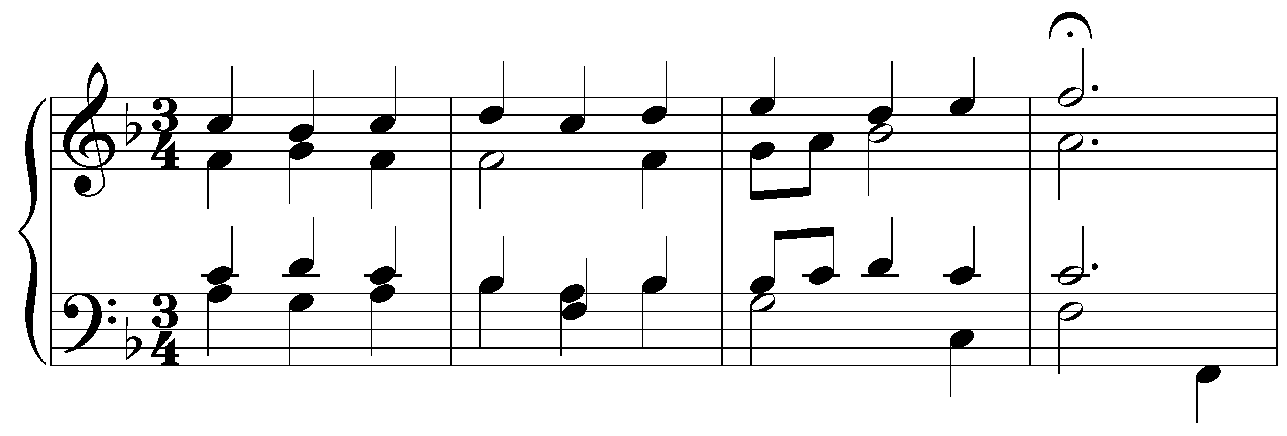
[Answer: the B^{b}-major chord on the downbeat of m. 4. Response if correct: “Correct! The IV chord on the downbeat of m. 4 is expanded via an auxiliary sonority.” Response if student clicks on the downbeat of m. 3: “While that is the initial reference sonority of an auxiliary chord expansion, the directions were to find an expansion of a non-tonic chord. Try again.” Response for all other incorrect answers: “Incorrect. Try again.”]
[Follow-up multiple choice question]
What type of auxiliary sonority expansion occurs in m. 4?
[Possible answers: “IV (III⁶) IV,” “IV (I⁶) IV,” “IV (I) IV,” “IV (V) IV.” Correct answer: “IV (I) IV.” Response if correct: “Correct!” Response if incorrect: “Incorrect. Try again.”]

Exercise 9.5c:
In the following passage in A minor (J.S. Bach, “Heut' triumphieret Gottes Sohn,” BWV 342, mm. 5-8), some non-tonic chord is expanded with an auxiliary sonority. Click on the initial reference sonority:
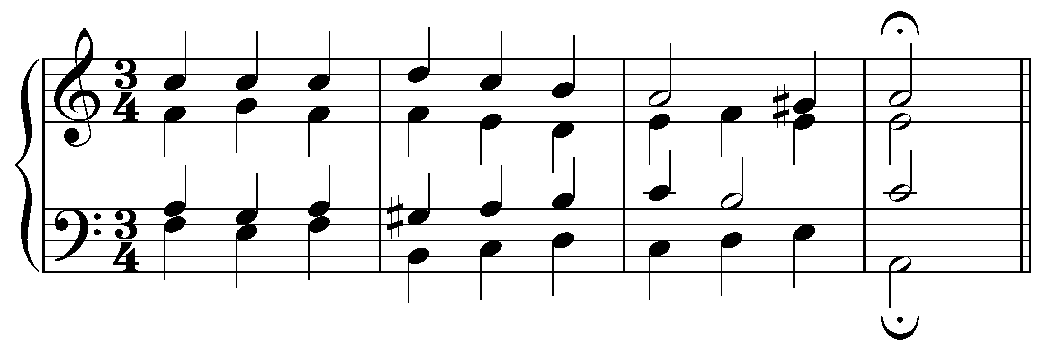
[Answer: the F-major chord on the downbeat of m. 5. Response if correct: “Correct! The vi chord on the downbeat of m. 5 is expanded via an auxiliary sonority.” Response if incorrect: “Incorrect. Try again.”]
[Follow-up multiple choice question]
What type of auxiliary sonority expansion occurs in m. 5?
[Possible answers: “VI (III⁶) VI,” “VI (vii^{o7}/ VI) VI,” “VI (V) VI,” “VI (iiº${}_{4}^{6}$) VI.” Correct answer: “vi (III⁶) vi.” Response if correct: “Correct!” Response if incorrect: “Incorrect. Try again.”]

Exercise 9.5d:
In the following passage in F major (J.S. Bach, “Ich dank dir, lieber Herre,” BWV 348, mm. 7-8), some non-tonic chord is expanded with an auxiliary sonority. Click on the initial reference sonority:
(IV V IV6)
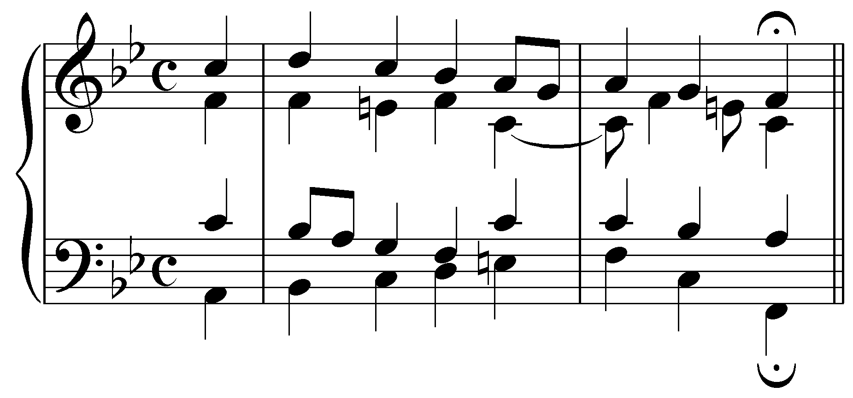
[Answer: the B^{b}-major chord on the downbeat of m. 7. Response if correct: “Correct! The IV chord on the downbeat of m. 7 is expanded via an auxiliary sonority.” Response if incorrect: “Incorrect. Try again. (Hint: There is an extra passing tone in one of the voices of this expansion.)”]
[Follow-up multiple choice question]
What type of auxiliary sonority expansion occurs in m. 7?
[Possible answers: “IV (I${}_{4}^{6}$) IV⁶,” “IV (I⁶) IV⁶,” “IV (vi) IV⁶,” “IV (V) IV⁶.” Correct answer: “IV (V) IV⁶.” Response if correct: “Correct!” Response if incorrect: “Incorrect. Try again.”]

The cadential ${}_{4}^{6}$ chord:

One final auxiliary sonority deserves special attention. This particular sonority appears primarily at cadences and coincidentally contains the pitches of I chord in second inversion. Consider the following example:

Example 34 (J.S. Bach, “Mach's mit mir, Gott, nach deiner Güt,” BWV 377, m. 11-12):
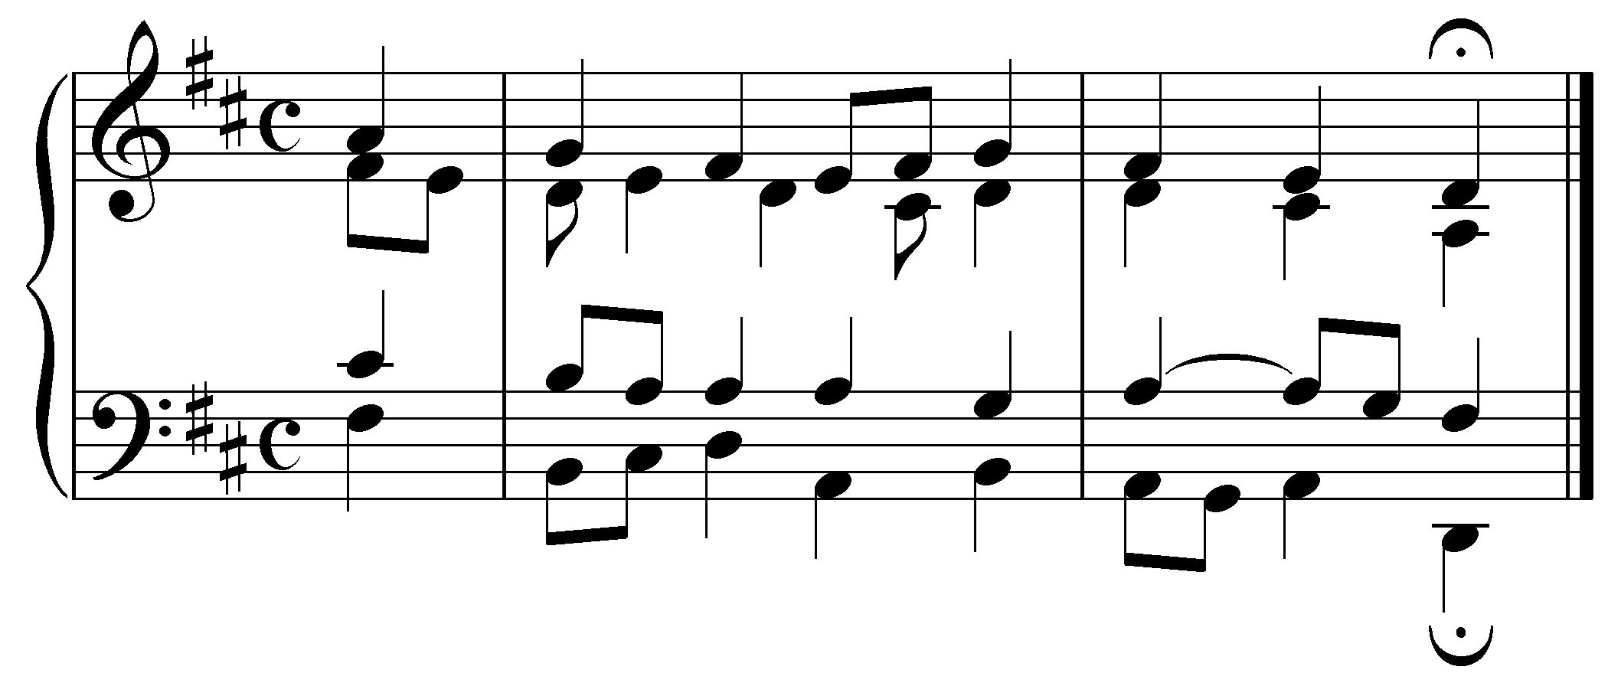

The chord on the downbeat of m. 12 contains the pitches D and F# above an A in the bass. You may be tempted to label this sonority “I${}_{4}^{6}$.” To do so, however, would contradict the function of the chord. This sonority is not a functional tonic chord, but rather an embellishment and intensification of the dominant.

Look again at the D and F#. Both are nonharmonic tones: the F# is an accented passing tone between scale degrees 4 and 2 while the D is a dissonant “4 - 3” suspension delaying the arrival of the leading tone. (See Lessons 8 for a review of nonharmonic tones.) Both pitches resolve on the following beat to a root position V chord and a perfect authentic cadence.

The sonority on the first beat of m. 12 is referred to as a cadential ${}_{4}^{6}$ chord. The first two beats of the measure should be analyzed as V${}_{4−3}^{6−5}$ to reflect the underlying importance of the V chord in the cadential IV - V - I progression:

Example 35:
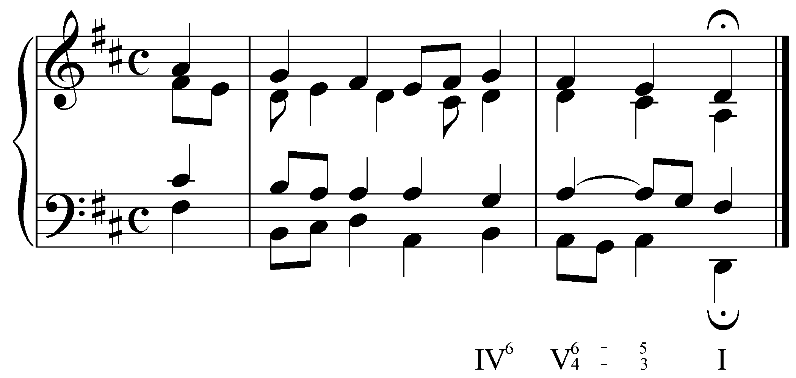

Popup box: The cadential ${}_{4}^{6}$ chord originated in the voiceleading practice of delaying the arrival of the leading tone in a cadence. This was usually done by suspending scale degree 1 from the preceding pre-dominant chord. Delaying the arrival of the fifth of the V chord (scale degree 2) as well completes the ${}_{4}^{6}$ chord. Because the cadential ${}_{4}^{6}$ chord consists primarily of accented, nonharmonic tones, it must always appear in a metrically strong position relative to the resolution. As you can see, this is the case in Example 34.

Activity 9.6:
Not all cadential ${}_{4}^{6}$ chords are as rhythmically straightforward as the one given in Example 34. In this activity you will be presented with the concluding phrases of several Bach chorales, each of which contains a cadential ${}_{4}^{6}$ chord. After identifying the nonharmonic tones (the fourth and the sixth above the bass), you will be asked how each is introduced.

Exercise 9.6a:
Identify the fourth above the bass in the cadential ${}_{4}^{6}$ chord in this excerpt (J.S. Bach, “Als der gütige Gott vollenden wollt sein Wort,” BWV 264, mm. 9-10):
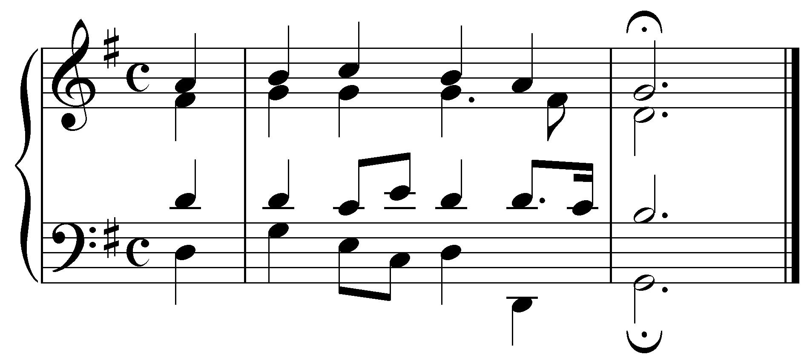
[Answer: the G dotted quarter note in the alto starting on beat three of m. 9. Response if correct: “Correct!” Response if incorrect: “Incorrect. Try again.”]

[Follow-up multiple choice question:] What type of nonharmonic tone is this?
[Possible answers: “Anticipation,” “Appoggiatura,” “Suspension,” “Accented passing tone.” Answer: “Suspension.” Response if correct: “Correct!” Response if incorrect: “Incorrect. Try again.”]

[Follow-up question:] Now identify the sixth above the bass in the cadential ${}_{4}^{6}$ chord.
[Answer: the B quarter not in the soprano on beat three of m. 9. Response if correct: “Correct!” Response if incorrect: “Incorrect. Try again.”]

[Follow-up multiple choice question:] What type of nonharmonic tone is this?
[Possible answers: “Anticipation,” “Appoggiatura,” “Suspension,” “Accented passing tone.” Answer: “Accented passing tone.” Response if correct: “Correct!” Response if incorrect: “Incorrect. Try again.”]

Exercise 9.6b:
Identify the fourth above the bass in the cadential ${}_{4}^{6}$ chord in this excerpt (J.S. Bach, “Alles ist an Gottes Segen,” BWV 263, mm. 11-12):
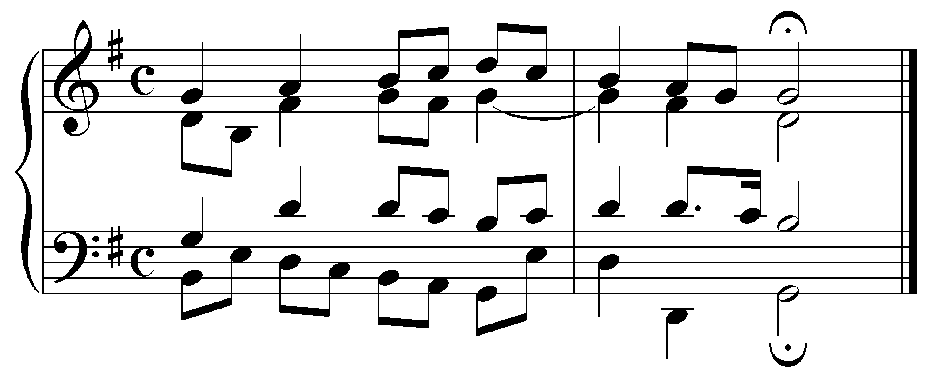
[Answer: the G quarter note in the alto starting on the downbeat of m. 12. Response if correct: “Correct!” Response if incorrect: “Incorrect. Try again.”]

[Follow-up multiple choice question:] What type of nonharmonic tone is this?
[Possible answers: “Anticipation,” “Appoggiatura,” “Suspension,” “Accented passing tone.” Answer: “Suspension.” Response if correct: “Correct!” Response if incorrect: “Incorrect. Try again.”]

[Follow-up question:] Now identify the sixth above the bass in the cadential ${}_{4}^{6}$ chord.
[Answer: the B quarter note in the soprano on the downbeat of m. 12. Response if correct: “Correct!” Response if incorrect: “Incorrect. Try again.”]

[Follow-up multiple choice question:] What type of nonharmonic tone is this?
[Possible answers: “Anticipation,” “Appoggiatura,” “Suspension,” “Accented passing tone.” Answer: “Accented passing tone.” Response if correct: “Correct!” Response if incorrect: “Incorrect. Try again.”]

Exercise 9.6c:
Identify the fourth above the bass in the cadential ${}_{4}^{6}$ chord in this excerpt (J.S. Bach, “Nicht so traurig, nicht so sehr,” BWV 384, mm. 11-12):
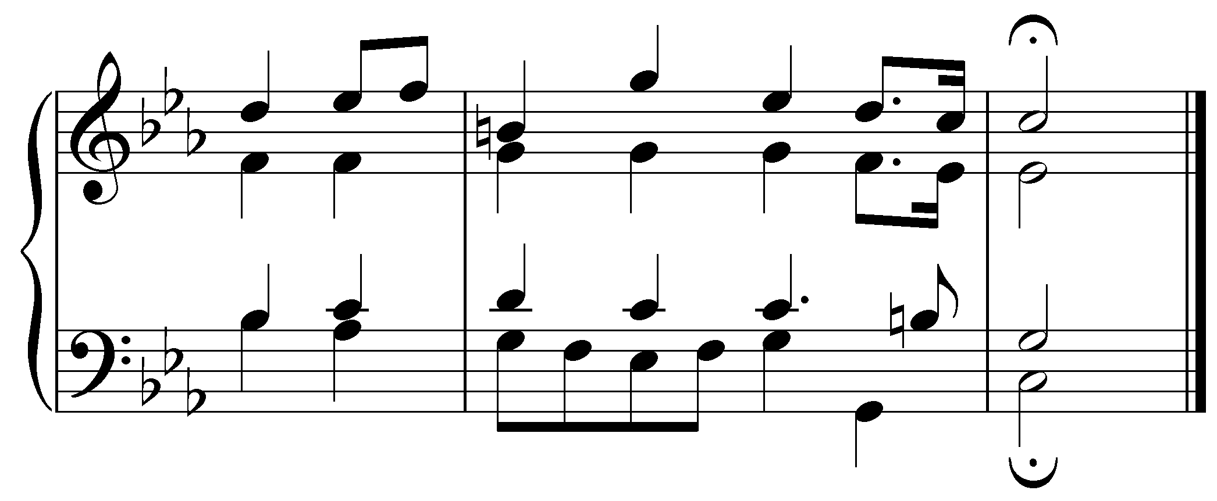
[Answer: the C dotted quarter note in the tenor starting on beat three of m. 11. Response if correct: “Correct!” Response if incorrect: “Incorrect. Try again.”]

[Follow-up multiple choice question:] What type of nonharmonic tone is this?
[Possible answers: “Anticipation,” “Appoggiatura,” “Suspension,” “Accented passing tone.” Answer: “Suspension.” Response if correct: “Correct!” Response if incorrect: “Incorrect. Try again.”]

[Follow-up question:] Now identify the sixth above the bass in the cadential ${}_{4}^{6}$ chord.
[Answer: the E^{b} quarter note in the soprano on beat three of m. 11. Response if correct: “Correct!” Response if incorrect: “Incorrect. Try again.”]

[Follow-up multiple choice question:] What type of nonharmonic tone is this?
[Possible answers: “Anticipation,” “Appoggiatura,” “Suspension,” “Accented passing tone.” Answer: “Appogiatura.” Response if correct: “Correct!” Response if incorrect: “Incorrect. Try again.”]

Exercise 9.6d:
Identify the fourth above the bass in the cadential ${}_{4}^{6}$ chord in this excerpt (J.S. Bach, “Es woll uns Gott genädig sein,” BWV 280, mm. 17-18):
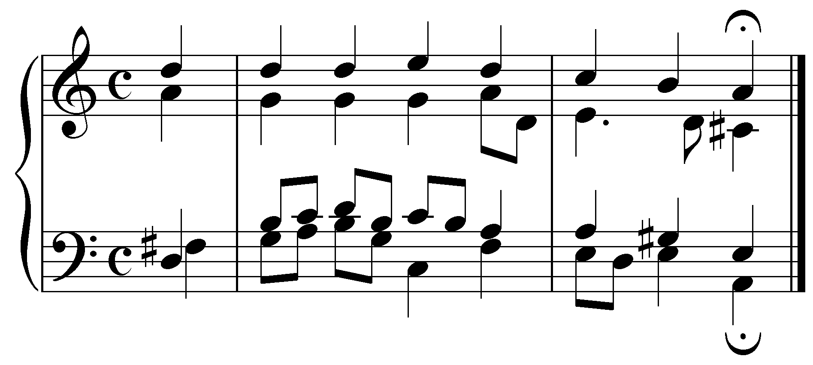
[Answer: the A quarter note in the tenor starting on the downbeat of m. 18. Response if correct: “Correct!” Response if incorrect: “Incorrect. Try again.”]

[Follow-up multiple choice question:] What type of nonharmonic tone is this?
[Possible answers: “Anticipation,” “Appoggiatura,” “Suspension,” “Accented passing tone.” Answer: “Suspension.” Response if correct: “Correct!” Response if incorrect: “Incorrect. Try again.”]

[Follow-up question:] Now identify the sixth above the bass in the cadential ${}_{4}^{6}$ chord.
[Answer: the C quarter note in the soprano on the downbeat of m. 18. Response if correct: “Correct!” Response if incorrect: “Incorrect. Try again.”]

[Follow-up multiple choice question:] What type of nonharmonic tone is this?
[Possible answers: “Anticipation,” “Appoggiatura,” “Suspension,” “Accented passing tone.” Answer: “Accented passing tone.” Response if correct: “Correct!” Response if incorrect: “Incorrect. Try again.”]

Conclusion:

In this lesson we have seen how common interval progressions, coupled with melodic embellishments, may be used to expand harmonies. These individual embellishments combine to form full, four-voiced sonorities. Often, these sonorities coincidentally contain the pitches of familiar chords in first or second inversion. However, even though auxiliary sonorities may resemble those chords, it is important to remember that they do not have the functional meaning of those chords. Instead, we refer to them as auxiliary sonorities. In other words, the V in a “I - V⁶ - I” expansion does not have a dominant function (as it would in “I - IV - V - I”). Accordingly, we have either placed the auxiliary sonority in parentheses (i.e. “I - (vii°⁶) - I⁶”) or refrained from labeling it altogether (i.e. “I____”). Although root-position triads are permissible, most auxiliary sonorities appear as inverted triads for the sake of smooth voice leading.

Although the majority of this lesson demonstrated the expansion of a I chord, we also saw that similar examples are possible as models for expanding other reference harmonies. In other words, the “I - (vii°⁶) - I⁶” expansion can be used as a model for expanding a ii harmony: “ii - (I⁶) - ii⁶.”

Auxiliary sonorities are an important tool in tonal music. It is important that you learn to recognize them and to distinguish them from functional harmonies.

