(Change the V⁶ on page 3 to a V${}_{4}^{6}$)

[Add this just before “Expansion of other chords” on p. 5:] “Root position” auxiliary sonorities:

All of the auxiliary sonorities we have examined so far have been inverted triads. This will not always be the case. Root-position triads may also be used as auxiliary sonorities. While this type of expansion is permissible, it is not always desirable. Typically, it is preferable to expand a reference sonority with a triad in inversion as this will lead to smoother voice leading in the bass. Furthermore, the increased stability of a triad in root position tends to undermine the auxiliary role. Consider the following example:

Example 14:
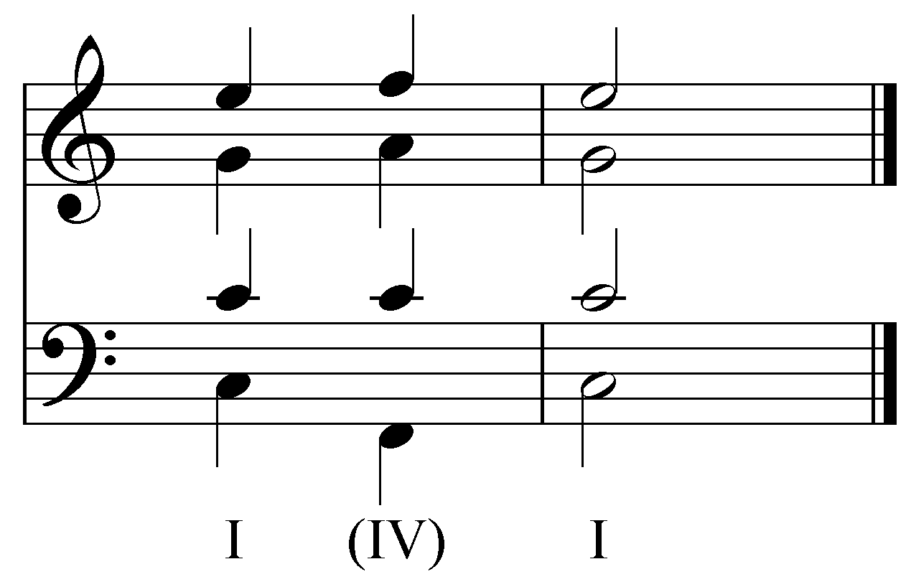

This auxiliary sonority is very similar to the one in example 9. In this case, however, the root of the IV chord (F) is in the bass. As you can see, the leaps down to F and then back up to C are more disjunct than the voice leading in the bass of example 9. Another common root-position auxiliary sonority uses a triad that coincidentally constitutes the structure of a V chord in root position:

Example 15:
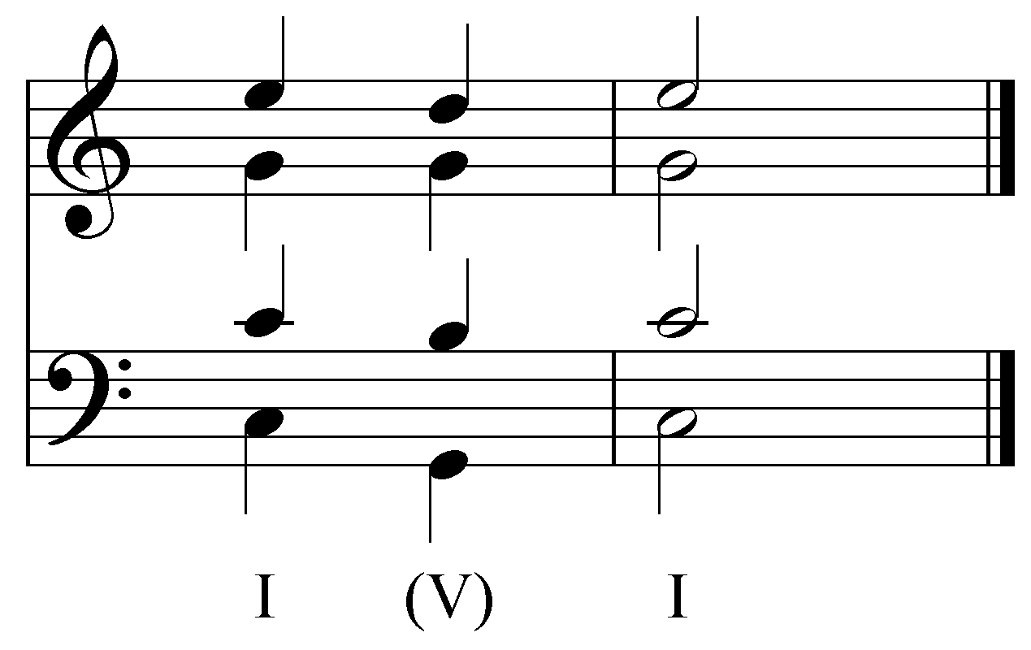

It is important to remember that auxiliary sonorities serve a different purpose than the functional harmonies that share their pitches. In example 15, for instance, the auxiliary sonority does not act as a functional V chord; instead, it expands the tonic harmony. This particular idiom is commonly found at the end of a piece, especially in a coda. In a typical coda, the final, cadential I chord has already arrived. What follows is simply a prolonged expansion of the tonic harmony. Although the music may seem to alternate between tonic and dominant chords, the dominant chords are subordinate, auxiliary sonorities used to expand the reference tonic harmony.

[Potential activity:
Give students a brief passage from a “I-V-I-V-I…” coda and ask them to identify the reference and subordinate harmonies.]

[Add the following to “Expansion of other chords”:]

Root-position auxiliary sonorities may also be used to expand harmonies other than the tonic. In the following example, V is the reference harmony. It is expanded by a triad that coincidentally constitutes the structure of a I chord in root position:

Example 16:
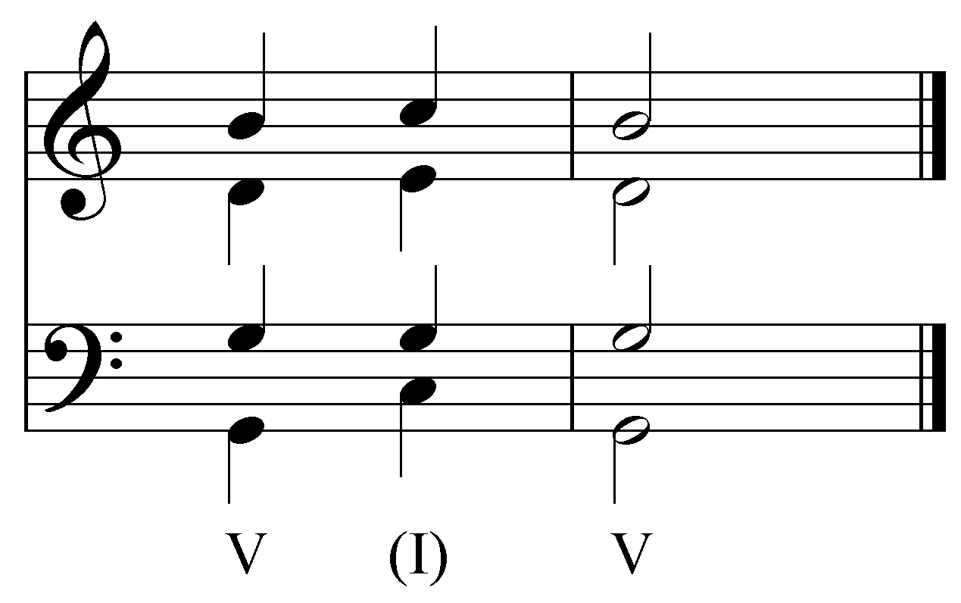

Example 16 may, at first glance, seem similar to example 15. Both passages seem to consist of alternating I and V chords in root position. In this case, however, V is the reference sonority and I is the auxiliary. Example 17 shows another expansion with a root-position auxiliary sonority. This time, vi is expanded by a triad that shares the pitches of a iii chord in root position:

Example 17:
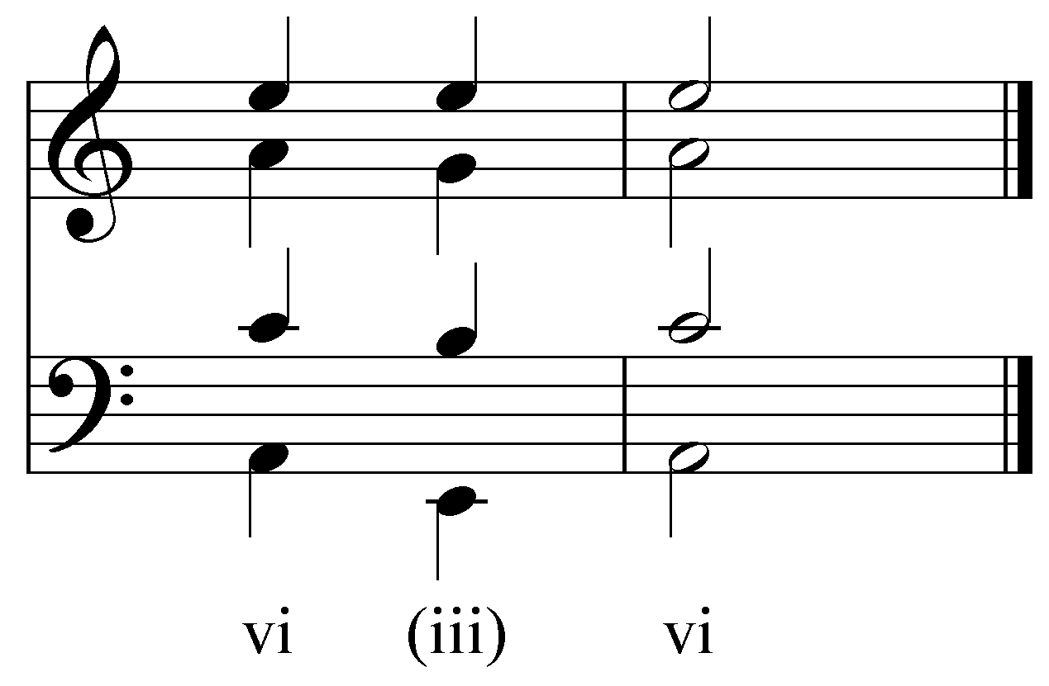

[Potential Activity:
Give students a brief passage of several measures in which certain harmonies are expanded via root-position auxiliary sonorities. Students are asked to identify which chords are reference sonorities and which are auxiliary.]

[Add a sentence to the conclusion regarding root position auxiliary sonorities.]

