Lesson CCC – The Minor Scale

Introduction:

In tonal music, the major scale is undoubtedly the most important and frequently used organization of pitches:

Example 1:
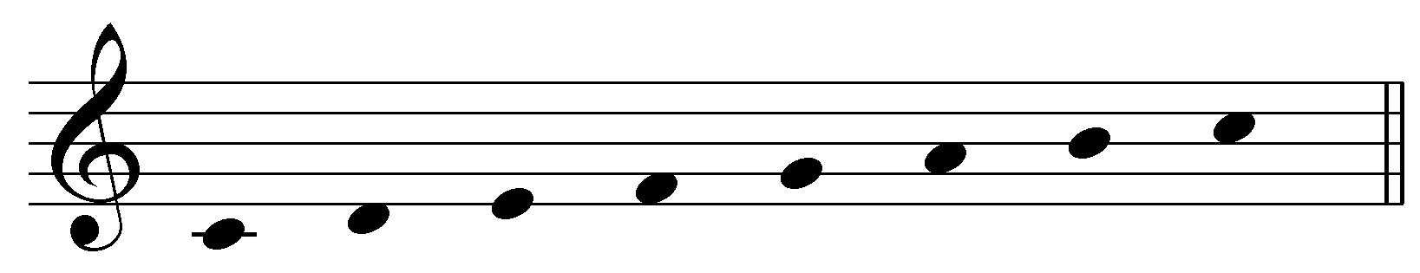

As you know, the major scale is built using a specific pattern of whole steps and half steps: W-W-H-W-W-W-H. This pattern is used in every manifestation of the major scale. The minor scale, on the other hand, is not as easy to define. You have probably come across three different versions of the minor scale, the natural minor scale:

Example 2:
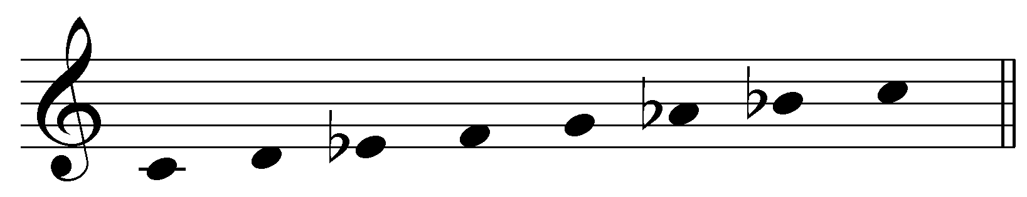

the harmonic minor scale, with its raised seventh scale degree:

Example 3:
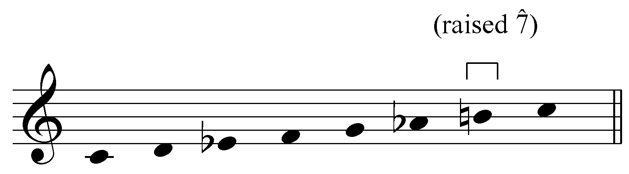

and the melodic minor scale, with the sixth and seventh scale degrees raised when ascending and lowered when descending:

Example 4:
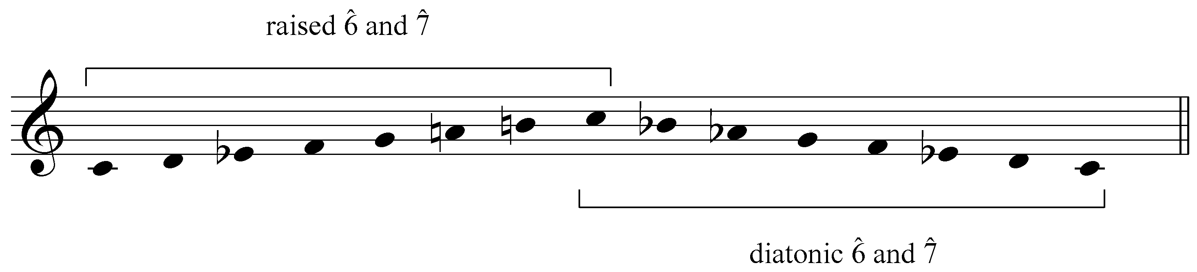

Of the three, the natural minor scale holds a privileged position. The natural minor scale is the diatonic form, which undergoes specific adjustments, based on musical context, to produce the other two forms. In this lesson, we will refer to the natural minor scale as the diatonic minor. As you will see, the harmonic and melodic minor scales incorporate tonality-defining characteristics of the major scale. In a sense, the harmonic and melodic minor scales are composite scales whose members mix defining traits of the diatonic (natural) minor and major scales.

In this lesson we will examine the diatonic minor scale and its two derivatives. For each version, we will also discuss where and why it appears.

The diatonic minor scale:

Because the major scale is so prevalent in tonal music, it is helpful to think of minor scales with respect to their parallel majors. Compare Examples 5 and 6:

Example 5 (the C major scale):

Example 6 (the diatonic C minor scale):

The majority of the members of each scale are the same. Both share scale degrees 1, 2, 4, and 5 (C, D, F, and G in this case). The minor scale is distinguished by its lowered scale degrees 3, 6 and 7 (Eb, Ab, and Bb instead of E, A, and B).

Activity 3.1:
A major scale and its parallel minor share the majority of their pitches. The minor scale is distinguished by its lowered scale degrees 3, 6, and 7. In this activity you will be presented with a series of major scales. For each example, you will be asked to identify which pitches need to be altered to create the parallel minor scale.

Exercise 3.1a:
G-major scale:
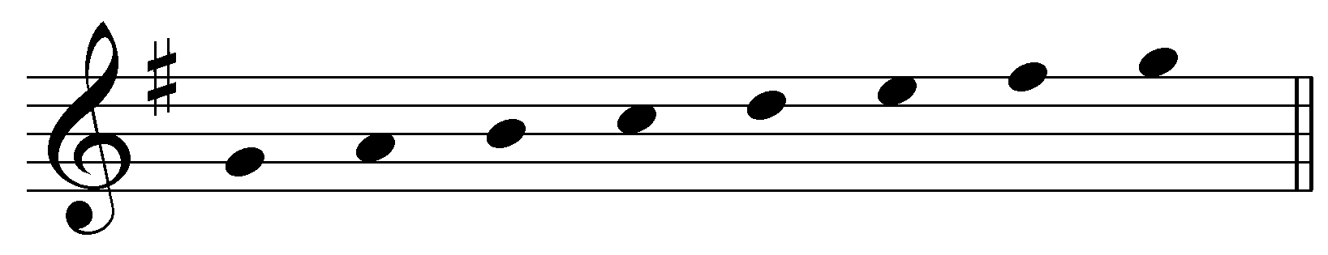
Adjust the pitches as necessary to create a G-minor scale.

Exercise 3.1b:
E^{b}-major scale:
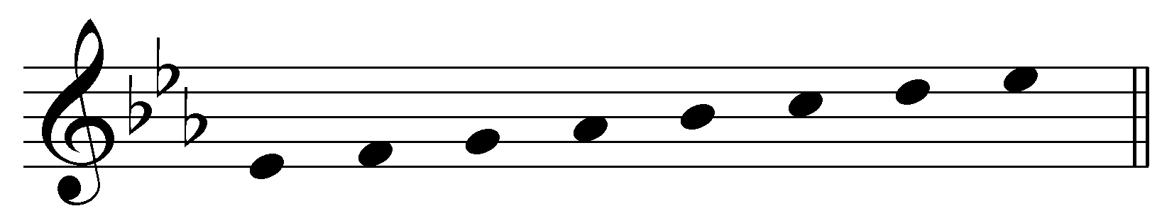
Adjust the pitches as necessary to create an E^{b}-minor scale.

Exercise 3.1c:
D-major scale:
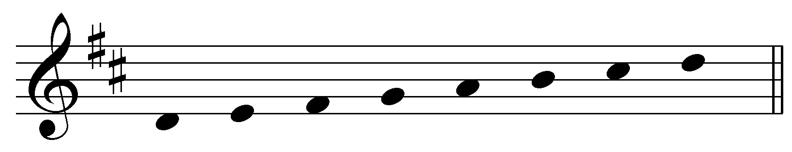
Adjust the pitches as necessary to create a D-minor scale.

Exercise 3.1d:
B^{b}-major scale:
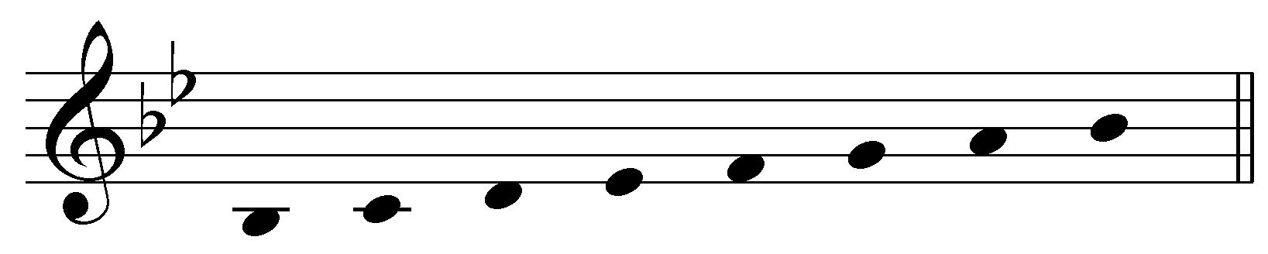
Adjust the pitches as necessary to create a B^{b}-minor scale.

The result of this construction is a different pattern of whole and half steps. While a major scale has a W-W-H-W-W-W-H pattern, the natural minor scale has W-H-W-W-H-W-W. This pattern gives the minor scale its distinctive sound.

The introduction to this unit explained that the natural (diatonic) minor scale differs from the major scale. The differences become apparent when the natural minor scale is used in common harmonic progressions. Consider the following short progression:

Example 7:
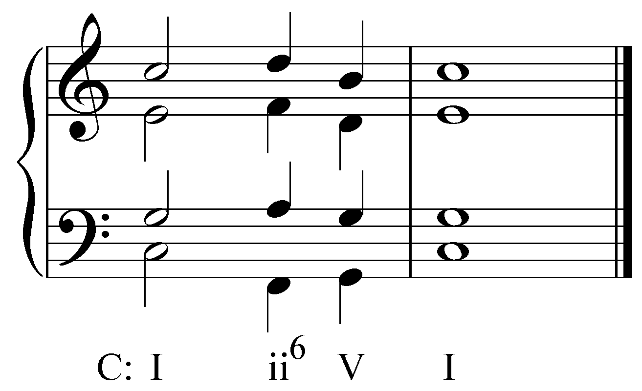

In this common cadential pattern the dominant chord—set up by the predominant ii⁶ chord—pulls strongly toward tonic. Now consider the same progression using the pitches of the diatonic minor:

Example 8:
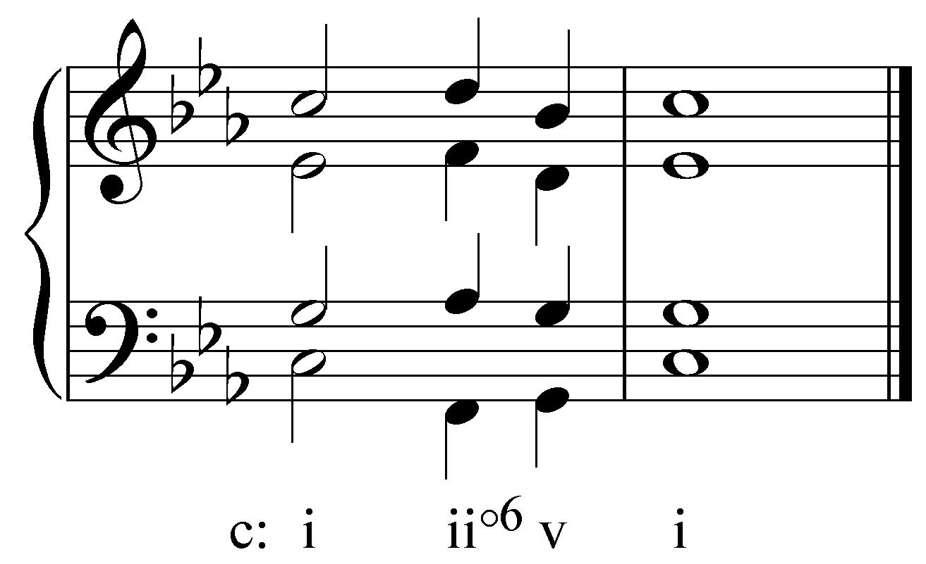

This progression sounds modal rather than tonal. Compared to Example 7, Example 8 lacks the strong pull from v to i. The reason for the lack in pull toward the tonic is the absence of a leading tone in the diatonic minor scale. Look again at Example 2 and note that the seventh scale degree is a whole step away from the tonic. The half-step relationship between the leading tone and the tonic in the diatonic major scale has a clearly perceptible directional force, while the analogous scale degrees in the diatonic minor lack that force. Because of its tendency to resolve to the tonic, the leading tone is one of the most important pitches of the major scale. Since the diatonic minor scale lacks a leading tone, the tension and pull toward the tonic are absent.

The harmonic minor composite:

The harmonic minor composite (often referred to as the “harmonic minor scale”) adjusts scale degree 7 of the diatonic minor scale in imitation of the major scale in order to create the otherwise missing leading tone. The Bb of the diatonic C minor scale is adjusted upward to B§, creating the needed leading tone, as shown here:

Example 9 (the harmonic minor composite):

The following example reproduces Example 8, this time with the leading-tone adjustment:

Example 10:
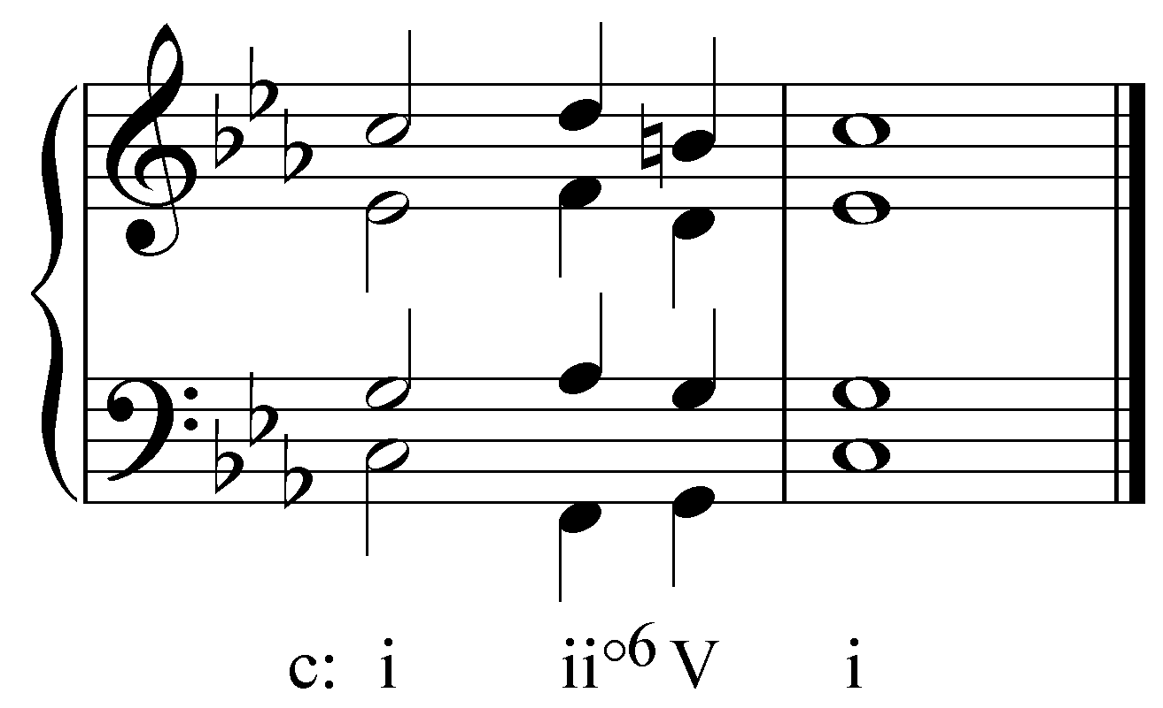

As you can hear, the presence of the leading tone in creates a stronger, satisfying sense of resolution at the arrival of tonic. The following example shows the triads built with the leading-tone adjusted harmonic minor scale:

Example 11:
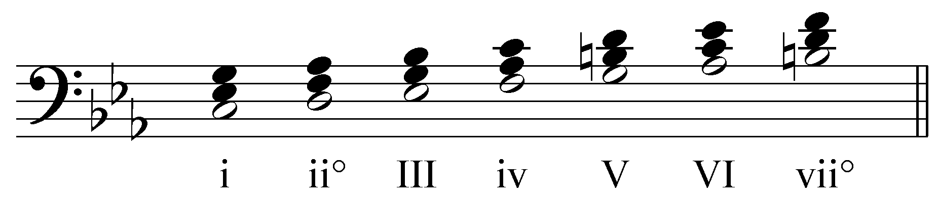

As Example 11 shows, the raised seventh scale degree applies only to the chords built on 5 and 7, both of which have a dominant function. If these chords were built using the pitches of the diatonic minor, V would be minor (v) and vii° would be major (VII). Neither v nor VII pull toward tonic as do their leading-tone adjusted forms, although both appear in other functional roles in a minor key. Listen again to Example 8 and compare it to Example 10. Which version of the V chord has a stronger pull back to tonic? The addition of a leading tone gives Example 10 a strong sense of resolution. The same would be true of a progression using vii° instead of VII.

In adjusting the diatonic minor scale by incorporating the leading tone from the major scale, we have the same V and vii° triads in minor as we do in the parallel major. The leading-tone adjustment not only strengthens the sense of tonality in a minor key, but also allows for modulation from a major key to its parallel minor, and vice versa, as we will see in later sections.

Popup box: As you may have noticed, the raised seventh scale degree does not apply to the chord built on scale degree 3. If the seventh scale degree were to be raised in a III chord, the result would be an augmented triad. The triad built on scale degree 3 is the tonic of the relative major. Having an augmented triad here would subvert this important relationship and is therefore not permitted. In this light, one should think of the harmonic minor scale not as a key in its own right, but rather a variant of the diatonic minor used at times to create a stronger sense of tonality.

Activity 3.2:
The harmonic minor composite incorporates a leading tone to give a stronger sense of tonality. In this activity you will be presented with a series of chords in minor keys. Some of these chords require a raised leading tone while others do not. Adjust the notes to incorporate a raised leading tone where appropriate. If no adjustments are required, click “No Change.”

[Incorrect answer response: “Try again. Remember, in the harmonic minor composite the leading tone is raised for chords built on scale degrees 5 and 7.]

Exercise 3.2a:
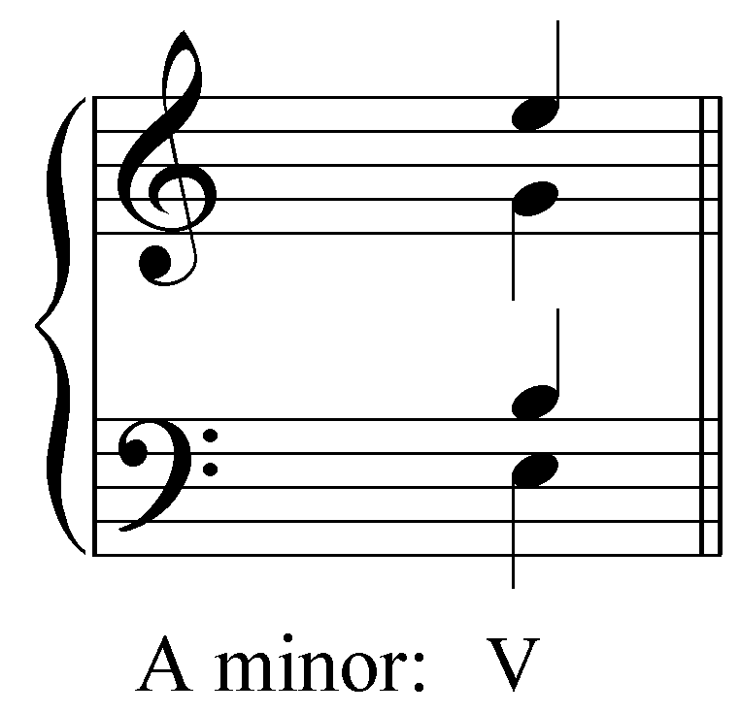
Does this chord require any adjusted notes? If so, adjust the notes where necessary to reflect the harmonic minor composite. If not, click “No Change.”

Exercise 3.2b:
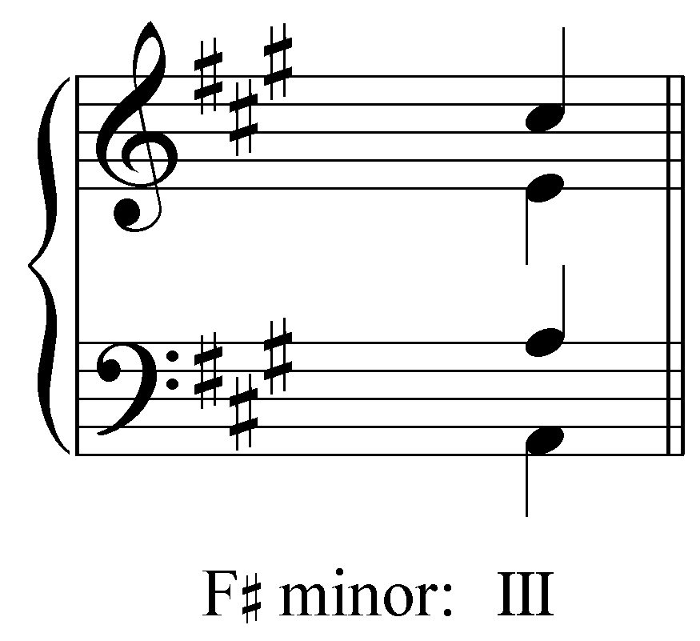
Does this chord require any adjusted notes? If so, adjust the notes where necessary to reflect the harmonic minor composite. If not, click “No Change.”

Exercise 3.2c:
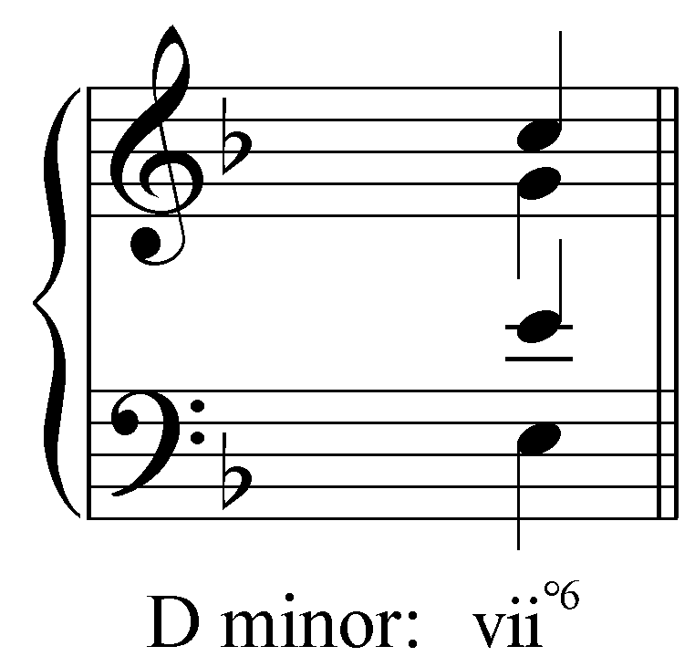
Does this chord require any adjusted notes? If so, adjust the notes where necessary to reflect the harmonic minor composite. If not, click “No Change.”

Exercise 3.2d:
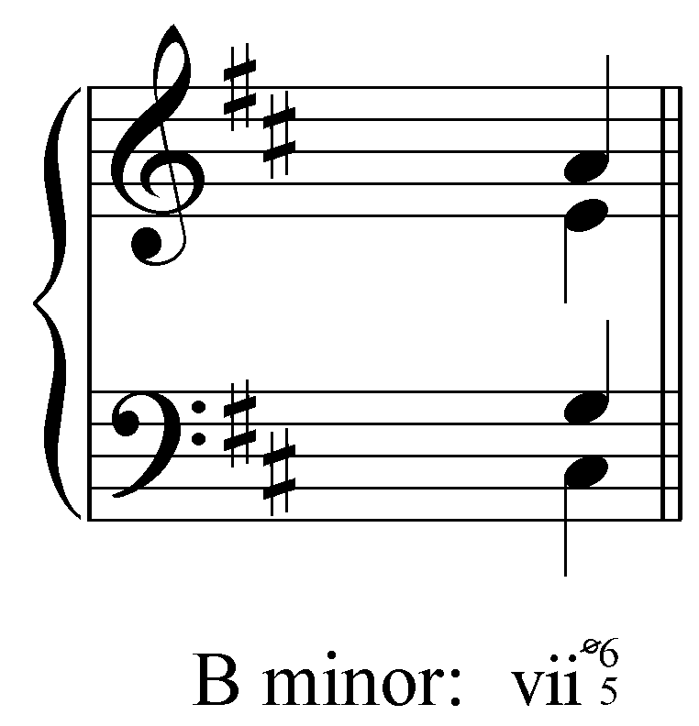
Does this chord require any adjusted notes? If so, adjust the notes where necessary to reflect the harmonic minor composite. If not, click “No Change.”

Exercise 3.2e:
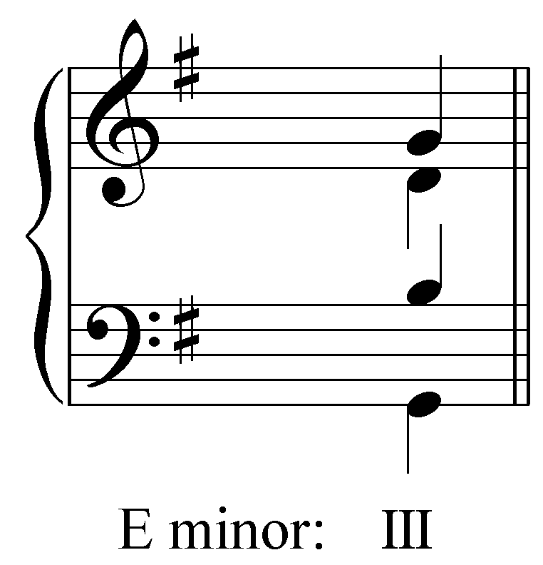
Does this chord require any adjusted notes? If so, adjust the notes where necessary to reflect the harmonic minor composite. If not, click “No Change.”

Exercise 3.2f:
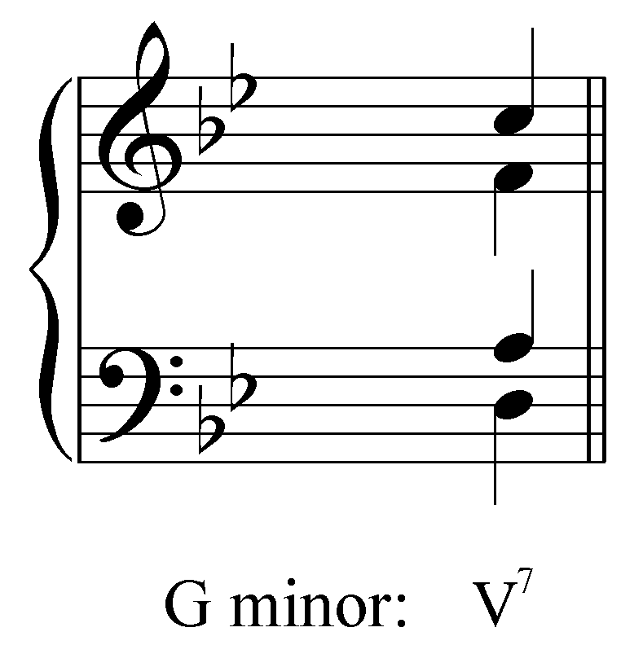
Does this chord require any adjusted notes? If so, adjust the notes where necessary to reflect the harmonic minor composite. If not, click “No Change.”

The melodic minor composite:

The melodic minor composite (often referred to as the “melodic minor scale”) provides a further modification of the diatonic minor to accommodate certain melodic circumstances. As with the harmonic minor composite, the melodic minor has a leading-tone adjustment. The raised seventh scale degree serves the same purpose as in the harmonic minor composite: it creates a pull toward the tonic. Just as the V chord in Example 7 resolves to tonic harmony, the leading tone of the melodic minor scale resolves to scale degree 8. This type of goal-directed melodic motion is at the heart of tonal music.

Raising scale degree 7 to create a leading tone, however, creates a melodic problem: an augmented second appears between the sixth and seventh scale degrees:

Example 12:
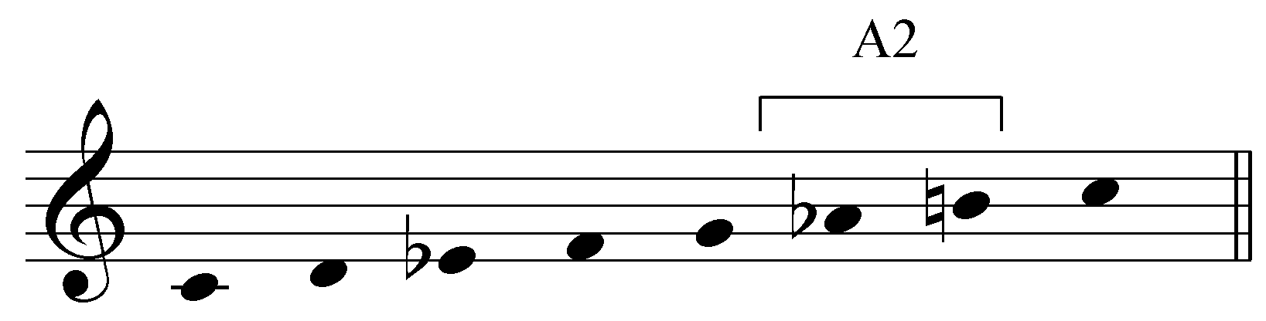

Augmented intervals are difficult to sing, sound awkward in the tonal style, and are therefore generally avoided. In the harmonic minor composite, the augmented second disrupts the otherwise smooth flow of half and whole-step motion in the melodic ascent. Furthermore, scale degree 6 in minor is a half-step away from scale degree 5 and thus tends strongly toward scale degree 5. By raising scale degree 6, we avoid both of these issues. The interval between 6 and 7 contracts to become a major second, thereby smoothing out the melodic line, and the whole-step distance between 5 and 6 eliminates the downward pull of 6 toward 5. Scale degrees 6 and 7 in minor appear in diatonic or adjusted form depending on several factors, primarily the harmonic context. The form used must be explained on a case-by-case basis. For demonstration purposes, Example 13 summarizes the harmonic minor composite scale, with the adjusted forms of scale degrees 6 and 7 in the scalar ascent, and the diatonic forms of those degrees in the descent.

Example 13:

Activity 3.3:
Like the harmonic minor composite, the melodic minor composite sometimes incorporates a leading tone to create a pull towards the tonic. To avoid the augmented interval between the submediant and the leading tone, the melodic minor composite will raise scale degree 6. In this activity, you will be presented with a series of diatonic minor scales. For each example, change scale degrees 6 and 7 to conform to the adjustments made in the melodic minor composite.

Exercise 3.3a:
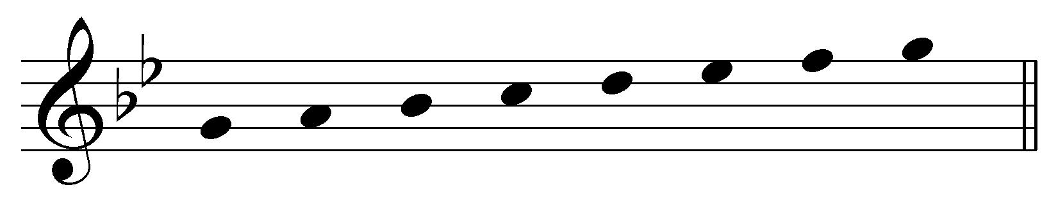
Change scale degrees 6 and 7 to conform to the adjusted melodic minor composite.

Exercise 3.3b:
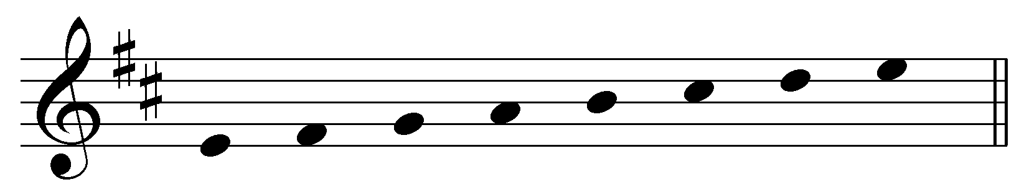
Change scale degrees 6 and 7 to conform to the adjusted melodic minor composite.

Exercise 3.3c:
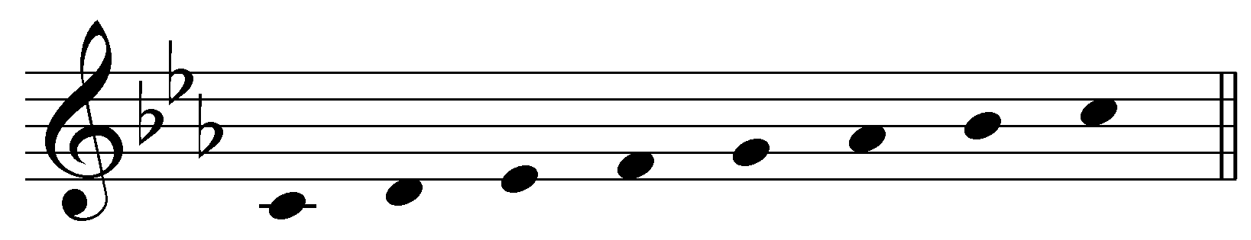
Change scale degrees 6 and 7 to conform to the adjusted melodic minor composite.

Exercise 3.3d:
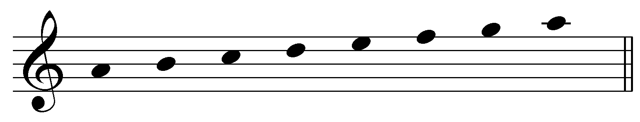
Change scale degrees 6 and 7 to conform to the adjusted melodic minor composite.

Conclusion:

The minor mode is less straightforward than the major mode. It consists of a primary form, the diatonic minor (also known as the “natural minor”), and two composite forms that incorporate elements of the diatonic major scale. Because the diatonic minor scale lacks a leading tone, it does not allow for the all-important cadential progression of dominant to tonic in tonal music. In order to allow for that vital progression in a minor key, scale degree 7 of the diatonic minor is adjusted (raised by a half step) to create a leading tone, in imitation of the major scale, resulting in a composite scale commonly known as the harmonic minor. Another composite minor scale, commonly known as the melodic minor, adjusts scale degree 6 upward in addition to raising scale degree 7 in order to eliminate the awkward augmented second between 6 and 7, and to smooth out melodic motion between scale degree 5 and 8. Scale degrees 6 and 7 can also be restored to their diatonic form in scalar descents.
It is important to remember that the natural (diatonic) minor scale is the basis of the two composite forms of the minor scale. The diatonic minor scale constitutes a key, the counterpart of the major key. The harmonic and melodic minor composites do not constitute independent keys. Rather, they are mixed-mode scales featuring adjustments to diatonic degrees 6 and 7 to suit the harmonic and melodic context.

