Lesson BBB – Three- and Four-Voice Progressions

Introduction:

In this follow-up to Lesson AAA (Basic Interval Progressions), you will first be given an opportunity to expand basic interval progressions by adding a third voice. While four-part, SATB textures are much more common, working with three voices will raise your sensitivity to the behavior of interval progressions in tonal music.

Once the three-part texture is secure, we will add a fourth voice to see how the principles apply to SATB part-writing. Finally, a chorale by J.S. Bach will be analyzed to show how interval progressions work in traditional repertoire.

Basic interval progressions in three voices:

As mentioned in the introduction, three-voice textures will provide a helpful intermediate step on the way to handling four-voice textures. Working initially with three voices will clarify how the basic interval progressions behave in settings of more than two voices. The examples below will begin with a two-voice, soprano/bass framework. We will then add a third voice, creating standard interval progressions with these framing voices. Since there are only three voices, it will be easy to see all of the contrapuntal relationships between voice pairs.

This part of the lesson is broken into three sections examining three common types of progressions. These three types are based on root motion between two chords: by fifth (as in V - I), by third (as in I - vi or I - iii) and by step (as in IV – V).

Root motion by fifth:

We begin with the following example of a V - I progression:

Example 1:
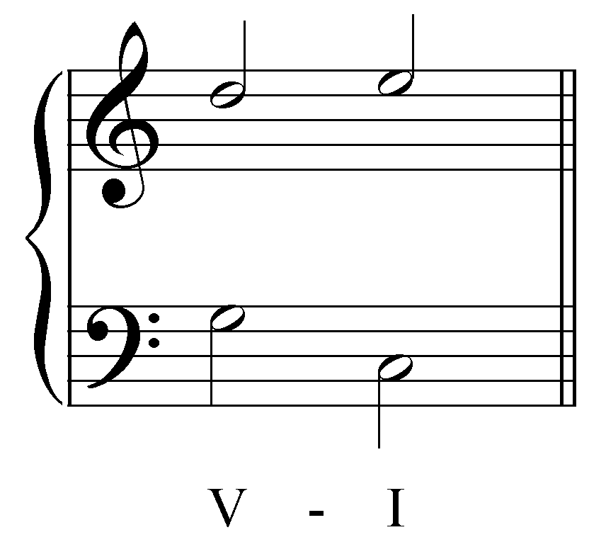

Above, you see a common interval progression in two voices. Roman numerals indicate which chords are used. V - I is a progression which illustrates root movement by fifth. We will now add a third, inner voice to this progression. The movement of the third voice will be decided by the standard interval progressions.

There are two important constraints to follow when adding a third voice:

- The added pitches must be members of the given chords. (In this case, for example, the added voice above the “V” must be a member of the V chord: G, B, or D. The added voice above the “I” chord must likewise be a C, E, or G.)
- The added pitches must form valid interval progressions with at least one of the given voices.

For the time being, since we are only working with three voices, do not worry about creating complete triads. Tripled roots and open-fifth sonorities are acceptable for now. Complete triads will be important further on, when we create four-voice textures. Try to include the third of the triad whenever possible while creating valid interval progressions. The result will be a richer, fuller harmony.

Keeping the above two constraints in mind, let us try adding a third voice to the Example 1. As mentioned above, try to include the third of the triad whenever possible. Let us start by adding a B to the V chord:

Example 2:
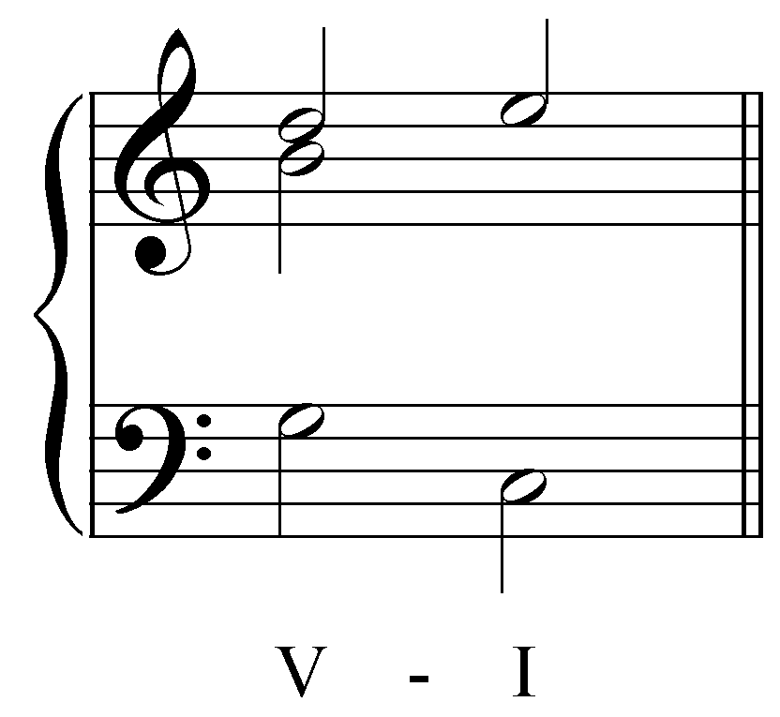

The next step, after picking a first pitch, is to survey the list of standard interval progressions. By adding a B to the V chord, we’ve created an interval of a third with the soprano voice. On the next beat, the soprano ascends away from the middle voice. Ask yourself which of the standard interval progressions begins with a third. “3 - 1” begins with a third, but since the soprano in our example ascends, the two parts cannot converge onto a unison. What about a “3 - 5” progression?:

Example 3:
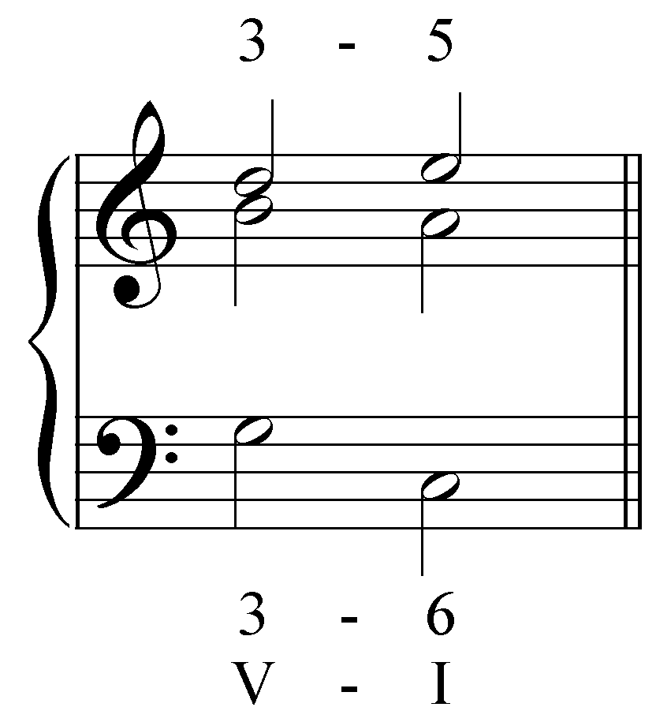

At first glance, this might seem like a good answer. But remember, one of the two constraints requires that added voices must be members of the given chords. The pitch A is not a member of the I chord, so B - A is not a valid inner voice.

What if our middle voice ascended by step, forming parallel thirds with the soprano?

Example 4:
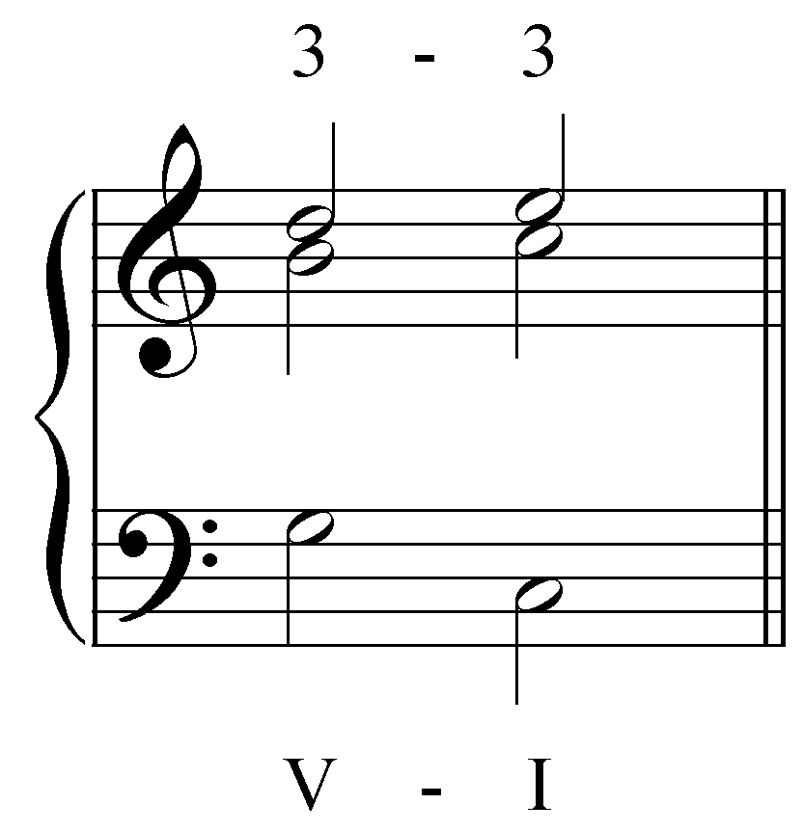

In this case, both of the added pitches are chord members: B is the third of V and C is the root of I. The 3 - 3 progression is also valid. Furthermore, B is the leading tone of C major and has a tendency to resolve to the tonic C. (We will return to the concept of tendency tones later on in Lesson EEE: The Dominant Seventh Chord.)

What if we chose a different starting pitch for our added voice? Let us try to find a valid middle voice that begins with G, the root of the V chord:

Example 5:
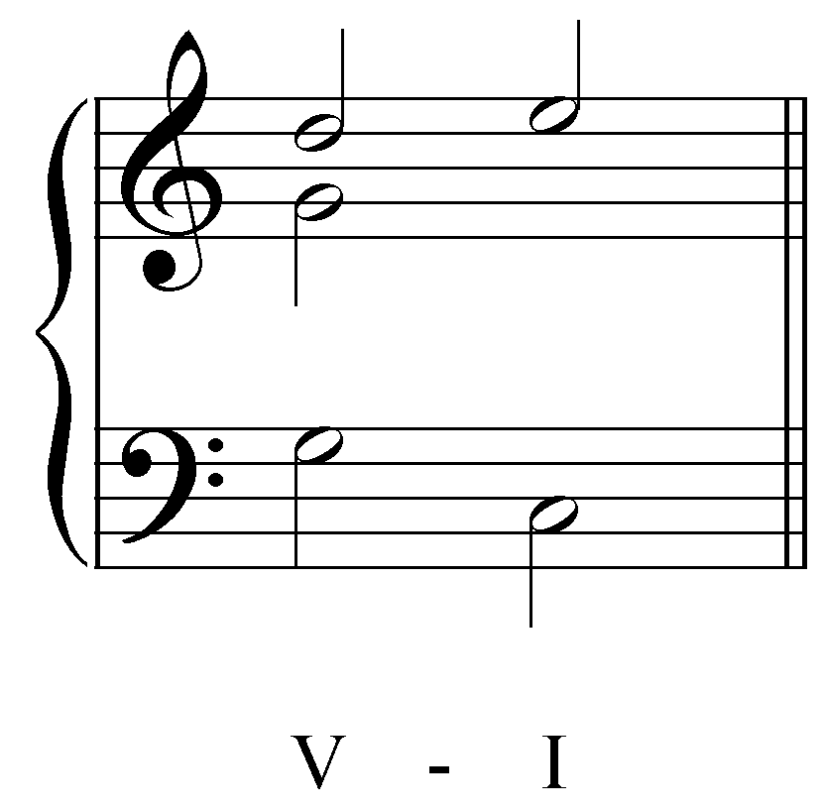

This G forms a fifth with the upper voice. What are some potential interval progressions that begin with a fifth and have the upper voice ascending by step? We know that the added voice cannot also ascend by step, because this would lead to parallel fifths, one of the forbidden interval progressions. One possibility is the oblique “5 - 6” progression:

Example 6:
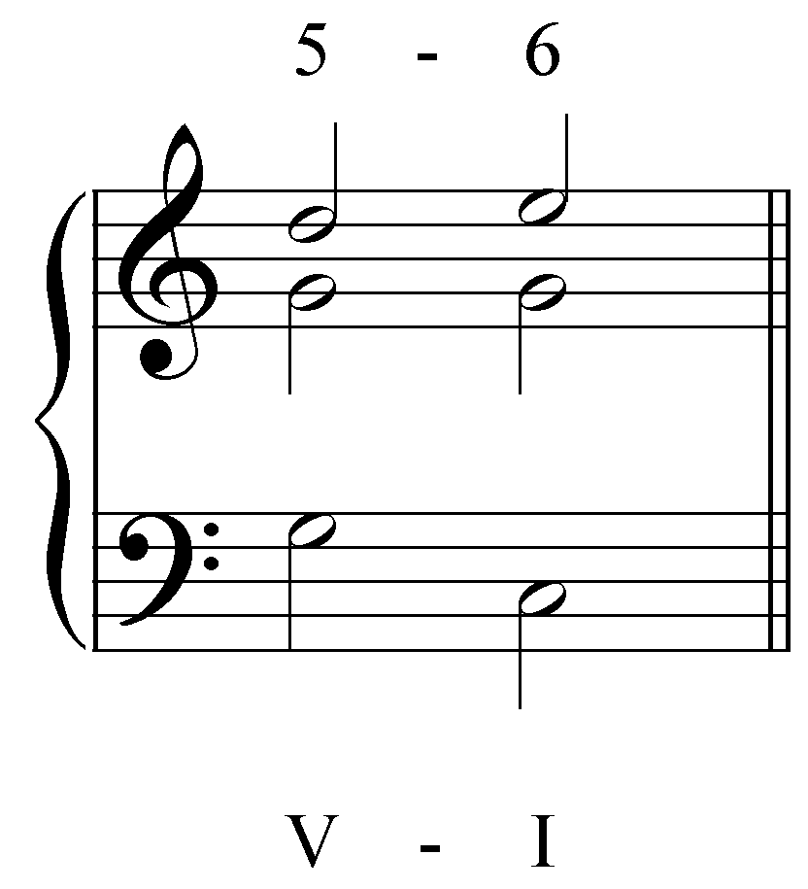

In this case, the added voice maintains the pitch G, which is a member of both the V and I chords. This is a valid added voice.

Activity 2.1:
As you will see with multi-voice progressions, there is often more than one possible outcome for a given setup. Taking the setup from Example 5, can you think of another pitch (other than sustaining G) that the middle voice could move to?

[Students enter answer onto score. Answer: up a fourth to C. Response if correct: “Correct! The middle voice could move from G up a fourth to C, creating a “5 - 3” progression with the soprano.” Response if student goes down a third to E: “Moving down to E will create a “5 - 8” progression with the soprano. While the “5 - 8” progression is valid, it is typically found between the bass and one of the upper voices. Try again.” Response if student goes to any other C, E, or G: “That pitch does belong to the I chord, but does not create valid interval progressions with the outer voices. Try again.” Response if student enters any other pitch: “That pitch does not belong to the I chord in C major. Try again.”

Now we will add a middle voice to a slightly longer passage. Here we have a short progression of four chords, each with falling-fifth root motion:

Example 7:
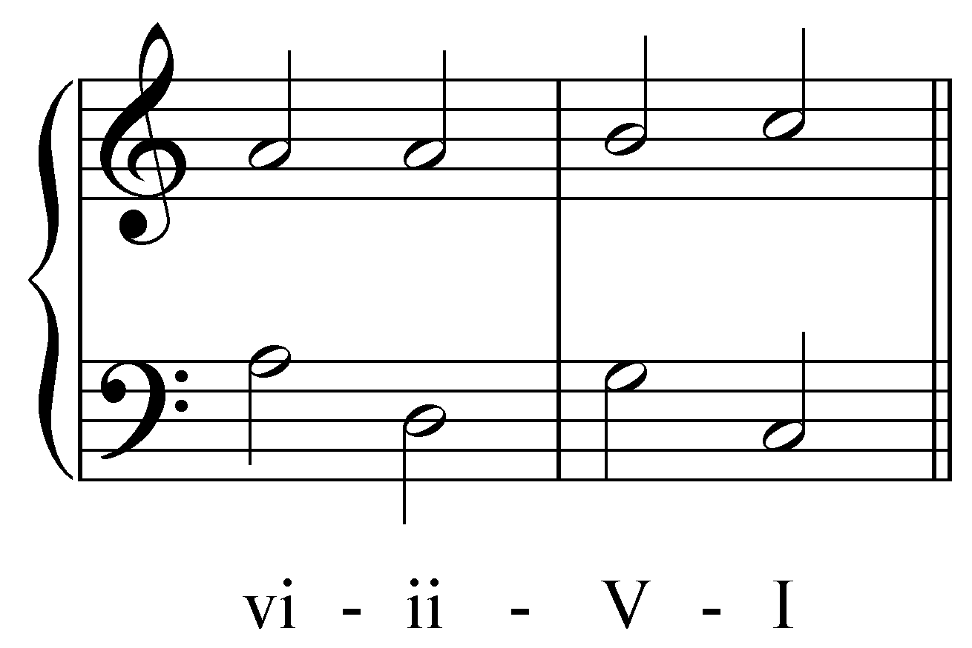

Let us begin by adding a C as a middle voice, creating a sixth with the soprano:

Example 8:
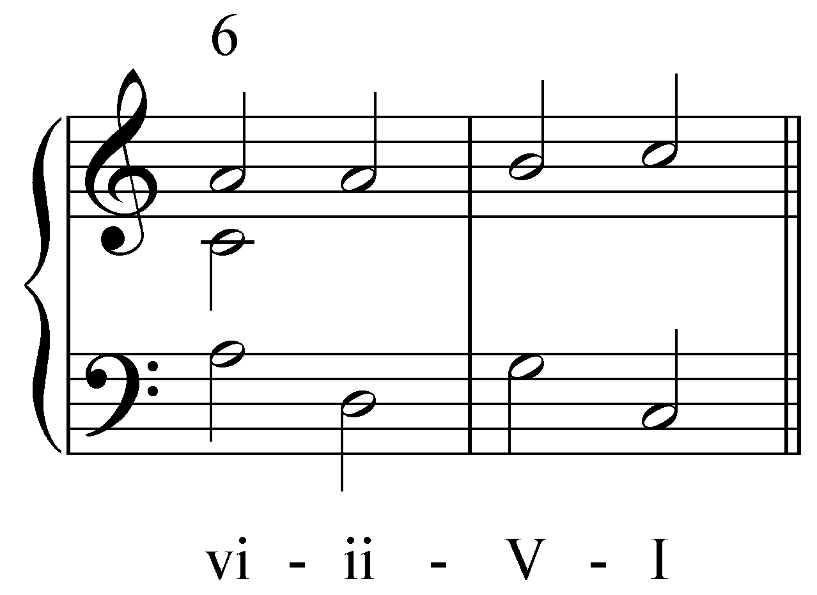

We can see that on the next beat, the soprano sustains its A. With this sustained pitch, we know that the interval progression must have oblique motion. What is the only standard interval progression that exhibits oblique motion?

Activity 2.2:
What is the only standard interval progression that exhibits oblique motion?
[Answer: “5 - 6” or “6 - 5.” Response if correct: “Correct!” Response if incorrect: “Incorrect. Try again.”]

The sixth must contract to a fifth:

Example 9:
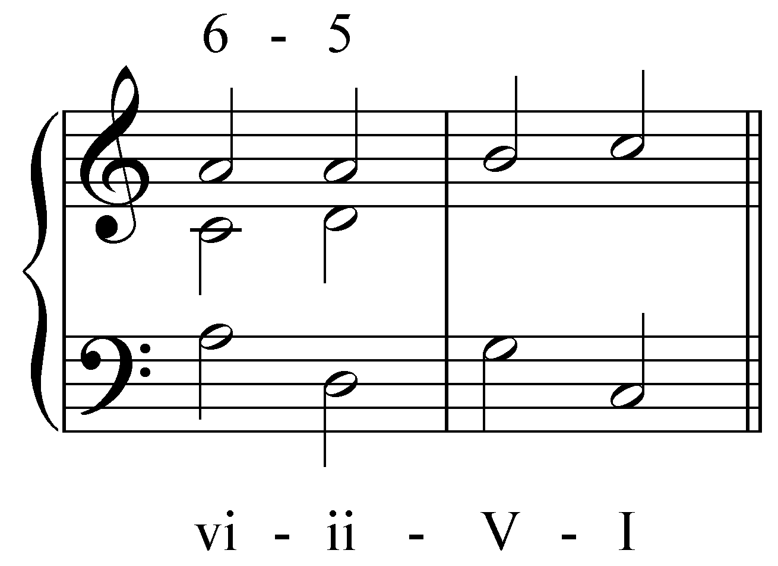

In the next step, from the ii chord to the V chord, the soprano ascends by step. Using basic interval progressions, what pitches could the middle voice move to and be a member of the V chord?

Activity 2.3:
Using basic interval progressions, what pitch could the middle voice move to and be a member of the V chord?

[Answer: hold on D. Response if correct: “Correct! By sustaining D, the middle voice creates another oblique interval progression with the soprano.” Response if student goes up a fourth to G: “This is a valid interval progression with the soprano (“5 - 3”), but beware of the parallel octaves created with the bass. Think of another answer and try again.” Response if student goes down a third to B: “This creates a valid interval progression with the soprano (“5 - 8”), but it creates a doubled leading tone, B. Both Bs above the V chord will have a strong pull to C which would in turn create parallel octaves between the soprano and the middle voice. Think of another answer and try again.” Response for any other G, B, or D: “This pitch does belong to the V chord, but does not create valid interval progressions with the outer voices. Try again.” Response for any other pitch: “That pitch does not belong to the V chord in C major. Try again.”]

The best option is for the middle voice to remain on D, creating another oblique “5 - 6” progression with the soprano:

Example 10:
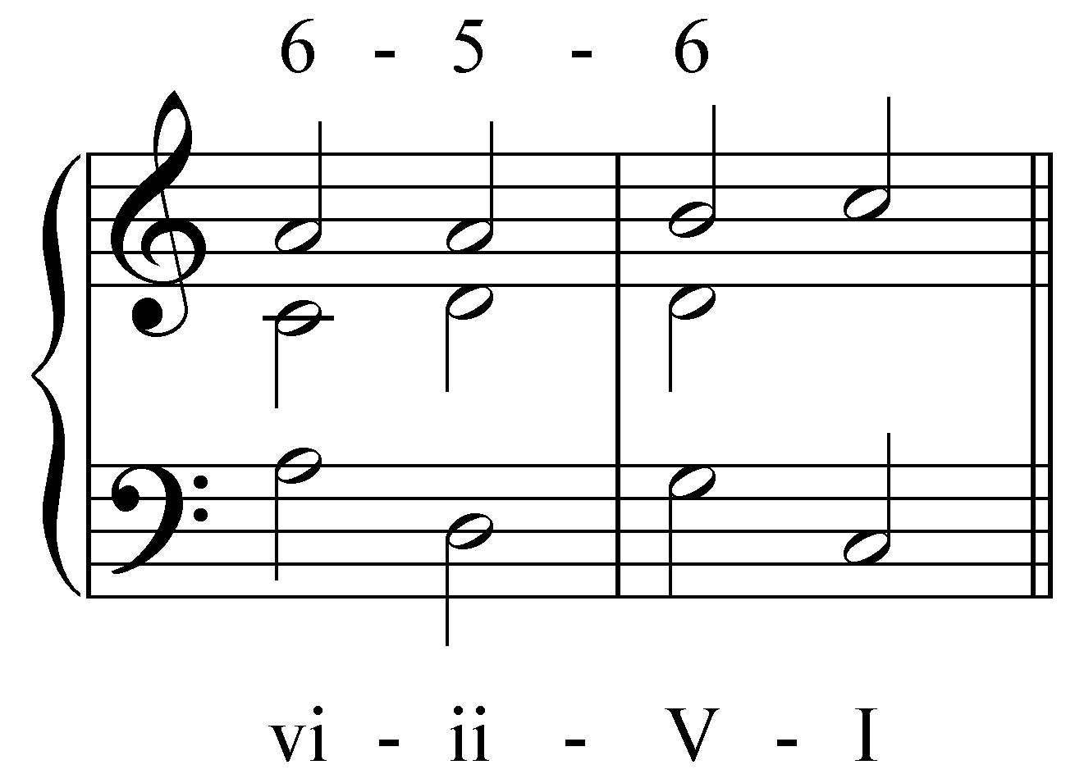

Finally, as the progression moves from V to I, the soprano ascends from the leading tone to the tonic pitch. There are two valid pitches that the middle voice could move to, what are they?

Activity 2.4:
There are two valid pitches that the middle voice could move to, what are they?

[There should be two answer fields so that students can enter both answers. Answers: up a step to E and down a step to C. Response if student moves up a step to E: “Correct! Stepping up to E creates parallel sixths with the soprano.” Response if student moves down a step to C: “Correct! Stepping down to C creates a “6 - 8” with the soprano and a “5 - 8” with the bass.” Response for any other C, E, or G: “This pitch does belong to the I chord, but does not create valid interval progressions with the outer voices. Try again.” Response for any other pitch: “That pitch does not belong to the I chord in C major. Try again.”]

Of the two options, E or C, C is the better choice because of the stronger sense of resolution created by the valid interval progressions with both the soprano and the bass:

Example 11:
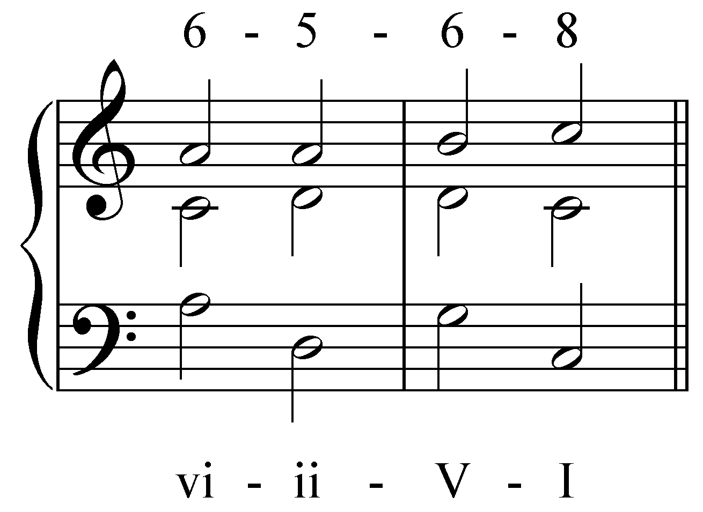

Root motion by third:

So far, all of the progressions to which we’ve added a third voice have had root motions of a fifth. Let us now try adding a voice to a progression in which the roots move by a third:

Example 12:
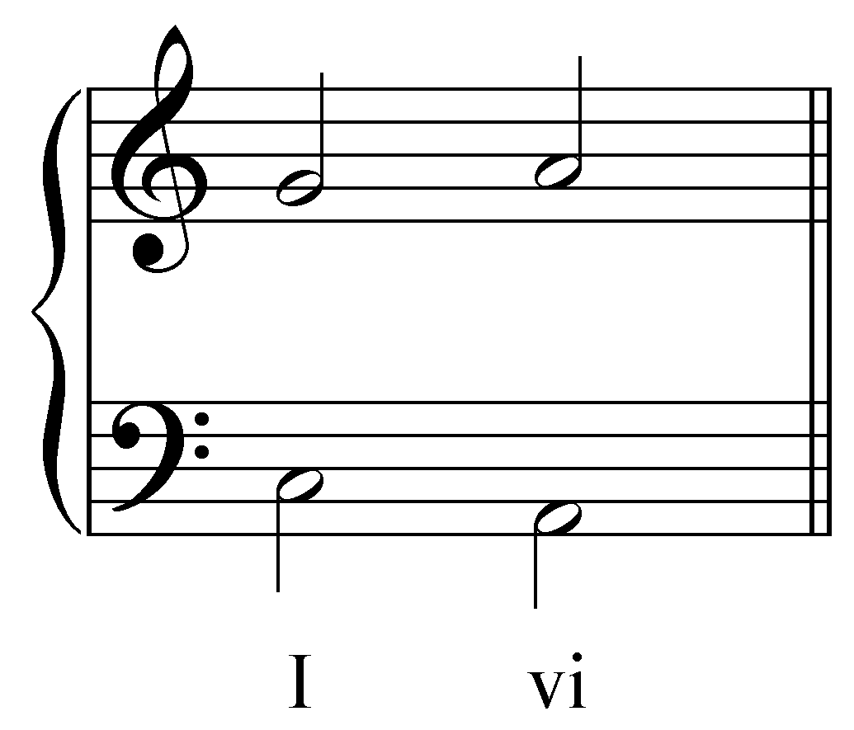

As mentioned above, it is a good idea to include the third of the chord whenever possible. Here, we’ve added the third of the I chord (E) as the middle voice:

Example 13:
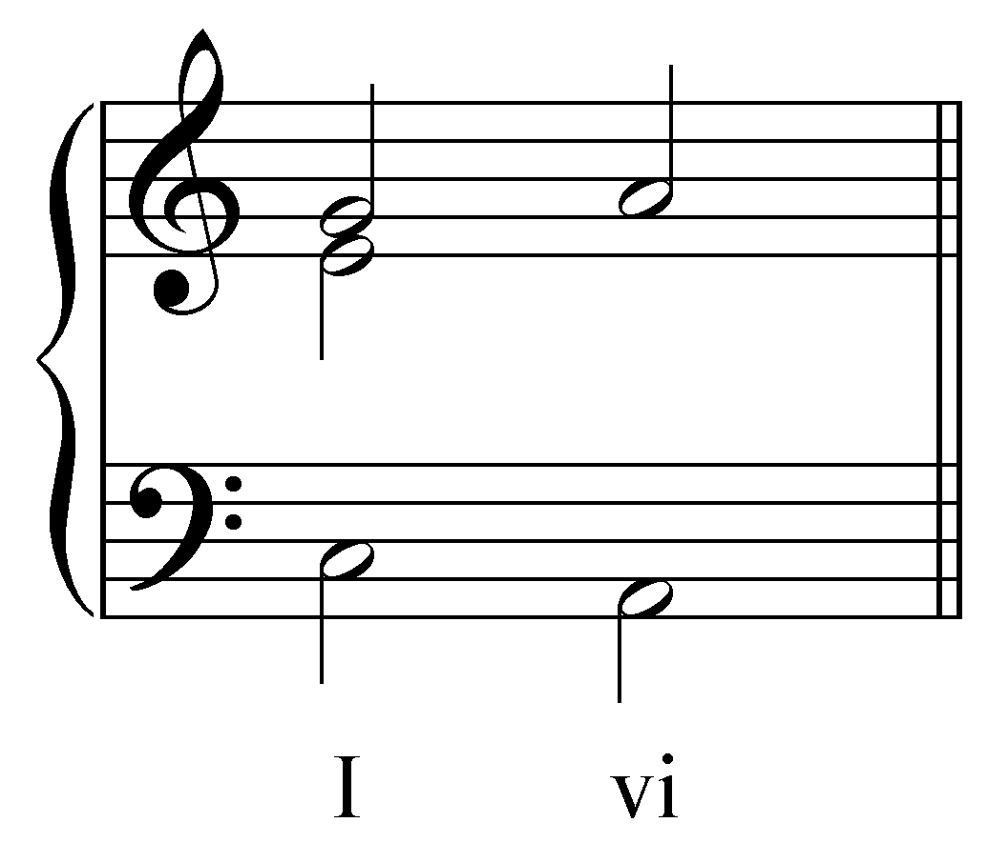

What pitch could the middle voice move to that both belongs to the chord and forms valid interval progressions?

Activity 2.5:
What pitch could the middle voice move to that both belongs to the chord and forms valid interval progressions?
[Answer: down a third to C. Response if correct: “Correct! This is the best choice since it is a member of the vi chord and creates valid interval progressions with both the bass (“3 - 3”) and the soprano (“3 - 6”).” Response for any other A, C, or E: “This pitch does belong to the vi chord, but does not create valid interval progressions with the outer voices. Try again.” Response for any other pitch: “That pitch does not belong to the vi chord in C major. Try again.”]

C is the best choice, forming a “3 - 3” progression with the bass and a “3 - 6” with the soprano:

Example 14:
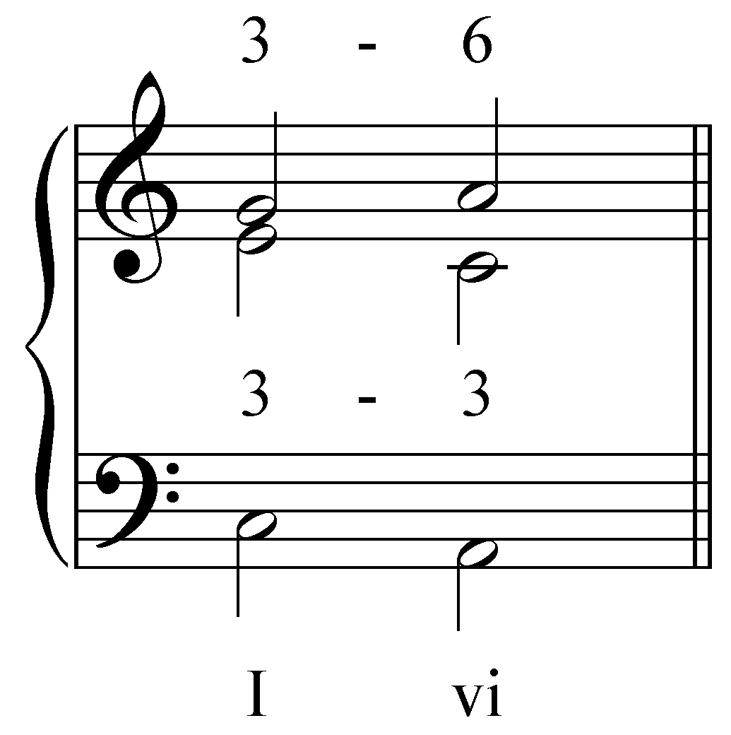

The same process could be applied to a progression in which the root motion ascends by a third. The following example shows a completed, three-voice progression:

Example 15:
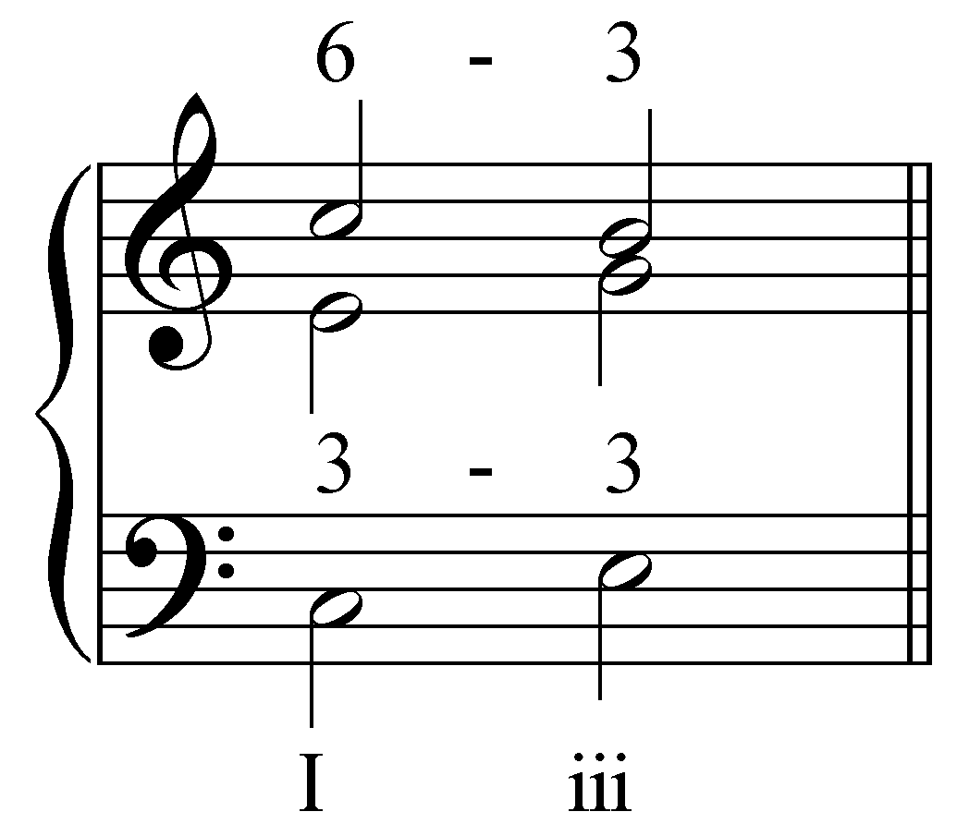

Here, the root-progression movies up by a third from I to iii. The outer voices form the familiar “8 - 5” progression. To these, an inner voice has been added, consisting of the third of the I chord (E) moving to the third of the iii chord (G). This inner voice forms valid interval progressions with both the soprano (“6 - 3”) and the bass (“3 - 3”).

Root motion by step:

Finally, there is one other type of progression to consider: root motion by step (step progression). This type of progression is slightly more difficult because of a greater risk of forbidden parallel fifths and octaves. Let us start with a typical step progression:

Example 16:
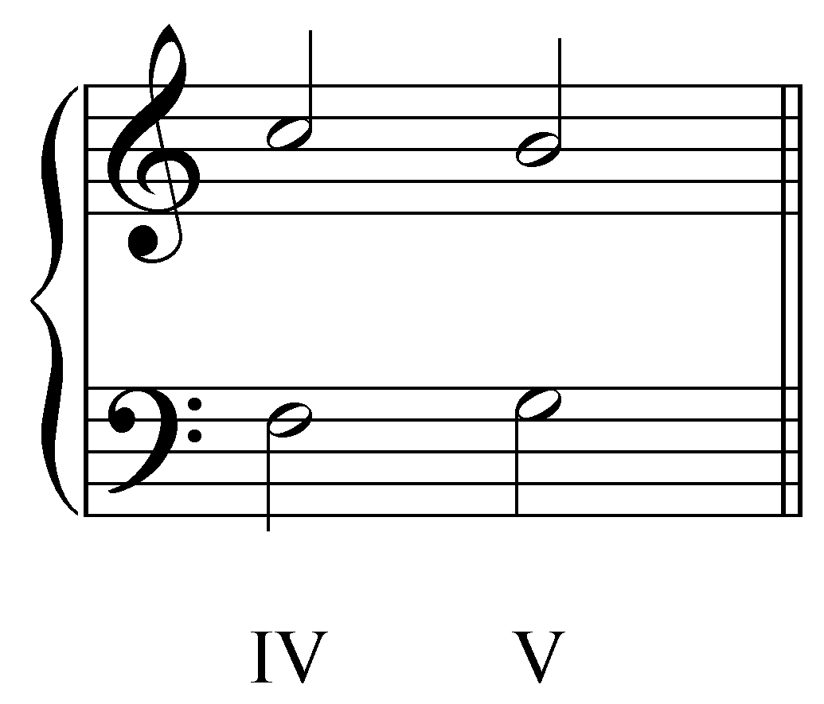

Here we have a IV - V progression with the outer voice framework forming a “5 - 3” progression. Let’s try adding a middle voice beginning on F:

Example 17:
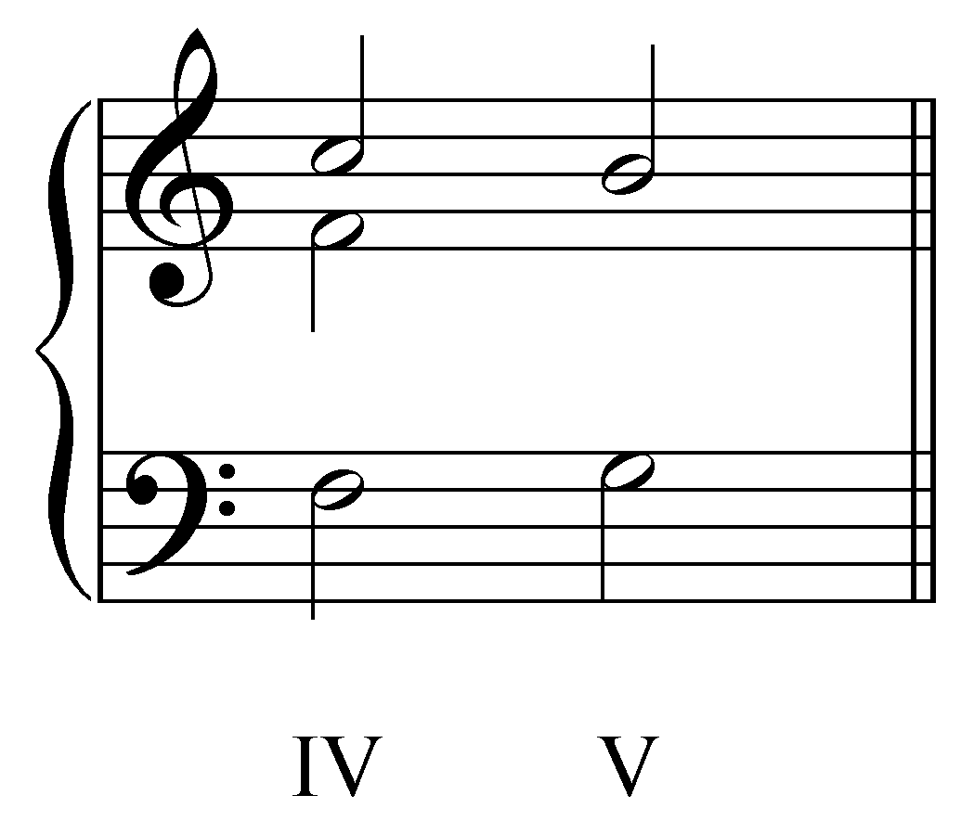

Noting the fifth that this F creates with the soprano, it might be tempting to have the middle voice ascends to form a “5 - 3” progression with the soprano:

Example 18:
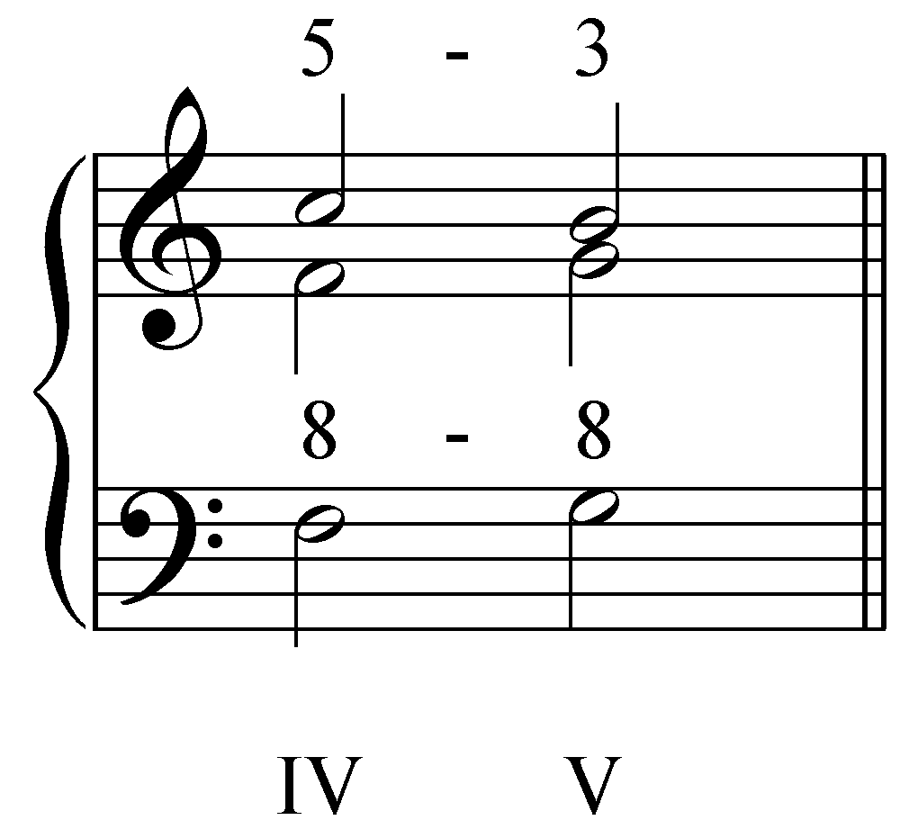

While the two upper voices form a valid interval progression, this motion in the middle voice creates forbidden parallel octaves with the bass. As noted above, parallel fifths and octaves are a common threat in step progressions. The best way to avoid those forbidden interval progressions is to strive for contrary motion between the bass and the upper voices. In this case, the middle voice may descend to D:

Example 19:
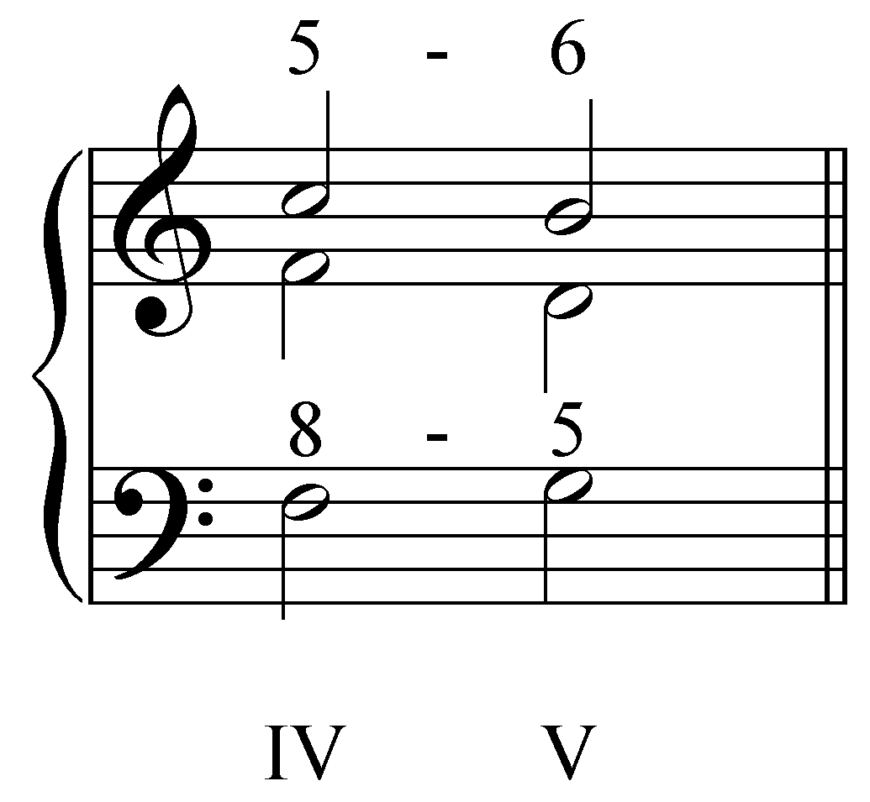

Having the middle voice descend from F to D creates valid interval progressions with both the bass and soprano.

Activity 2.6:
The progression given in Example 16 could also have a middle voice beginning on A (the third of the IV chord). What member of the V chord could this A move to while forming valid interval progressions?

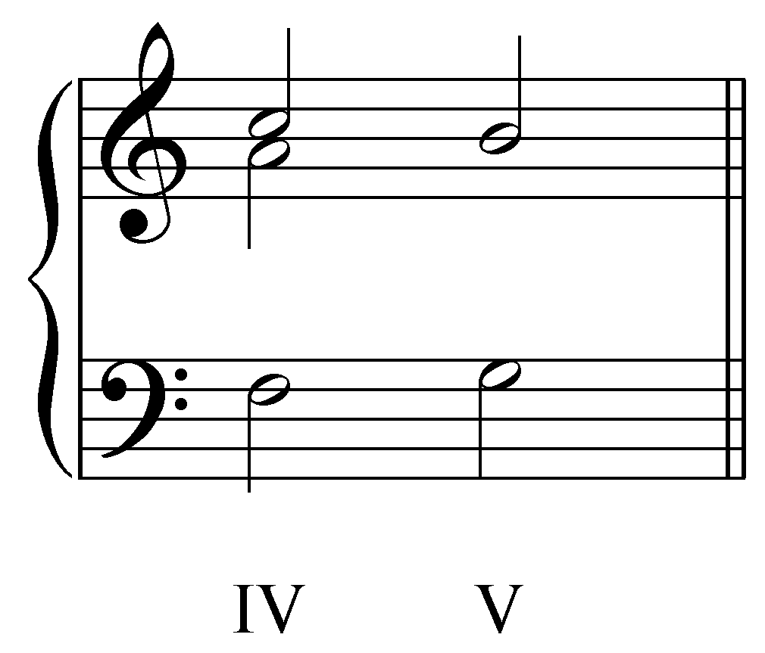
[Answer: down a step to G. Response if correct: “Correct! Stepping down to G will create valid interval progressions with the soprano (“3 - 3”) and the bass (“3 - 1”).” Response if student steps up to B: “While this may seem to be a valid answer (it creates valid interval progressions with both the bass and the soprano), it leads to a doubled leading tone in the V chord. Since B has such a strong pull to C in C major, this will lead to a parallel unison. Try again.” Response for any other G, B, or D: “This pitch does belong to the V chord, but does not create valid interval progressions with the outer voices. Try again.” Response for any other pitch: “That pitch does not belong to the V chord in C major. Try again.”]

Basic interval progressions and four-part textures:

The principles outlined above form the foundation of voice leading in tonal music. To demonstrate, we will now examine several chorale-style SATB passages to see how standard interval progressions work in a four-voice texture. Consider, for example, the following four-voice progression:

Example 20:
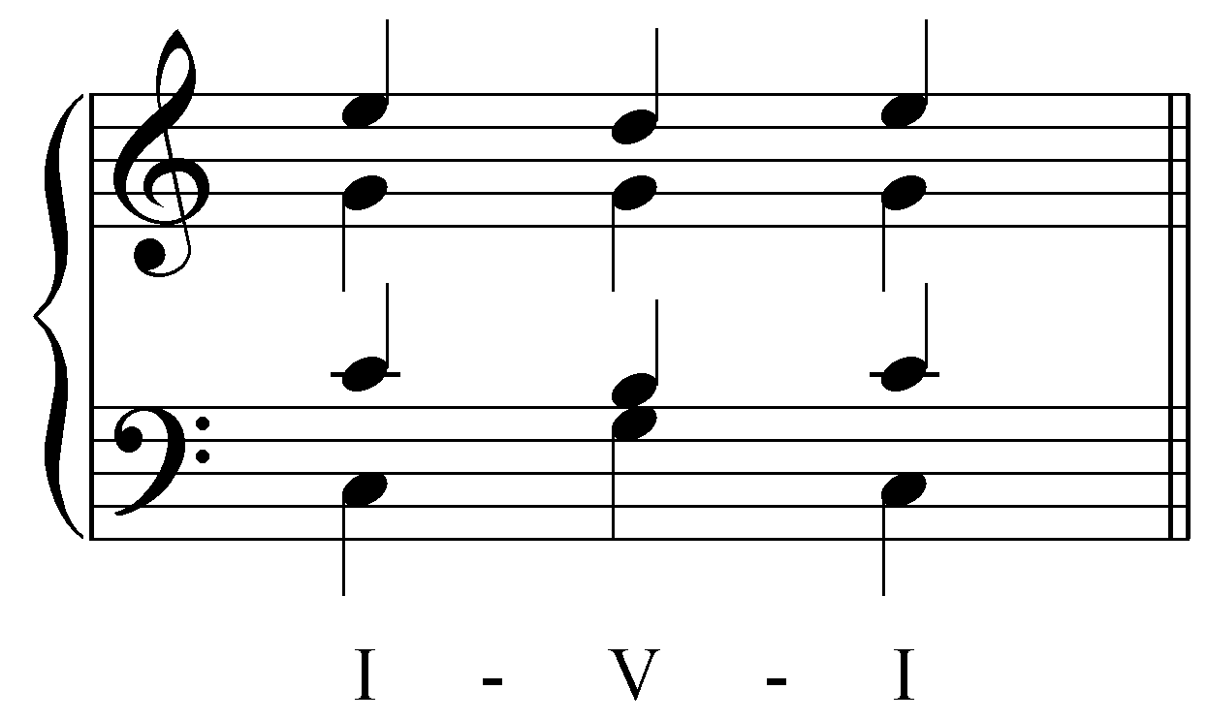

This short passage can be broken down to show that each inner voice forms a standard interval progression with another voice. Let us begin with just the outer voices:

Example 21:
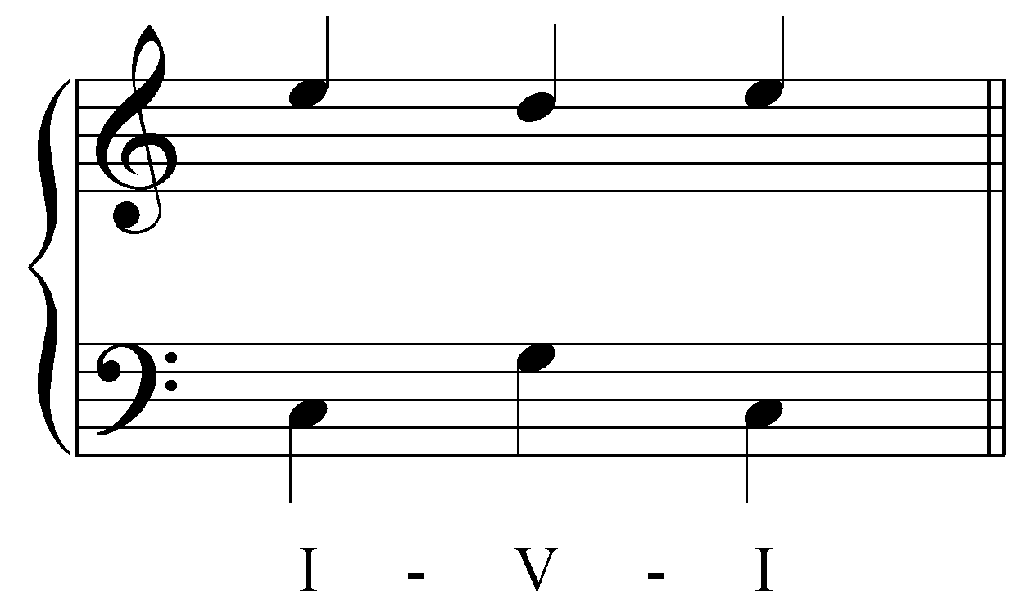

This is a very common outer-voice framework for a I - V - I progression. We can add an inner voice by having the soprano voice act as the upper part of a standard interval progression. In the following example, the alto voice is added, forming first a 6 - 5 progression with the soprano and then a 5 - 6:

Example 22:
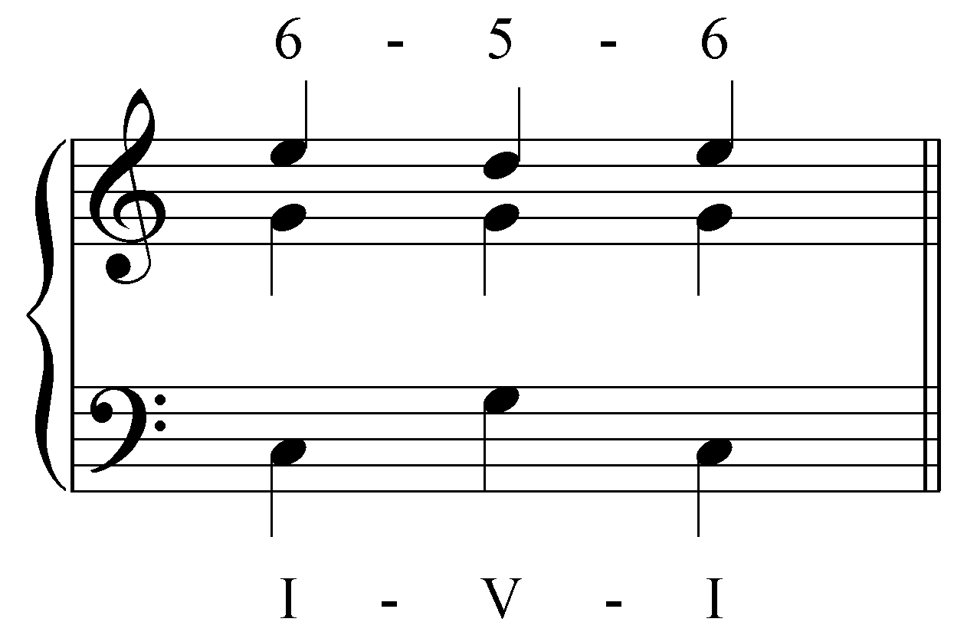

The tenor voice can be added in a similar way. In this case, the tenor follows the soprano in parallel tenths:

Example 23:
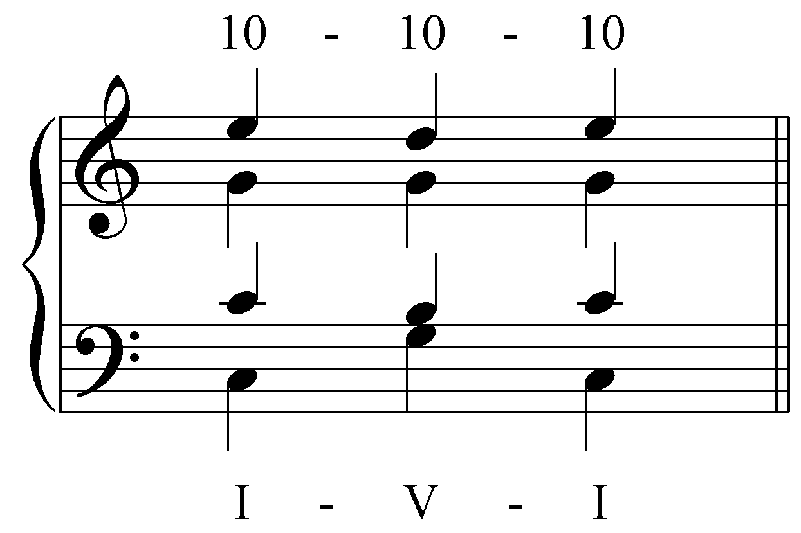

And so we have created a four-voice texture for this I - V - I progression. It is worth noting that the intervals between the tenor and alto also follow a standard interval progressions (5 - 6 - 5). This will not always be the case. Consider the following example:

Example 24:
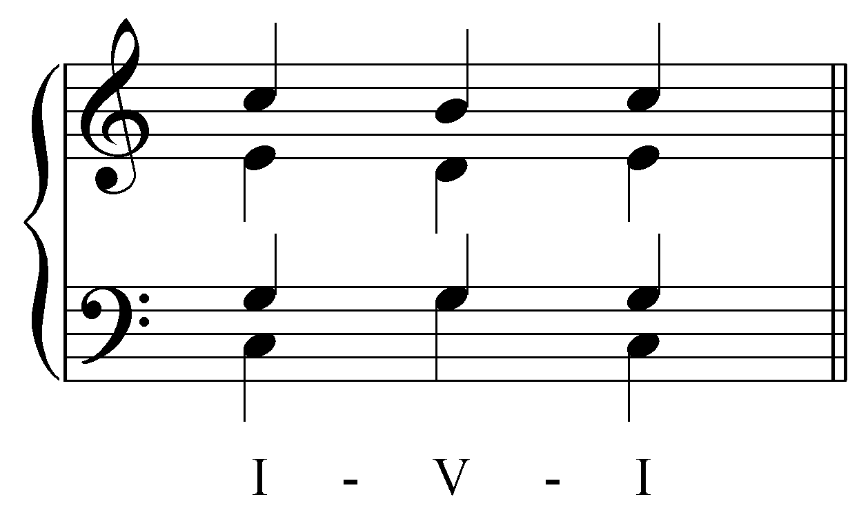

Just as with Example 23, the added voices form standard interval progressions. In this case, the alto part creates parallel sixths with the soprano:

Example 25:
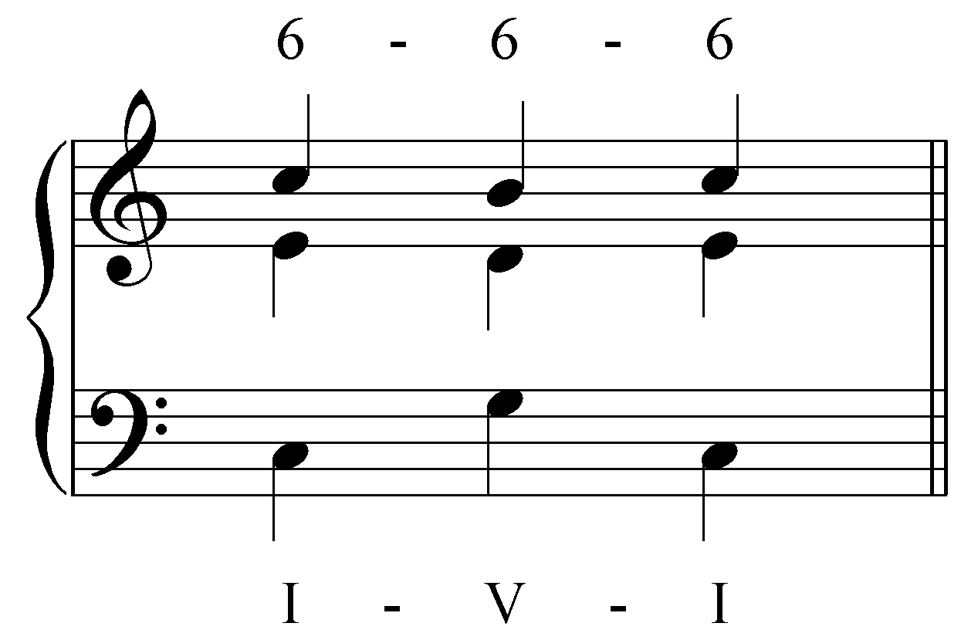

…and the tenor part forms a 6 - 5 - 6 with the alto part:

Example 26:
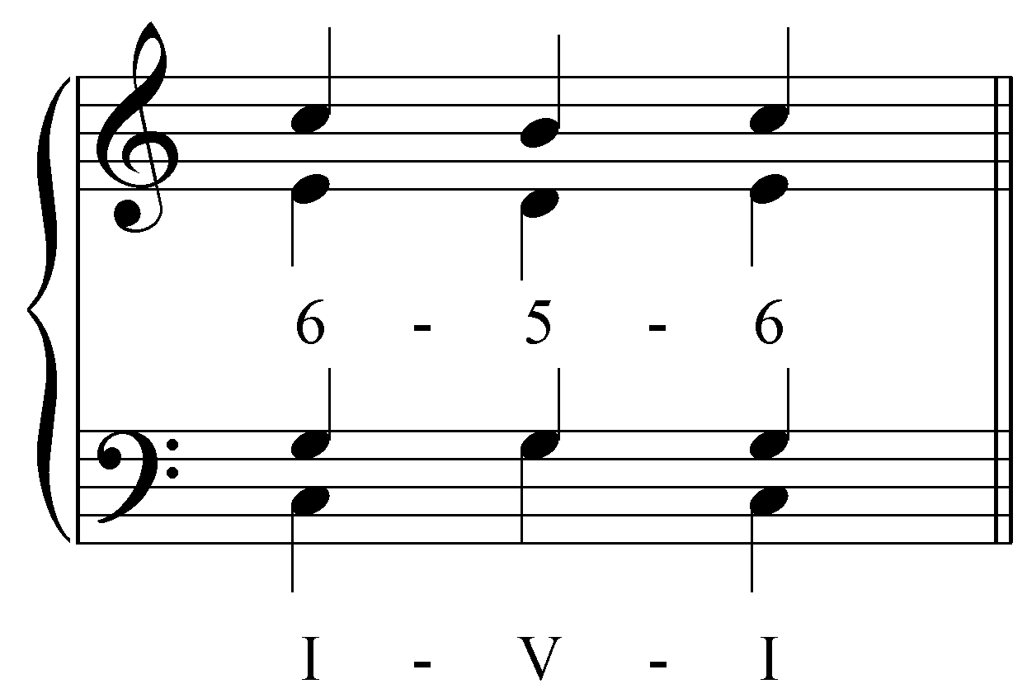

However, this example differs from the previous one in one important respect. Look at the intervals between the soprano and the tenor parts. These two parts form a 4 - 3 - 4 progression. Neither 4 - 3 nor 3 - 4 is a standard interval progression. In fact, you may have noticed that fourths do not appear at all among the basic interval progressions. As explained earlier, fourths are considered dissonant in two-voice textures and are therefore disallowed there. However, that rule must be qualified for textures with three or more voices.

When perfect fourths come about as the byproduct of adding additional voices, they are valid and common between any voice pairs not involving the bass. (Perfect fourths involving the bass require a further qualification of the rule regarding their use. This will be discussed in Lesson III.) In other words, they are allowed between a pair of upper voices. In such situations, the fourths are referred to as resultant intervals—byproducts (results) of standard interval progressions between other voices. This is because when perfect fourths occur between upper voices, they are actually inversions of (consonant) perfect fifths. A fourth formed with the bass, on the other hand, is in almost all cases a dissonant fourth, the result of a melodic event. (We will return to this subject in Lesson HHH on nonharmonic tones.) It is important that you be able to distinguish resultant intervals from those that are part of standard interval progressions.

Activity 2.7:
In this activity, you will complete the two inner voices of a “I - V” progression in G major. The first pitches have been provided:

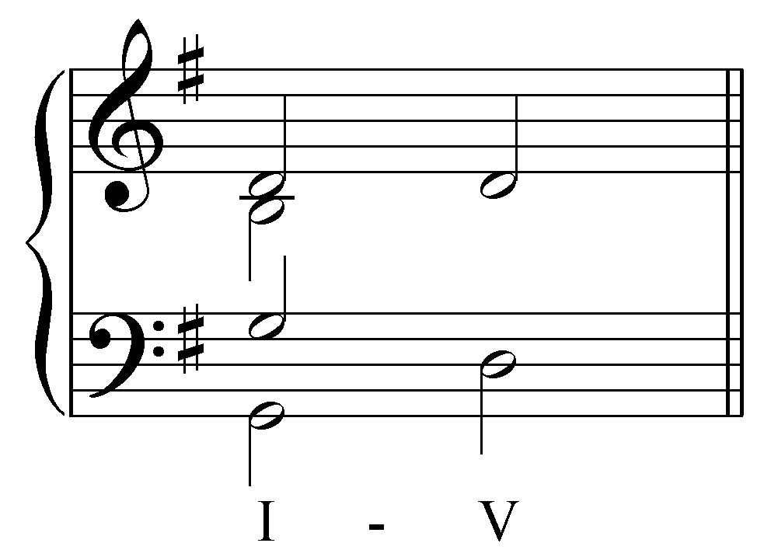
[Students must enter both answers correctly. Answers: B in alto moves down by step to A and G in tenor moves down by step to F#. Response if both answers are correct: “Correct! Both voices can move down by step.” Response if alto is correct but tenor is incorrect: “That is almost correct. Check your tenor voice and try again (remember, both voices must be members of the V chord and form valid interval progressions).” Response if alto is correct but tenor is incorrect: “That is almost correct. Check your tenor voice and try again (remember, both voices must be members of the V chord and form valid interval progressions).” Response if both voices are incorrect: “Both voices are incorrect. Try again.”]

In the above two examples, we considered standard interval progressions at work in a progression with root motion of a fifth. The same situation exists with progressions of chords whose roots are a third or a step apart. In the following example, let us determine how the inner voices move in a step progression:

Example 27:
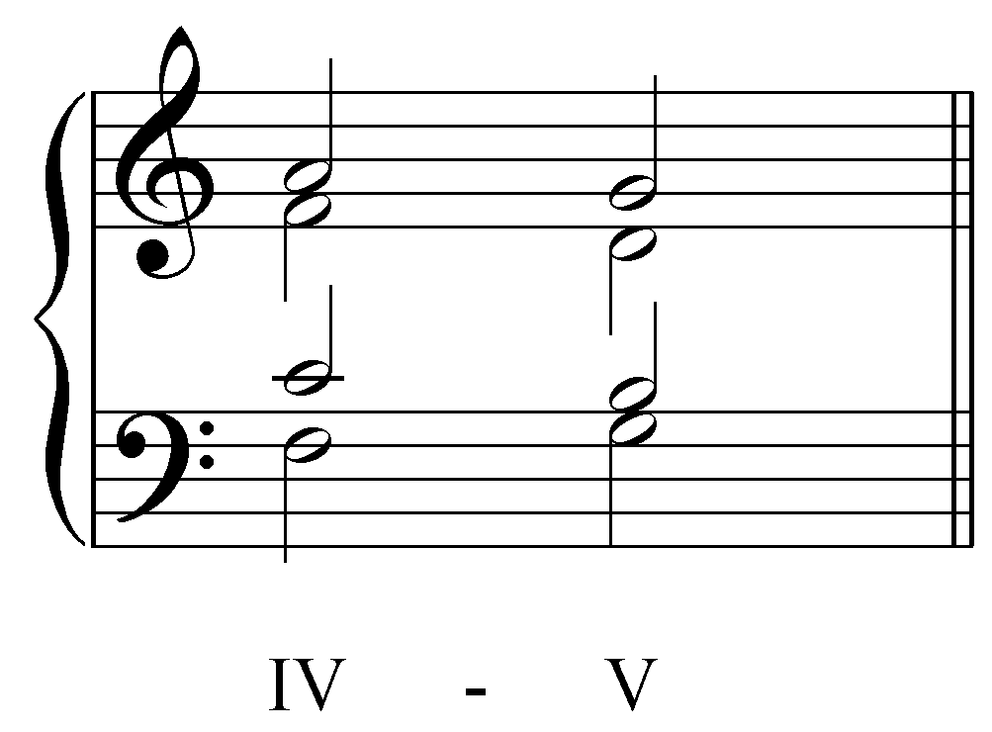

The bass and soprano form a “10 - 8” progression:

Example 28:
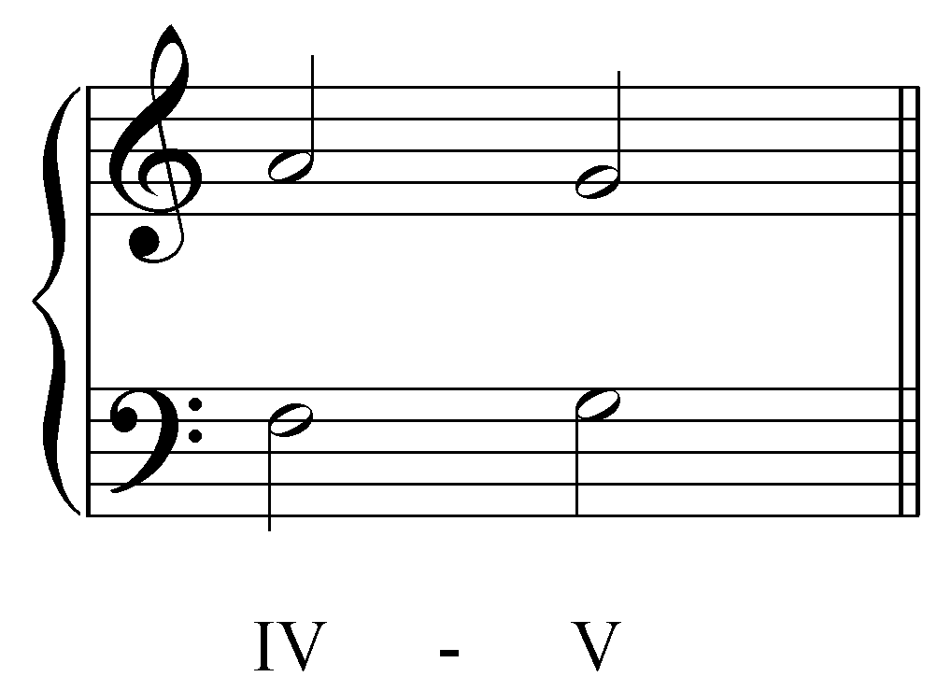

To this we may add the tenor voice which forms a “5 - 3” progression with the bass:

Example 29:
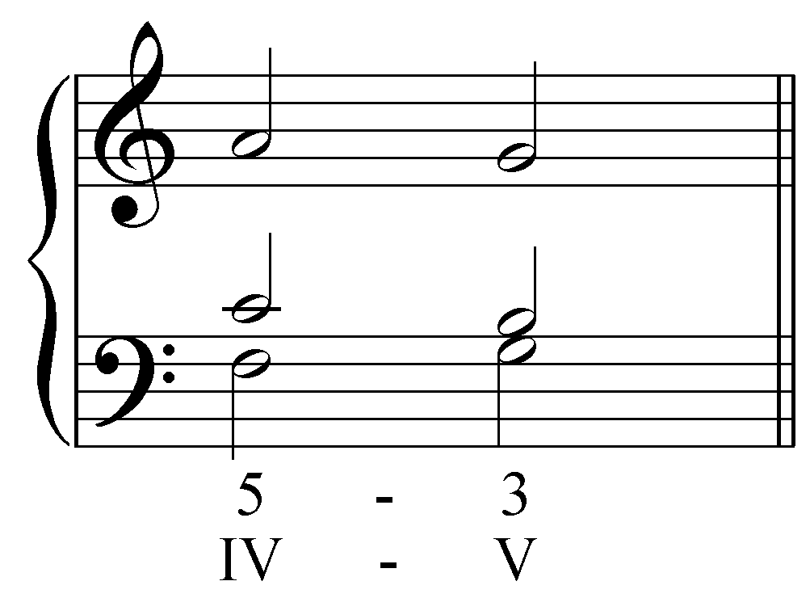

(The tenor voice may alternatively be seen as creating a “6 - 6” progression with the soprano.) And finally, the alto voice forms an “8 - 5” progression with the bass as well:

Example 30:
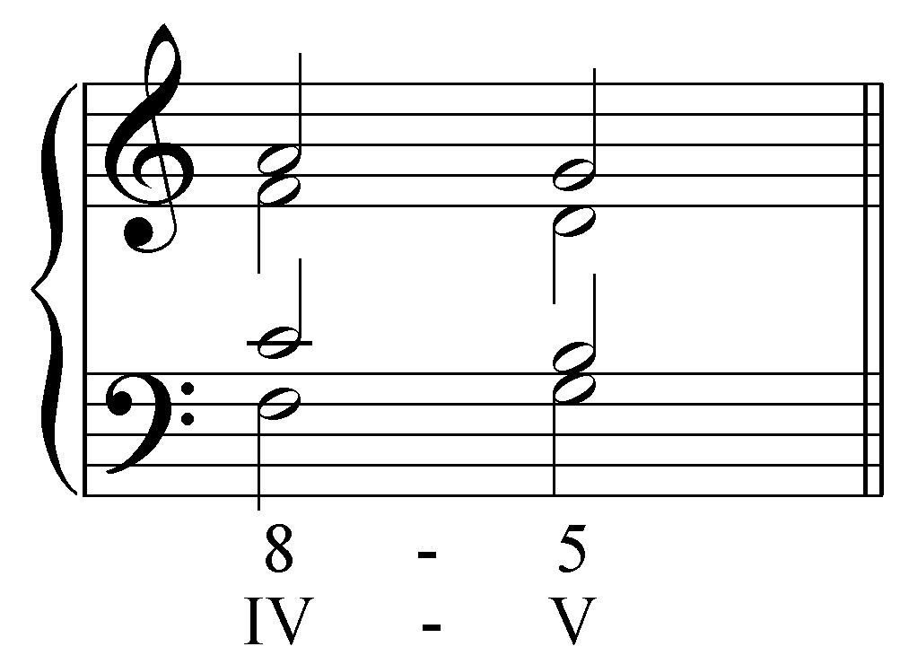

The “3 - 4” progression between the soprano and alto and the “4 - 3” progression between the alto and tenor are, as in Example 27, resultant intervals.

Activity 2.8:
In this activity you will analyze the voice leading in a progression from V to vi.

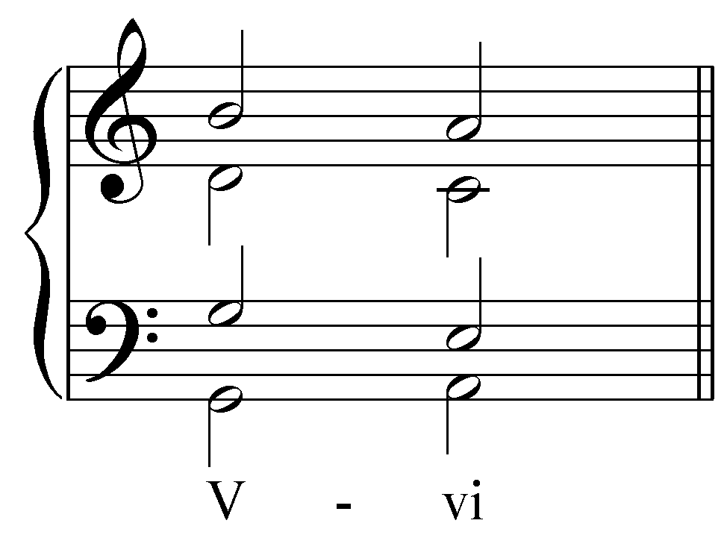
Bass and soprano: ________ [Answer: “3 - 1.”]
Bass and alto: ________ [Answer: “5 - 3.”]
Bass and tenor: ________ [Answer: “8 - 5.”]
Tenor and soprano: ________ [Answer: “3 - 4.”]
Tenor and alto: ________ [Answer: “5 - 6.”]
Alto and soprano: ________ [Answer: “6 - 6.”]

[Students must fill in each blank correctly. Response if correct: “Correct!” Response if incorrect: “Incorrect. Try again.”]

[Follow-up multiple choice question 1:]
Do any of these progressions contain resultant intervals?
[Possible answers: Yes/No. Answer: Yes. Response if correct: “Correct!” Response if incorrect: “Incorrect. Try again.”]

[Follow-up multiple choice question 2:]
Which of these progressions contains resultant intervals?
[Possible answers: the list from above. Answer: “Tenor and soprano.” Response if correct: “Correct!” Response if incorrect: “Incorrect. Try again.”]

Analysis of a Bach chorale using basic interval patterns:

Now that we are able to build four-part textures using basic interval patterns, we can analyze larger pieces of music. Consider the following chorale by J.S. Bach:

Example 30 (J.S. Bach, BWV 67.7, “Du Friedefürst, Herr Jesu Christ”):
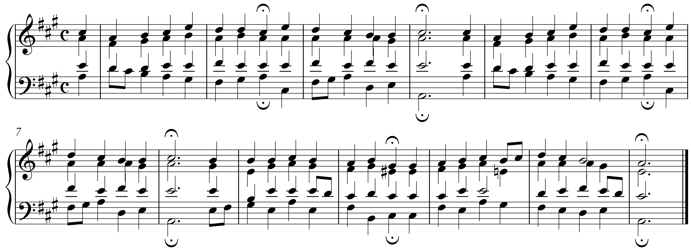

Analyzing the entire chorale may seem daunting at first, so let us begin with the first phrase:

Example 31:
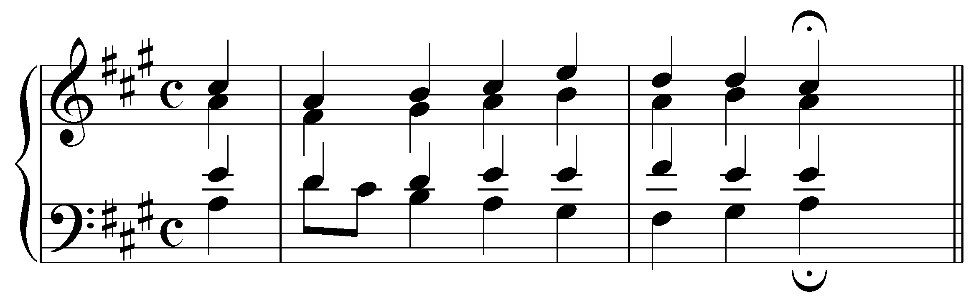

If we consider only the outer voices we can see the standard interval progressions that form the basis of this chord progression:

Example 32:
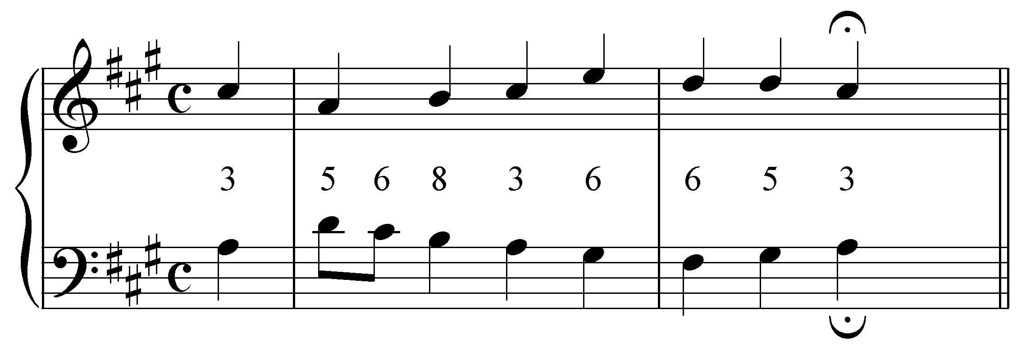

As you can see, all of the intervals between the soprano and bass form valid interval progressions. Even the decorative passing eighth note in the bass takes advantage of the oblique “5 - 6” progression. Adding the alto voice, we see that most of the intervals formed with the bass or soprano are valid:

Example 33:
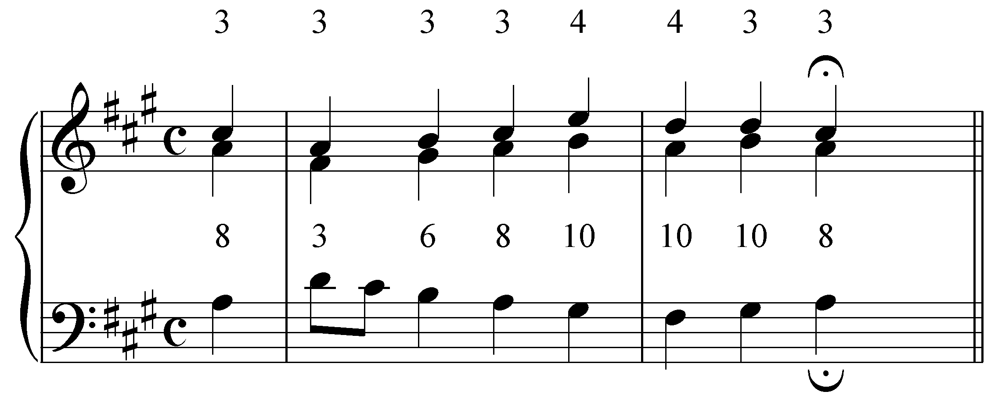

For the most part, the alto voice harmonizes the soprano with parallel thirds. At the end of the first measure, however, the intervals between the alto and soprano diverge to form fourths. These dissonant intervals are justified by the interval progressions formed by the alto and the bass. These are all valid progressions and we can see that the alto is harmonizing the bass at the end of m.1 (“8 - 10 - 10 - 10”). The dissonant fourths, therefore, are resultant intervals.

When we add the remaining voice, the tenor, we can see that it forms valid interval progressions with the soprano (except for the dissonant seventh on beat two of the second measure) and the bass:

Example 34:
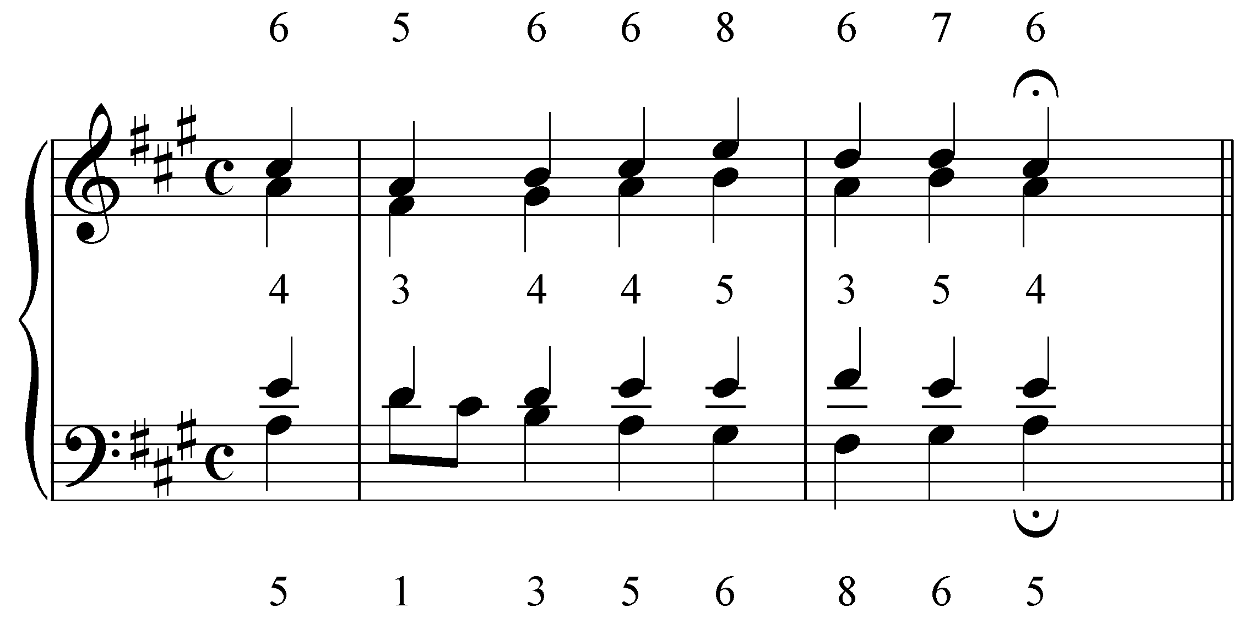

Except for the third on the downbeat of m.1 and the “5 - 3 - 5” at the end of the same measure, the intervals formed between the alto and bass are mostly resultant intervals.

Activity 2.9:
In this activity, you will analyze the interval progressions of the second phrase of the same chorale.

Identify the interval progressions between the tenor and the soprano voices:
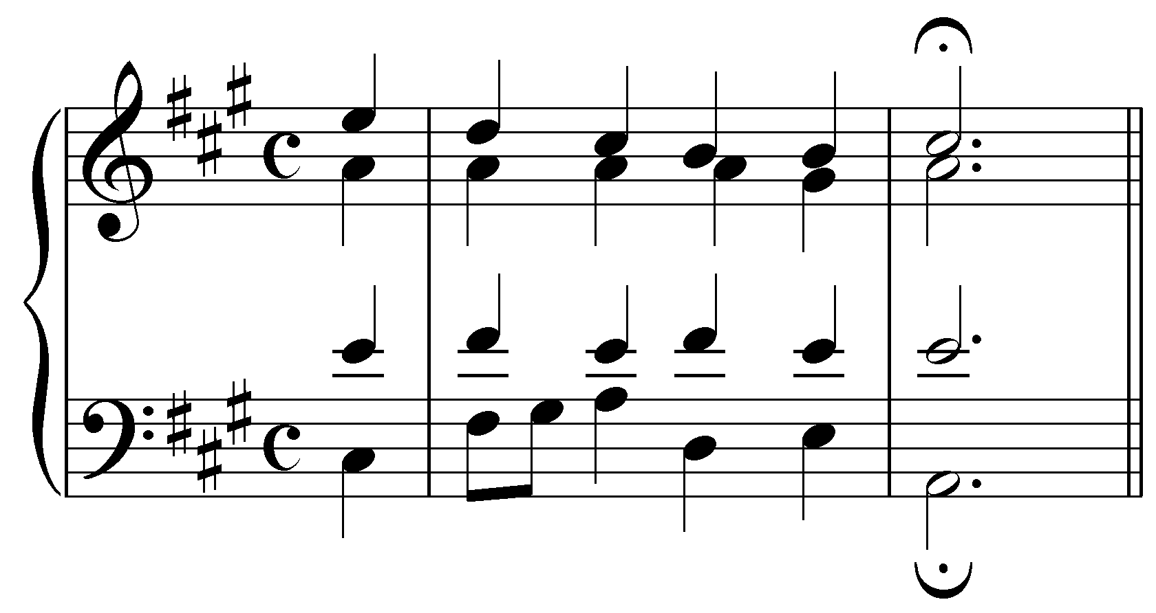
[Students will receive feedback for each of the intervals they identify. Answers: 8, 6, 6, 4, 5, 6. Response for correct answer: “Correct!” Response for incorrect answer: “This interval is incorrect. Try again.”]

[Follow-up multiple choice question 1:]
Do any of these progressions contain resultant intervals?
[Possible answers: Yes/No. Answer: Yes. Response if correct: “Correct!” Response if incorrect: “Incorrect. Try again.”]

[Follow-up multiple choice question 2:]
Which of these is a resultant interval?
[Possible answers: the list from above (or simply have students click on the correct answer). Answer: the 4 on beat three of the first complete measure. Response if correct: “Correct!” Response if incorrect: “Incorrect. Try again.”]

Conclusion:

The standard interval progressions discussed in Lesson AAA form the basis of multi-voiced tonal music. A great deal of multi-part music is found in chorale-style SATB setting. Keeping track of four voices at once can be a formidable task, so familiarity with the workings of two- and three-voice progressions will aid in the writing and analysis of more complex textures.

In three-voice textures it is possible to maintain valid interval progressions between any pair of voices. This is not always the case with four-voice textures. Because of the increased number of inter-voice relationships, dissonant, resultant intervals are often formed. These dissonances arise as the result of valid interval progressions between other voice pairs and are effectively covered up by the consonances.

These basic interval progressions are the foundation of multi-voiced textures and govern pieces even as complex as a chorale by J.S. Bach. By breaking an SATB setting down first into its outer voices and then adding the inner voices, you will be able to trace these fundamental progressions and explain the resultant dissonances that inevitably occur.

